**Database :-**

----------------

=> db is a organized collection of interrelated data. for a univ db stores

data related to students, courses, faculty etc and a bank db stores data

related to customers,accounts,trans etc.

**Types of Databaes :-**

--------------------------

1 OLTP DB (online transaction processing)

2 OLAP DB (online analytical processing)

=> organizations uses OLTP for storing day-to-day transactions

and OLAP for analysis

=>OLTP is for running business and OLAP is used for analyzing business

=> day-to-day operations on db includes

C create

R read

U update

D delete

DBMS :-

-----------

=> DBMS stands for database management system

=> it is an interface between user and database

USER-------DBMS---------DB

Evolution of DBMS :-

---------------------------

1960 FMS (File Mgmt System)

1970 HDBMS (Hierarchical DBMS)

NDBMS (Network DBMS)

1980 RDBMS (Relational DBMS)

1990 ORDBMS (Object Relational DBMS)

RDBMS :-

------------

=> relational data model concepts are introduced by E.F.CODD (Edgar Frank Codd)

=> E.F.CODD introduced 12 rules called codd rules.

=> a db that supports all 12 rules called perfect rdbms software.

Codd’s rules are proposed by a computer scientist named Dr. Edgar F. Codd and he also invent the relational model for database management. These rules are made to ensure data integrity, consistency, and usability. This set of rules basically signifies the characteristics and requirements of a relational database management system ([RDBMS](https://www.geeksforgeeks.org/rdbms-full-form/)). In this article, we will learn about various Codd’s rules.

**Codd’s Rules in DBMS**

**Rule 1: The Information Rule**

All information, whether it is user information or metadata, that is stored in a database must be entered as a value in a cell of a table. It is said that everything within the database is organized in a table layout.

**Rule 2: The Guaranteed Access Rule**

Each data element is guaranteed to be accessible logically with a combination of the table name, primary key (row value), and attribute name (column value).

**Rule 3: Systematic Treatment of NULL Values**

Every Null value in a database must be given a systematic and uniform treatment.

**Rule 4: Active Online Catalogue Rule**

The database catalogue, which contains metadata about the database, must be stored and accessed using the same relational database management system.

**Rule 5: The Comprehensive Data Sublanguage Rule**

A crucial component of any efficient database system is its ability to offer an easily understandable data manipulation language (DML) that facilitates defining, querying, and modifying information within the database.

**Rule 6: The View Updating Rule**

All views that are theoretically updatable must also be updatable by the system.

**Rule 7: High-level Insert, Update, and Delete**

A successful database system must possess the feature of facilitating high-level insertions, updates, and deletions that can grant users the ability to conduct these operations with ease through a single query.

**Rule 8: Physical Data Independence**

Application programs and activities should remain unaffected when changes are made to the physical storage structures or methods.

**Rule 9: Logical Data Independence**

Application programs and activities should remain unaffected when changes are made to the logical structure of the data, such as adding or modifying tables.

**Rule 10: Integrity Independence**

Integrity constraints should be specified separately from application programs and stored in the catalogue. They should be automatically enforced by the database system.

**Rule 11: Distribution Independence**

The distribution of data across multiple locations should be invisible to users, and the database system should handle the distribution transparently.

**Rule 12: Non-Subversion Rule**

If the interface of the system is providing access to low-level records, then the interface must not be able to damage the system and bypass security and integrity constraints.

Information Rule :-

-------------------------

=> according to information rule data must be organized in tables i.e. rows and columns

CUST

CID CNAME CITY => column / field / attribute

10 SACHIN MUM

11 RAHUL DEL

12 VIJAY HYD => row/record/tuple

Database = Collection of tables

Table = Collection of rows & cols

Row = Collection of field values

Column = Collection of values of one field

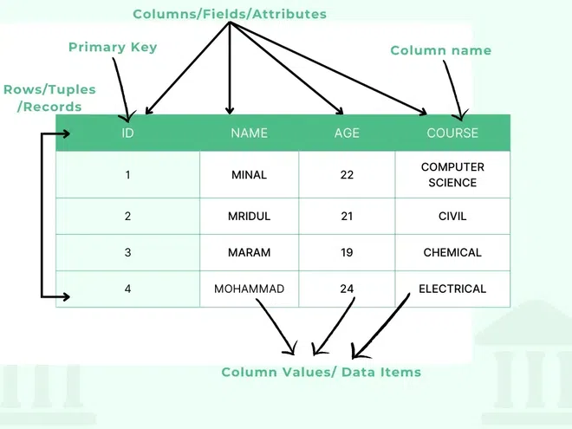

=> every table must contain primary key to uniquely identify

ex :- accno, empid, aadharno, panno, voterid

RDBMS features :-

-------------------------

1 easy to access and manipulate data

2 less redundancy (duplication of data)

3 more security

4 supports data integrity i.e. data quality

5 supports data sharing

6 supports transactions(ACID properties)

A Atomicity

C Consistency

I Isolation

D Durability

RDBMS softwares :- (SQL databaes)

----------------------------

SQL SERVER from microsoft

ORACLE from oracle corp

MYSQL from oracle corp

DB2 from ibm

RDS from amazon

POSTGRESQL from postgresql

NoSQL Databases :-

------------------------------

MongoDB

cassandra

ORDBMS :-

---------------

=> ordbms is combination of RDBMS & OOPS

ORDBMS = RDBMS + OOPS (reusability)

=> rdbms doesn't supports reusability but ordbms supports reusability.

Examples :-

SQL SERVER

ORACLE

POSTGRESQL

what is db ?

what is dbms ?

what is rdbms ?

what is ordbms ?

10-jun-24

DB Development Life Cycle :-

------------------------------------------

Analyse

Design

Develop

Test

Deploy / Implement

Maintain

Design :-

------------

=> Designing db means designing tables

=> db is designed by db designers or architects by using

1 ER Model (Entity Relationship)

2 Normalization

Development :-

---------------------

=> DB is developed by Developers & DBAs (DB Admin)

=> DB is developed by using any rdbms tool like SQL SERVER.

Roles and Responsibilities of Developer and DBA

|  |  |  |
| --- | --- | --- |
| **Developer** | | **DBA** |
| creating tables | | installation of sql server |
| creating views | | creating databases |
| creating synonyms | | creating logins |
| creating sequences | | db backup & restore |
| creating indexes | | db export & import |
| creating procedures | | db upgradation & migration |
| creating functions | | performance tuning |
| creating triggers | writing queries | |

sql server 2012 =====> sql server 2019 upgradation

mysql ===========> sql server migration

Testing :-

------------

=> DB is tested by QA (Quality Assurance) team by using

1 manual

2 automation tools like selenium

Deploy / Implementation :-

------------------------------------

=> copying db from dev server to prod server is called deploy or implementation

and after deploying db end users can use db for day-to-day transactions.

=================================================================

SQL SERVER

===========

=> sql server is basically a rdbms product from microsoft and also supports

ordbms features and used to create and to manage database.

=> sql server can be used for both DB Development & DB Administration.

sql server versions :-

----------------------------

version year

SQL SERVER 1.1 1991

SQL SERVER 4.2 1993

SQL SERVER 6.0 1995

SQL SERVER 6.5 1996

SQL SERVER 7.0 1998

SQL SERVER 2000 2000

SQL SERVER 2005 2005

SQL SERVER 2008 2008

SQL SERVER 2012 2012

SQL SERVER 2014 2014

SQL SERVER 2016 2016

SQL SERVER 2017 2017

SQL SERVER 2019 2019

SQL SERVER 2022 2022

11-jun-24

CLIENT / SERVER Architecture :-

----------------------------------------------

1 server

2 client

server :-

-----------

=> server is a system where sql server is installed and running.

=> inside the server sql server manages

1 DB

2 INSTANCE

=> DB is created in hard disk and acts as permanent storage

=> INSTANCE is created in ram and acts as temporary storage

client :-

-----------

=> client is also a system from where users can

1 connects to server

2 submit requests

3 receives response

client tool :-

---------------

SSMS (Sql Server Management Studio)

USER------SSMS-----------------------------------SQL SERVER-------DB

SQL :-

----------

=> structured query language

=> language used to communicate with sql server

=> user communicates with sql server by sending commands called queries

=> a query is a command / instruction / question submitted to sql server

to perform some operation over db.

=> SQL is originally introduced by IBM and initial name of this language was

**"sequel"** and later it is renamed to SQL.

=> common to all relational database softwares.

USER---SSMS-------------------SQL----------------------SQL SERVER---------DB

USER----SQLPLUS--------------SQL--------------------ORACLE---------------DB

USER---MYSQLWORK-----------SQL----------------------MYSQL-------------DB

BENCH

=> based on operations over db SQL is categorized into following sublanguages.

DDL (DATA DEFINITION LANG)

DML (DATA MANIPULATION LANG)

DQL (DATA QUERY LANG)

TCL (TRANSACTION CONTROL LANG)

DCL (DATA CONTROL LANG)

|  |  |  |  |  |
| --- | --- | --- | --- | --- |
| **SQL** | | | | |
| **DDL** | **DML** | **DQL** | **TCL** | **DCL** |
| create | insert | select | commit | grant |
| alter | update |  | rollback | revoke |
| drop | delete |  | save transaction |  |
| truncate | merge |  |  |  |

DATA & DATA DEFINITION :-

---------------------------------------

EMPID ENAME SAL => DATA DEFINITION / METADATA

1 A 5000 => DATA

download & install :-

---------------------------

1 SQL server

2 ssms

SQL server :-

--------------

download :-

----------------

https://www.microsoft.com/en-in/sql-server/sql-server-downloads

installation :-

-------------------

https://www.mssqltips.com/sqlservertip/7313/install-sql-server-2022/

ssms :-

---------

download :-

-----------------

https://learn.microsoft.com/en-us/sql/ssms/download-sql-server-management-studio-ssms?view=sql-server-ver16

12-jun-24

How to connect to SQL server :-

-----------------------------------------

=> open ssms and enter following details

SERVER TYPE :- DB ENGINE

SERVER NAME :- DESKTOP-G2DM7GI

AUTHENTICATION :- SQL SERVER Authentication

LOGIN :- SA (system admin)

PASSWORD :- 123

=> click connect

=> by default, SQL server comes with following 4 databases called system databases

1 master

2 model

3 msdb

4 tempdb

creating new database :-

---------------------------------

=> In object explorer select Databases => New Database

Enter Database Name :- DB11AM

=> click OK

=> a DB is created with following two files

1 DATA

2 LOG

=> DATA file stores data and log file stores operations

NAME TYPE SIZE AUTOGROWTH PATH

DB11AM DATA 8 MB 64 MB C:\----

DB11AM_LOG LOG 8 MB 64 MB C:\---

path :-

-----------

C:\Program Files\Microsoft SQL Server\MSSQL15.MSSQLSERVER\MSSQL\DATA\

DB11AM.MDF

DB11AM_LOG.LDF

**mdf => master data file**

**ldf => log data file**

command to create new database :-

------------------------------------------------

=> open master db as follows

Databases

system databases

master => New Query

=> type the following query to create new database

CREATE DATABASE salesDB

Datatypes in SQL SERVER :-

----------------------------------------

=> a datatype specifies

1 type of the data allowed in a column

2 amount of memory allocated for column

|  |  |  |  |  |  |  |
| --- | --- | --- | --- | --- | --- | --- |
| **DATATYPES** | | | | | | |
| **CHAR** | | **INTEGER** | **FLOAT** | **CURRENCY** | **DATE** | **BINARY** |
| **ASCII** | **UNICODE**(n-National) |
| char | nchar | tinyint | numeric(p,s) | smallmoney | date | Binary |
| varchar | nvarchar | smallint | decimal(p,s) | money | time | varbinary |
| varchar(max) | nvarchar(max) | int |  |  | datetime | varbinary(max) |
|  |  | bigint |  |  |  |  |
|  |  | numeric(p) |  |  |  |  |

**char(size) :-**

----------------

=> allows character data up to 8000 chars

=> recommended for fixed length char columns

ex :- NAME CHAR(10)

SACHIN - - - -

wasted

RAVI - - - - - -

wasted

=> In char datatype extra bytes are wasted, so char is not recommended for variable length fields and char is recommended for fixed length fields.

ex :- GENDER CHAR(1)

M

F

STATE_CODE CHAR(2)

AP

TG

**varchar(size) :-**

------------------------

=> allows character data up to 8000 chars

=> recommended for variable length fields

ex :- NAME VARCHAR(10)

SACHIN - - - -

released

=> In varchar extra bytes are released

**NOTE :-** char,varchar allows ascii chars (256 chars) that includes a-z,A-Z,0-9

and special chars.

ex :- PANNO CHAR(10)

VEHNO CHAR(10)

EMAILID VARCHAR(30)

**VARCHAR(max) :-**

--------------------------

=> allows character data up to **2GB**

ex :- TEXT VARCHAR(max)

1024 bytes = 1 KB

1024 KB = 1 MB

1024 MB = 1 GB

1024 GB = 1 TB

1024 TB = 1 PB

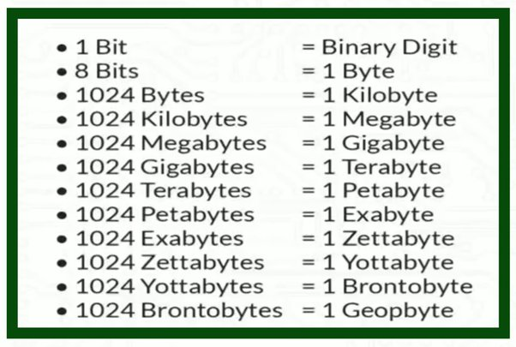

**nchar/nvarchar/nvarchar(max) :- ( n => national)**

--------------------------------------------------------------------

=> allows Unicode chars (65536 chars) that includes all ASCII chars and chars belongs to different languages

13-JUN-24

**Integer Types :-**

---------------------

=> allows numbers without decimal

|  |  |  |  |
| --- | --- | --- | --- |
| Tinyint | | 1 | 0 to 255 |
| Smallint | | 2 | -32768 to 32767 (-2^15 to 2^15-1) |
| Int | | 4 | -2^31 to 2^31-1 (-2147483648 to 2147483647) |
| bigint | 8 | | -2^63 to 2^63-1 (-9,223,372,036,854,775,808 to 9,223,372,036,854,775,807) |

ex :- age tinyint

empid smallint

custid int

**Numeric(p) :-**

-------------------

=> allows numbers without decimal up to 38 digits

ex :- empid NUMERIC(4)

10

100

1000

10000 => not allowed

phone NUMERIC(10)

aadharno NUMERIC(12)

accno NUMERIC(15)

**numeric(p,s) / decimal(p,s) :-**

---------------------------------------

=> allows numbers with decimal

p => precision => total no of digits allowed

s => scale => no of digits allowed after decimal

ex :- salary DECIMAL(7,2)

5000

5000.55

50000.55

500000.55 => not allowed

5000.5689 => allowed => 5000.57

5000.5637 => allowed => 5000.56

5000.5657 => allowed => 5000.57

savg DECIMAL(5,2)

**CURRENCY types :-**

-----------------------------

=> currency types are used for fields related to money

smallmoney 4 -214748.3648 **to** 214748.3647

money 8 -922,337,203,685,477.5808 **to** 922,337,203,685,477.5807

ex :- salary smallmoney

bal money

**DATE & TIME :-**

------------------------

DATE => allows only date

TIME => allows only time

DATETIME => allows both date & time

=> default date format in SQL server is yyyy-mm-dd

=> default time format is hh:mi:ss

ex :- DOB DATE

2003-10-5

LOGIN TIME

10:00:00

TXNDT DATETIME

2024-06-13 9:30:30

**Binary Types :-**

----------------------

=> allows multimedia objects like audio, video, images

binary => allows binary data up to 8000 bytes

varbinary => allows binary data up to 8000 byes

varbinary(max) => allows binary data up to 2GB

ex :- photo binary(5000)

photo varbinary(5000)

video varbinary(max)

===============================================================

CREATING TABLES IN SQL SERVER DB:-

------------------------------------------------------------

CREATE TABLE <tabname>

(

colname datatype(size) ,

colname datatype(size),

-------------------------------

)

**Rules :-**

----------

1 table name should start with alphabet

2 name should not contain spaces & special chars but allows _(underscore), $(doller),#(pound)

3 name can be upto 128 chars

**4 table can have 1024 cols**

**5 no of rows unlimited**

ex :- 123emp invalid

emp 123 invalid

emp*123 invalid

emp_123 valid

=> create table with following structure ?

EMP

EMPID ENAME JOB SAL HIREDATE DEPT

CREATE TABLE EMP

(

EMPID SMALLINT,

ENAME VARCHAR(10),

JOB VARCHAR(10),

SAL SMALLMONEY,

HIREDATE DATE,

DEPT VARCHAR(10)

)

=> above command created table structure that includes columns,datatype and size

SP_HELP :- sp => stored procedure

------------------

=> command to see the structure of the table

SP_HELP <tabname>

ex :-

SP_HELP EMP

EMPID smallint 2

ENAME varchar 10

JOB varchar 10

SAL smallmoney 4

HIREDATE date 3

DEPT varchar 10

**INSERTING DATA INTO TABLE :-**

----------------------------------------------

=> **"insert"** command is used to insert data into table

=> we can insert

1 single row

2 multiple rows

**inserting single row :-**

-----------------------------

Syntax :- INSERT INTO <tabname> VALUES(v1,v2,v3,----)

ex :-

INSERT INTO EMP VALUES(100,'sachin','clerk',4000,'2024-06-13','hr')

INSERT INTO EMP VALUES(101,'virat','manager',8000,getdate(),'it')

14-jun-24

**inserting multiple rows :-**

----------------------------------

INSERT INTO EMP VALUES(102,'david','analyst',6000,'2020-08-15','sales') ,

(103,'anand','clerk',5000,'2018-04-20','it'),

(104,'rahul','manager',10000,'2019-09-12','sales')

create table emp(empid int, ename varchar(50),job varchar(10), sal smallmoney, hiredate date, dept varchar(10));

sp_help emp;

select * from emp;

insert into emp values(101,'Sachin','Clerk',4000,'2024-06-13','HR');

insert into emp values(102,'Virat','Manager',8000,getdate(),'IT');

insert into emp values(103,'David','Analyst',6000,'2020-08-15','SALES'),

(104,'Anand','Clerk',5000,'2018-04-20','IT'),

(105,'Rahul','Manager',10000,'2019-09-12','SALES');

insert into emp values(106,'Vijay',NULL, NULL,getdate(),'IT');

insert into emp (empid,ename,hiredate,dept)

values(107,'Pravin',getdate(),'IT');

**inserting nulls :-**

----------------------

=> a null means blank or empty

=> it is not equal to 0 or space

=> nulls can be inserted in two ways

**method 1 :-**

----------------

INSERT INTO EMP VALUES(105,'vijay',null,null,'2021-02-15','hr')

**method 2 :-**

---------------

INSERT INTO EMP(EMPID,ENAME,HIREDATE,DEPT)

VALUES(106,'pravin',getdate(),'it')

remaining two fields job,sal are filled with nulls

==============================================================

**Operators in SQL SERVER :-**

---------------------------------------

Arithmetic Operators => + - * / %

Relational Operators => > >= < <= = <> !=

Logical Operators => AND OR NOT

Special Operators => BETWEEN

IN

LIKE

IS

ANY

ALL

EXISTS

PIVOT

Set Operators => UNION

UNION ALL

INTERSECT

EXCEPT

**Displaying Data :-**

-----------------------

=> "**SELECT**" command is used to display / retrieve data from table

=> we can display all rows or specific rows

=> we can display all cols or specific cols

syntax :- SELECT columns / * FROM tablename

SQL = ENGLISH

QUERIES = SENTENCES

CLAUSES = WORDS

* => all columns

ex :-

=> display employee names and salaries?

SELECT ENAME,SAL FROM EMP

|  |  |
| --- | --- |
| ename | sal |
| Sachin | 4000 |
| Virat | 8000 |
| David | 6000 |
| Anand | 5000 |
| Rahul | 10000 |
| Vijay | NULL |
| Pravin | NULL |

=> display employee names,job,sal and hiredates ?

SELECT ENAME,JOB,SAL,HIREDATE FROM EMP

|  |  |  |  |
| --- | --- | --- | --- |
| **ENAME** | **JOB** | **SAL** | **HIREDATE** |
| Sachin | Clerk | 4000 | 13-06-2024 |
| Virat | Manager | 8000 | 27-07-2024 |
| David | Analyst | 6000 | 15-08-2020 |
| Anand | Clerk | 5000 | 20-04-2018 |
| Rahul | Manager | 10000 | 12-09-2019 |
| Vijay | NULL | NULL | 27-07-2024 |
| Pravin | NULL | NULL | 27-07-2024 |

=> display all the data from emp table ?

SELECT * FROM EMP

|  |  |  |  |  |  |
| --- | --- | --- | --- | --- | --- |
| **EMPID** | **ENAME** | **JOB** | **SAL** | **HIREDATE** | **DEPT** |
| 101 | Sachin | Clerk | 4000 | 13-06-2024 | HR |
| 102 | Virat | Manager | 8000 | 27-07-2024 | IT |
| 103 | David | Analyst | 6000 | 15-08-2020 | SALES |
| 104 | Anand | Clerk | 5000 | 20-04-2018 | IT |
| 105 | Rahul | Manager | 10000 | 12-09-2019 | SALES |
| 106 | Vijay | NULL | NULL | 27-07-2024 | IT |
| 107 | Pravin | NULL | NULL | 27-07-2024 | IT |

**WHERE clause :-**

-------------------------

=> where clause is used to get specific row/rows from table based on a condition

=> where clause is used to filter out the rows based on the condition(s).

SELECT columns / *

FROM tablename

WHERE condition

**condition :-**

---------------

COLNAME OP VALUE

=> a **condition** is a relational expression that **returns true / false**

=> **op** must be any relational operator like **> >= < <= = <>**

=> if cond = true row is selected , if false row is not selected.

**ex :-**

=> display employee details whose id = 103 ?

SELECT * FROM EMP WHERE EMPID = 103

|  |  |  |  |  |  |
| --- | --- | --- | --- | --- | --- |
| EMPID | ENAME | JOB | SAL | HIREDATE | DEPT |
| 103 | David | Analyst | 6000 | 15-08-2020 | SALES |

=> display employee details whose name = vijay ?

SELECT * FROM EMP WHERE ENAME = 'vijay'

|  |  |  |  |  |  |
| --- | --- | --- | --- | --- | --- |
| EMPID | ENAME | JOB | SAL | HIREDATE | DEPT |
| 106 | Vijay | NULL | NULL | 27-07-2024 | IT |

**Note :** Case doesn’t matter 'vijay' and 'Vijay' both are same

=> employee details earning more than 5000 ?

SELECT * FROM EMP WHERE SAL > 5000

|  |  |  |  |  |  |
| --- | --- | --- | --- | --- | --- |
| **EMPID** | **ENAME** | **JOB** | **SAL** | **HIREDATE** | **DEPT** |
| 102 | Virat | Manager | 8000 | 27-07-2024 | IT |
| 103 | David | Analyst | 6000 | 15-08-2020 | SALES |
| 105 | Rahul | Manager | 10000 | 12-09-2019 | SALES |

=> employees joined after 2020 ?

SELECT * FROM EMP WHERE HIREDATE > 2020 => ERROR

SELECT * FROM EMP WHERE HIREDATE > '2020-12-31'

|  |  |  |  |  |  |
| --- | --- | --- | --- | --- | --- |
| **EMPID** | **ENAME** | **JOB** | **SAL** | **HIREDATE** | **DEPT** |
| 101 | Sachin | Clerk | 4000 | 13-06-2024 | HR |
| 102 | Virat | Manager | 8000 | 27-07-2024 | IT |
| 106 | Vijay | NULL | NULL | 27-07-2024 | IT |
| 107 | Pravin | NULL | NULL | 27-07-2024 | IT |

=> employees joined before 2020 ?

SELECT * FROM EMP WHERE HIREDATE < '2020-01-01'

|  |  |  |  |  |  |
| --- | --- | --- | --- | --- | --- |
| **EMPID** | **ENAME** | **JOB** | **SAL** | **HIREDATE** | **DEPT** |
| 104 | Anand | Clerk | 5000 | 20-04-2018 | IT |
| 105 | Rahul | Manager | 10000 | 12-09-2019 | SALES |

=> employees not working for sales dept ?

SELECT * FROM EMP WHERE DEPT <> 'sales'

15-jun-24

**Compound Condition :-**

------------------------------

=> multiple conditions combined with AND / OR operators are called compound

condition.

|  |  |  |
| --- | --- | --- |
| **WHERE cond1** | **AND cond2** | **Result** |
| T | T | T |
| T | F | F |
| F | T | F |
| F | F | F |

|  |  |  |
| --- | --- | --- |
| **WHERE cond1** | **OR cond2** | **Result** |
| T | T | T |
| T | F | T |
| F | T | T |
| F | F | F |

=> employees working as clerk, manager ?

SELECT * FROM EMP WHERE JOB='CLERK' OR JOB='MANAGER'

|  |  |  |  |  |  |
| --- | --- | --- | --- | --- | --- |
| **EMPID** | **ENAME** | **JOB** | **SAL** | **HIREDATE** | **DEPT** |
| 101 | Sachin | Clerk | 4000 | 13-06-2024 | HR |
| 102 | Virat | Manager | 8000 | 27-07-2024 | IT |
| 104 | Anand | Clerk | 5000 | 20-04-2018 | IT |
| 105 | Rahul | Manager | 10000 | 12-09-2019 | SALES |

=> employees whose id = 101,103,105 ?

SELECT *

FROM EMP

WHERE EMPID=101 OR EMPID = 103 OR EMPID=105

|  |  |  |  |  |  |
| --- | --- | --- | --- | --- | --- |
| **EMPID** | **ENAME** | **JOB** | **SAL** | **HIREDATE** | **DEPT** |
| 101 | Sachin | Clerk | 4000 | 13-06-2024 | HR |
| 103 | David | Analyst | 6000 | 15-08-2020 | SALES |
| 105 | Rahul | Manager | 10000 | 12-09-2019 | SALES |

=> display sales dept manager details?

SELECT *

FROM EMP

WHERE DEPT = 'sales' AND JOB = 'manager'

|  |  |  |  |  |  |
| --- | --- | --- | --- | --- | --- |
| **Empid** | **Ename** | **Job** | **Sal** | **Hiredate** | **Dept** |
| 105 | Rahul | Manager | 10000 | 12-09-2019 | SALES |

=> employees earning more than 5000 and less than 10000 ?

SELECT *

FROM EMP

WHERE SAL > 5000 AND SAL < 10000

|  |  |  |  |  |  |
| --- | --- | --- | --- | --- | --- |
| **EMPID** | **ENAME** | **JOB** | **SAL** | **HIREDATE** | **DEPT** |
| 102 | Virat | Manager | 8000 | 27-07-2024 | IT |
| 103 | David | Analyst | 6000 | 15-08-2020 | SALES |

=> employees joined in 2020 ?

SELECT *

FROM EMP

WHERE HIREDATE >= '2020-01-01'

AND

HIREDATE <= '2020-12-31'

|  |  |  |  |  |  |
| --- | --- | --- | --- | --- | --- |
| **EMPID** | **ENAME** | **JOB** | **SAL** | **HIREDATE** | **DEPT** |
| 103 | David | Analyst | 6000 | 15-08-2020 | SALES |

=> employees working as clerk, manager and earning more than 5000?

SELECT *

FROM EMP

WHERE JOB='clerk'

OR

JOB='manager'

AND

SAL>5000

=>**Note:** above query returns clerks earning less than 5000 because operator AND

has got more priority than operator OR , so SAL>5000 applied only to

manager and it is not applied to clerk, so to overcome this problem use ( ).

SELECT *

FROM EMP

WHERE (

JOB='clerk'

OR

JOB='manager'

)

AND

SAL>5000

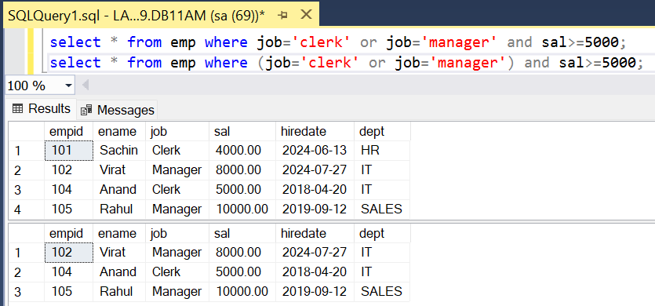

=>

STUDENT

SNO SNAME S1 S2 S3

1 A 80 90 70

2 B 30 60 50

CREATE TABLE STUDENT

(

SID INT,

SNAME VARCHAR(10),

S1 TINYINT,

S2 TINYINT,

S3 TINYINT

)

INSERT INTO STUDENT VALUES(1,'A',80,90,70),(2,'B',30,60,50)

|  |  |  |  |  |
| --- | --- | --- | --- | --- |
| **SNO** | **SNAME** | **S1** | **S2** | **S3** |
| 1 | A | 80 | 90 | 70 |
| 2 | B | 30 | 60 | 50 |

list of students who are passed?

SELECT * FROM STUDENT WHERE S1>=35 AND S2>=35 AND S3>=35

list of students who are failed?

SELECT * FROM STUDENT WHERE S1<35 OR S2<35 OR S3<35

**IN operator:-**

------------------

=> use IN operator for list comparison.

=> use IN operator for "=" comparison with multiple values.

=> IN operator is used whenever we have to filter the row based on different values of same column.

=> It reduces the no of comparisons and joining of conditions using operators.

WHERE COLNAME = V1,V2,V3,------ => Invalid

WHERE COLNAME IN (V1,V2,V3,---) => Valid

=> employees whose id =101,103,105 ?

SELECT * FROM EMP WHERE EMPID **IN** (101,103,105)

|  |  |  |  |  |  |
| --- | --- | --- | --- | --- | --- |
| **EMPID** | **ENAME** | **JOB** | **SAL** | **HIREDATE** | **DEPT** |
| 101 | Sachin | Clerk | 4000 | 13-06-2024 | HR |
| 103 | David | Analyst | 6000 | 15-08-2020 | SALES |
| 105 | Rahul | Manager | 10000 | 12-09-2019 | SALES |

=> employees working as clerk,manager ?

SELECT * FROM EMP WHERE JOB **IN** ('clerk','manager')

|  |  |  |  |  |  |
| --- | --- | --- | --- | --- | --- |
| **EMPID** | **ENAME** | **JOB** | **SAL** | **HIREDATE** | **DEPT** |
| 101 | Sachin | Clerk | 4000 | 13-06-2024 | HR |
| 102 | Virat | Manager | 8000 | 27-07-2024 | IT |
| 104 | Anand | Clerk | 5000 | 20-04-2018 | IT |
| 105 | Rahul | Manager | 10000 | 12-09-2019 | SALES |

=> employees not working for dept it,hr ?

SELECT * FROM EMP WHERE DEPT **NOT IN** ('hr','it')

|  |  |  |  |  |  |
| --- | --- | --- | --- | --- | --- |
| **EMPID** | **ENAME** | **JOB** | **SAL** | **HIREDATE** | **DEPT** |
| 103 | David | Analyst | 6000 | 15-08-2020 | SALES |
| 105 | Rahul | Manager | 10000 | 12-09-2019 | SALES |

**BETWEEN operator :-**

-------------------------------

=> use between operator for range comparison i.e. between two values

WHERE COLNAME BETWEEN V1 AND V2 (COL >= V1 AND COL <= V2)

=> employees earning between 5000 and 10000 ?

SELECT *

FROM EMP

WHERE SAL **BETWEEN** 5000 **AND** 10000

|  |  |  |  |  |  |
| --- | --- | --- | --- | --- | --- |
| **EMPID** | **ENAME** | **JOB** | **SAL** | **HIREDATE** | **DEPT** |
| 102 | Virat | Manager | 8000 | 27-07-2024 | IT |
| 103 | David | Analyst | 6000 | 15-08-2020 | SALES |
| 104 | Anand | Clerk | 5000 | 20-04-2018 | IT |
| 105 | Rahul | Manager | 10000 | 12-09-2019 | SALES |

=> employees joined in 2020 ?

SELECT *

FROM EMP

WHERE HIREDATE **BETWEEN** '2020-01-01' **AND** '2020-12-31'

|  |  |  |  |  |  |
| --- | --- | --- | --- | --- | --- |
| **EMPID** | **ENAME** | **JOB** | **SAL** | **HIREDATE** | **DEPT** |
| 103 | David | Analyst | 6000 | 15-08-2020 | SALES |

=> not joined in 2020 ?

WHERE HIREDATE **NOT BETWEEN** '2020-01-01' **AND** '2020-12-31'

|  |  |  |  |  |  |
| --- | --- | --- | --- | --- | --- |
| **EMPID** | **ENAME** | **JOB** | **SAL** | **HIREDATE** | **DEPT** |
| 101 | Sachin | Clerk | 4000 | 13-06-2024 | HR |
| 102 | Virat | Manager | 8000 | 27-07-2024 | IT |
| 104 | Anand | Clerk | 5000 | 20-04-2018 | IT |
| 105 | Rahul | Manager | 10000 | 12-09-2019 | SALES |
| 106 | Vijay | NULL | NULL | 27-07-2024 | IT |
| 107 | Pravin | NULL | NULL | 27-07-2024 | IT |

=> employees working as clerk,manager and earning between 5000 and 10000

and not joined in 2020 and not working for dept hr,sales ?

SELECT *

FROM EMP

WHERE JOB IN ('clerk','manager')

AND

SAL BETWEEN 5000 AND 10000

AND

HIREDATE NOT BETWEEN '2020-01-01' AND '2020-12-31'

AND

DEPT NOT IN ('hr','sales')

|  |  |  |  |  |  |
| --- | --- | --- | --- | --- | --- |
| **EMPID** | **ENAME** | **JOB** | **SAL** | **HIREDATE** | **DEPT** |
| 102 | Virat | Manager | 8000 | 27-07-2024 | IT |
| 104 | Anand | Clerk | 5000 | 20-04-2018 | IT |

=> display samsung,redmi,realme mobiles whose price between 10000 and 20000 ?

PRODUCTS

prodid pname price category brand

SELECT *

FROM PRODUCTS

WHERE BRAND IN ('samsung','redmi','realme')

AND

PRICE BETWEEN 10000 AND 20000

AND

CATEGORY='mobiles'

17-JUN-24

**IMP Note:**

SELECT *

FROM EMP

WHERE SAL BETWEEN 10000 AND 5000

A ERROR

B RETURNS NO ROWS

C RETURNS ROWS

D NONE

ANS :- B

Internally :

WHERE SAL BETWEEN 5000 AND 10000 (SAL>=5000 AND SAL<=10000)

WHERE SAL BETWEEN 10000 AND 5000 (SAL>=10000 AND SAL<=5000)

**NOTE :-**

=> **use between with lower and upper but not with upper and lower**

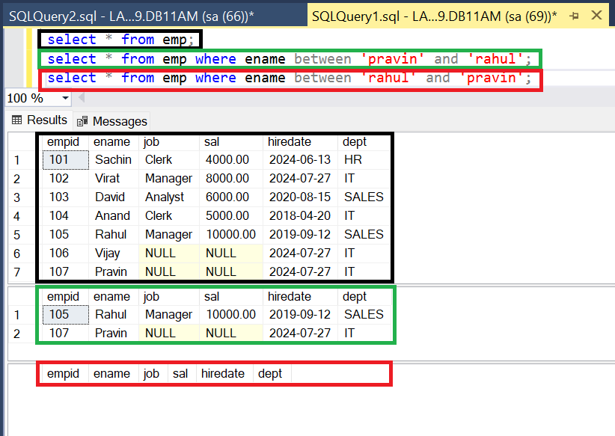

**LIKE operator:-**

---------------------

=> use LIKE operator for pattern comparison

ex :- name starts with 's'

name ends with 'd'

name contains 'a'

Syntax:

WHERE COLNAME LIKE 'PATTERN'

=> pattern contains alphabets, digits, wildcard chars

=> Brackets in Pattern not mandatory, ' ' single quote is mandatory.

**Wildcard Chars :-**

---------------------

Using wildcard characters makes the LIKE operator more flexible than using the = and != string comparison operators. If any one of the arguments isn't of character string data type, the SQL Server Database Engine converts it to character string data type, if it's possible.

% => 0 or many chars

_ => exactly 1 char

=> employees name starts with 's' ?

SELECT * FROM EMP WHERE ENAME LIKE 's%'

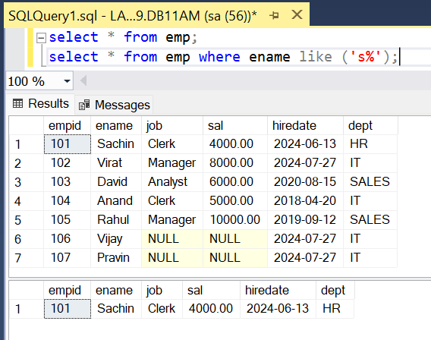

=> employees name ends with 'd' ?

SELECT * FROM EMP WHERE ENAME LIKE '%d'

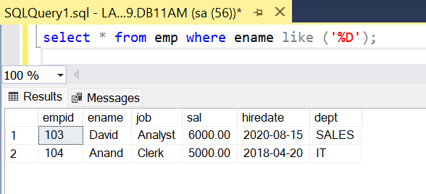

=> employees name contains 'a' ?

SELECT * FROM EMP WHERE ENAME LIKE '%a%'

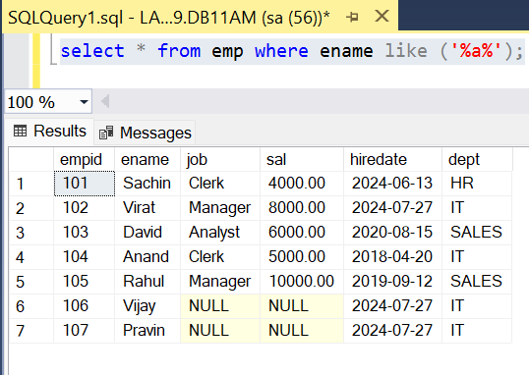

=> employees where 'a' is the 3rd char in their name ?

SELECT * FROM EMP WHERE ENAME LIKE '__a%'

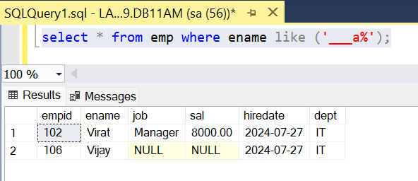

=> employees where 'a' is the 4th char from last ?

SELECT * FROM EMP WHERE ENAME LIKE '%a___'

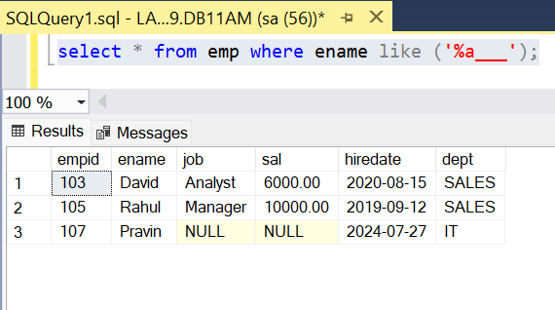

=> name contains 5 chars ?

SELECT * FROM EMP WHERE ENAME LIKE '_____'

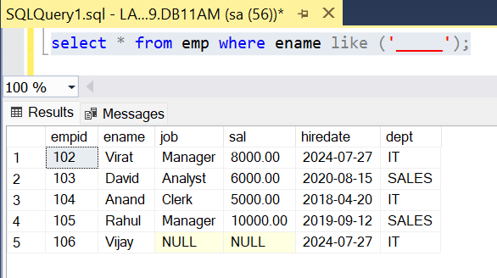

=> employees joined in aug month ? YYYY-MM-DD

SELECT * FROM EMP WHERE **HIREDATE** LIKE '_____08___'

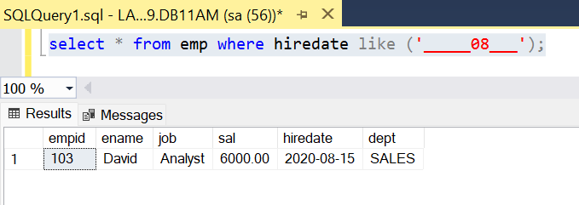

=> employees joined in 2020 year ?

SELECT * FROM EMP WHERE HIREDATE LIKE '2020%'

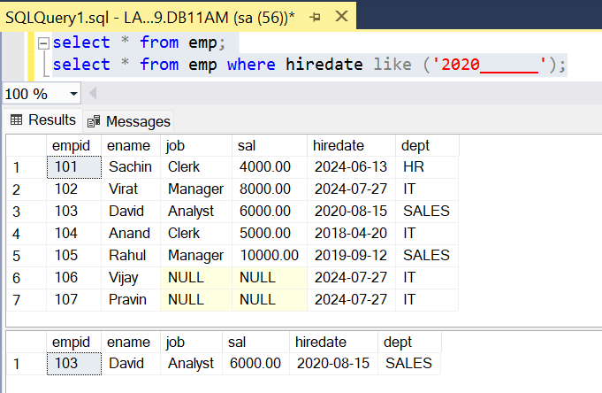

=> employees joined in 1st 9 days of any of month any year ?

SELECT * FROM EMP WHERE HIREDATE LIKE '%0_'

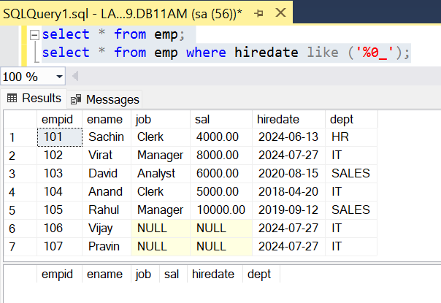

=> employees name starts with 'a','d','p','r' ?

SELECT * FROM EMP WHERE ENAME LIKE '[adpr]%'

=> employees name do not starts with 'a','d','p','r' ?

SELECT * FROM EMP WHERE ENAME LIKE '[^adpr]%'

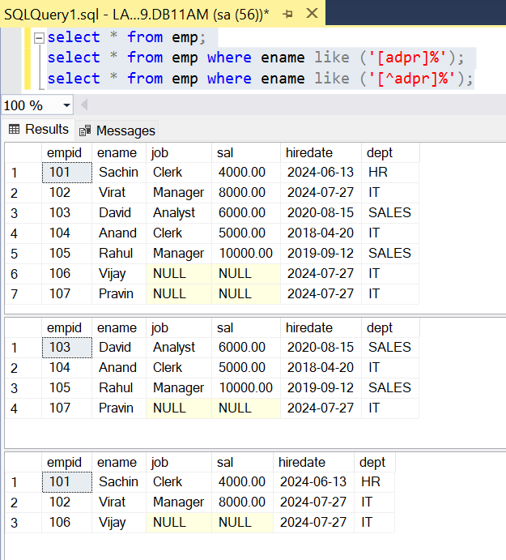

=> employees name starts between 'a' and 'p' ?

SELECT * FROM EMP WHERE ENAME LIKE '[a-p]%'

=> employees name do not starts between 'a' and 'p' ?

SELECT * FROM EMP WHERE ENAME LIKE '[^a-p]%'

or

SELECT * FROM EMP WHERE ename **not** like ('[a-p]%');

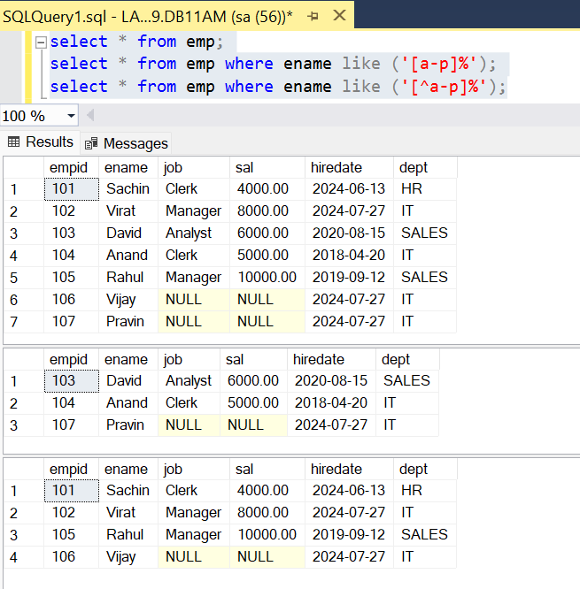

=>

CUST

CID CNAME

10 sachin_tendulkar

11 virat%kohli

12 mahendra_singh_dhoni

Create above table:

create table cust (CID INT, CNAME VARCHAR(20))

Insert Records:

insert into cust values(10,'Sachin_Tendulkar'),(11,'Virat%Kohli'),(12,'Mahendra_Singh_Dhoni')

=> employees name contains "_" ?

SELECT * FROM CUST WHERE CNAME LIKE '%_%'

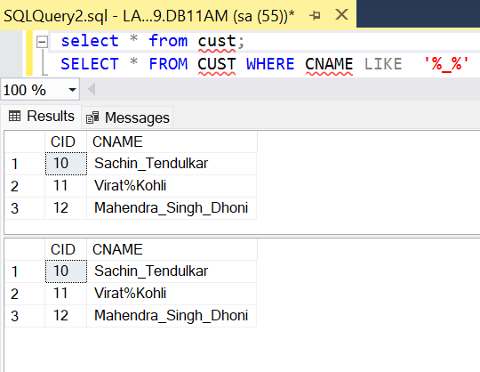

above query displays all cust records because '_' is not treated as search char and

it is treated as wildcard char , to overcome this problem use escape char.

SELECT * FROM CUST WHERE CNAME LIKE '%\_%' ESCAPE '\'

the char that immediately follows "\" is not treated as wildcard char and it is treated as normal char

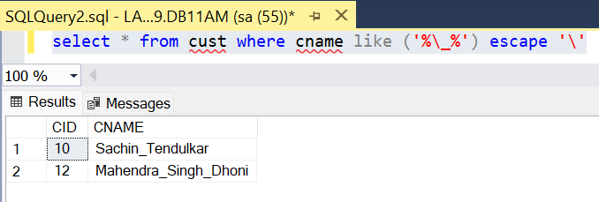

=> name contains "%" ?

SELECT * FROM CUST WHERE CNAME LIKE '%\%%' ESCAPE '\'

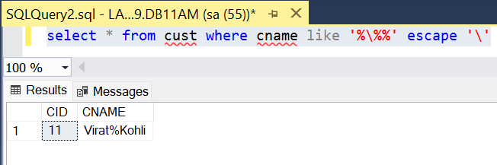

=> name contains 2 "_" ?

SELECT * FROM CUST WHERE CNAME LIKE '%\_%\_%' ESCAPE '\'

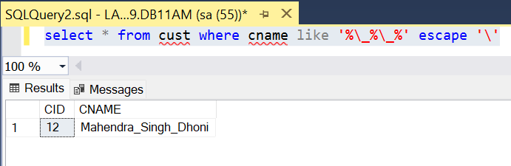

=> Filter results for description with first character A and second character N

select * from emp where ename like'[a][n]%'

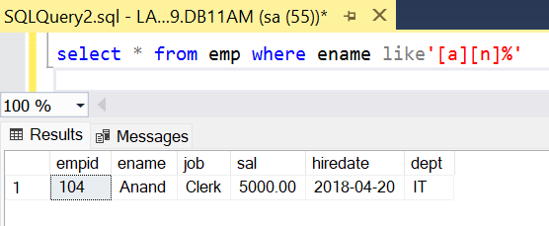

*alter table emp add email varchar(20)

*update emp set email=ename+'@gmail.com'

|  |  |  |  |  |  |  |
| --- | --- | --- | --- | --- | --- | --- |
| **Empid** | **Ename** | **Job** | **Sal** | **Hiredate** | **Dept** | **Email** |
| 101 | Sachin | Clerk | 4000 | 13-06-2024 | HR | Sachin@gmail.com |
| 102 | Virat | Manager | 8000 | 27-07-2024 | IT | Virat@gmail.com |
| 103 | David | Analyst | 6000 | 15-08-2020 | SALES | David@gmail.com |
| 104 | Anand | Clerk | 5000 | 20-04-2018 | IT | Anand@gmail.com |
| 105 | Rahul | Manager | 10000 | 12-09-2019 | SALES | Rahul@gmail.com |
| 106 | Vijay | NULL | NULL | 27-07-2024 | IT | Vijay@gmail.com |
| 107 | Pravin | NULL | NULL | 27-07-2024 | IT | Pravin@gmail.com |

Select The emp with first character should be from A and D alphabets the second character should be from F and L alphabet.

select * from emp

select * from emp where email like '[a-p][a-r]%'

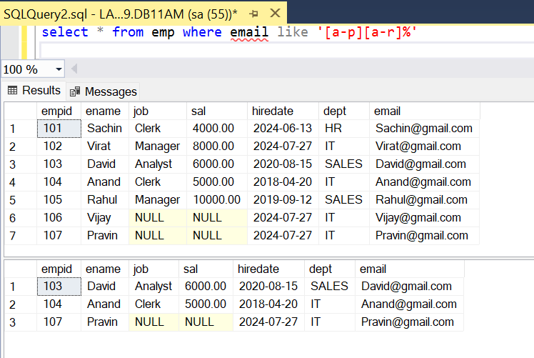

select * from emp where email like '[a-p][^m-r]%'

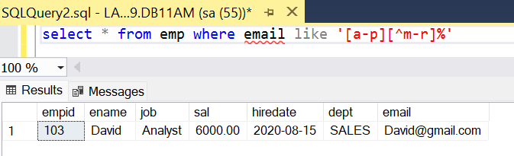

18-jun-24

**IS operator:-**

------------------

=> In databases, NULL is unknown, not applicable or missing information, therefore, you cannot use the comparison operators (=, >,<, etc.,) to check whether a value is NULL or not. For example,

The expression A = NULL, B <> NULL or NULL = NULL returns NULL because NULL values cannot be compared.

Fortunately, SQL provides the IS operator to check whether a value is NULL.

=> use IS operator for NULL comparison.

WHERE COLNAME IS NULL

WHERE COLNAME IS NOT NULL

=> employees who are not earning salary?

SELECT * FROM EMP WHERE SAL IS NULL

select * from emp To show all Records

select * from emp where sal=null; Invalid

select * from emp where sal is null; Valid

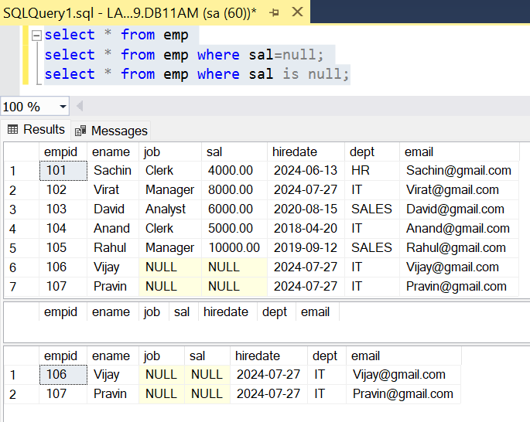

=> employees earning salary ?

SELECT * FROM EMP WHERE SAL IS NOT NULL

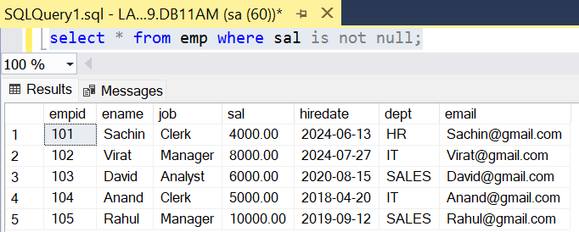

=> employees not assigned with any job ?

SELECT * FROM EMP WHERE JOB IS NULL

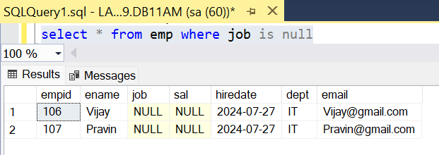

**Summary:-**

WHERE COLNAME IN (V1,V2,V3,---)

WHERE COLNAME BETWEEN V1 AND V2

WHERE COLNAME LIKE 'PATTERN'

WHERE COLNAME IS NULL

**ALIAS :-**

-----------

=> SQL aliases are **used to give a temporary Name to table, or a column in a table.**

=> Aliases are often used to make **column names more readable**.

=> **An alias only exists for the duration of that query**.

=> An alias is created with the **AS** keyword.

=> Alias means another name or alternative name

=> used to change column heading

COLNAME/EXPR [AS] ALIAS

**Ex :-**

=> display ENAME ANNUAL SAL ?

SELECT ENAME,SAL*12 AS ANNSAL

FROM EMP

SELECT ENAME,SAL*12 AS [ANNUAL SAL]

FROM EMP

=> select ename as [Emp Name], sal*12 as Annual_Salary from emp;

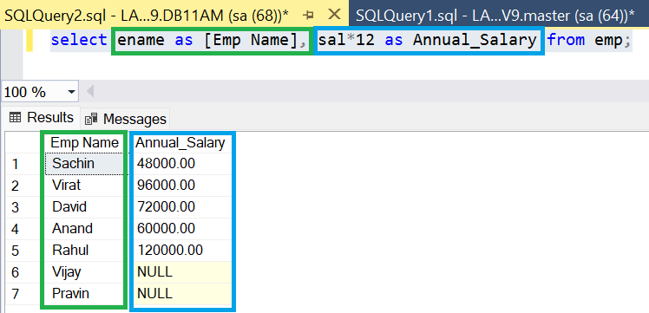

=> display ENAME SAL HRA DA TAX TOTSAL ?

HRA = house rent allowance = 20% on sal

DA = dearness allowance = 30% on sal

TAX = 10% on sal

TOTSAL = SAL + HRA + DA - TAX

select ename as [EMP Name],

sal as ***[Basic Salary]***,

sal*0.2 as ***HRA***,

sal*0.3 as ***DA***,

sal*0.1 as ***TAX***,

sal + sal*0.2 + sal*0.3 + sal*0.1 as [***Total Salary***] from emp

**Output:**

|  |  |  |  |  |  |
| --- | --- | --- | --- | --- | --- |
| **EMP Name** | **Basic Salary** | **HRA** | **DA** | **TAX** | **Total Salary** |
| Sachin | 4000 | 800 | 1200 | 03-02-1901 | 6400 |
| Virat | 8000 | 1600 | 2400 | 10-03-1902 | 12800 |
| David | 6000 | 1200 | 1800 | 22-08-1901 | 9600 |
| Anand | 5000 | 1000 | 1500 | 14-05-1901 | 8000 |
| Rahul | 10000 | 2000 | 3000 | 26-09-1902 | 16000 |
| Vijay | NULL | NULL | NULL | NULL | NULL |
| Pravin | NULL | NULL | NULL | NULL | NULL |

=> employees earning more than 1 lac annual salary ?

SELECT *

FROM EMP

WHERE SAL*12 > 100000

==============================================================

**ORDER BY clause :-**

----------------------------

=> Order by clause is used to sort table data based on one or more columns either in ascending or in descending.

SELECT columns

FROM tabname

[WHERE cond]

ORDER BY colname ASC / DESC ,------

Ex :-

=> arrange employee list name wise ascending?

SELECT *

FROM EMP

ORDER BY ENAME ASC

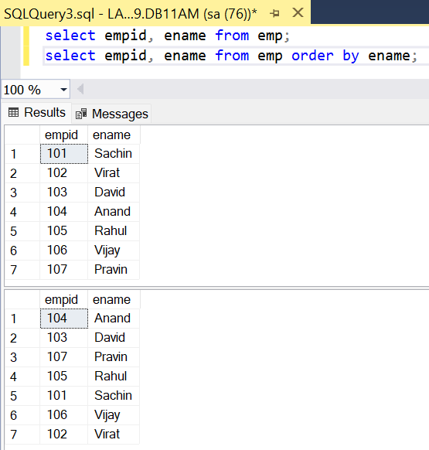

=> arrange employee list sal wise desc ?

SELECT *

FROM EMP

ORDER BY SAL DESC

|  |  |  |  |  |  |  |
| --- | --- | --- | --- | --- | --- | --- |
| **EmpID** | **Name** | **Sal** |  | **EmpID** | **Name** | **Sal** |
| 1 | A | 3000 |  | 2 | B | 6000 |
| 2 | B | 6000 | ====> | 4 | D | 5000 |
| 3 | C | 4000 |  | 3 | C | 4000 |
| 4 | D | 5000 |  | 1 | A | 3000 |

=> arrange employee hiredate wise ? employee who joined first display first ?

SELECT *

FROM EMP

ORDER BY HIREDATE ASC

|  |  |  |  |  |  |  |
| --- | --- | --- | --- | --- | --- | --- |
| **Empid** | **Ename** | **Job** | **Sal** | **Hiredate** | **Dept** | **Email** |
| 104 | Anand | Clerk | 5000 | 20-04-2018 | IT | Anand@gmail.com |
| 105 | Rahul | Manager | 10000 | 12-09-2019 | SALES | Rahul@gmail.com |
| 103 | David | Analyst | 6000 | 15-08-2020 | SALES | David@gmail.com |
| 101 | Sachin | Clerk | 4000 | 13-06-2024 | HR | Sachin@gmail.com |
| 102 | Virat | Manager | 8000 | 27-07-2024 | IT | Virat@gmail.com |
| 106 | Vijay | NULL | NULL | 27-07-2024 | IT | Vijay@gmail.com |
| 107 | Pravin | NULL | NULL | 27-07-2024 | IT | Pravin@gmail.com |

=> arrange employee list dept wise asc and with in dept sal wise desc ?

create table emp1 (empid int, ename varchar(10),sal money,deptid int)

insert into emp1 values(1,'A',3000,20),

(2,'B',5000,10),

(3,'C',6000,30),

(4,'D',4000,20),

(5,'E',6000,10),

(6,'F',4000,30),

(7,'G',3000,40)

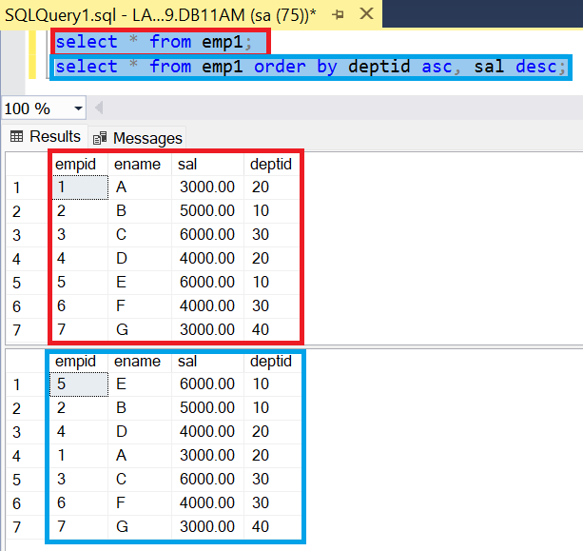

=> find out employees highest and least experienced in each dept ?

SELECT EMPNO,ENAME,HIREDATE,DEPTNO

FROM EMP

ORDER BY DEPTNO ASC ,HIREDATE ASC

|  |  |  |  |  |  |  |
| --- | --- | --- | --- | --- | --- | --- |
| **EMPID** | **ENAME** | **JOB** | **SAL** | **HIREDATE** | **DEPT** | **EMAIL** |
| 101 | Sachin | Clerk | 4000 | 13-06-2024 | HR | Sachin@gmail.com |
| 102 | Virat | Manager | 8000 | 27-07-2024 | IT | Virat@gmail.com |
| 106 | Vijay | NULL | NULL | 27-07-2024 | IT | Vijay@gmail.com |
| 107 | Pravin | NULL | NULL | 27-07-2024 | IT | Pravin@gmail.com |
| 104 | Anand | Clerk | 5000 | 20-04-2018 | IT | Anand@gmail.com |
| 103 | David | Analyst | 6000 | 15-08-2020 | SALES | David@gmail.com |
| 105 | Rahul | Manager | 10000 | 12-09-2019 | SALES | Rahul@gmail.com |

=> arrange student list avg desc , m desc,p desc ?

create table student1(rollno int, sname varchar(10),Maths tinyint, phys tinyint, chem tinyint);

insert into student1 values(1,'A',80,90,70),

(2,'B',60,70,50),

(3,'C',90,70,80),

(4,'D',90,80,70);

STUDENT1

|  |  |  |  |  |
| --- | --- | --- | --- | --- |
| **ROLLNO** | **SNAME** | **MATHS** | **PHYS** | **CHEM** |
| 1 | A | 80 | 90 | 70 |
| 2 | B | 60 | 70 | 50 |
| 3 | C | 90 | 70 | 80 |
| 4 | D | 90 | 80 | 70 |

SELECT * , (MATHS+PHYS+CHEM)/3 AS AVG FROM STUDENT1 ORDER BY (MATHS+PHYS+CHEM)/3 DESC, MATHS DESC, PHYS DESC;

**OUTPUT:**

|  |  |  |  |  |  |
| --- | --- | --- | --- | --- | --- |
| **ROLLNO** | **SNAME** | **MATHS** | **PHYS** | **CHEM** | **AVG** |
| 4 | D | 90 | 80 | 70 | 80 |
| 3 | C | 90 | 70 | 80 | 80 |
| 1 | A | 80 | 90 | 70 | 80 |
| 2 | B | 60 | 70 | 50 | 60 |

**19-jun-24**

=> employees working as clerk, manager and arrange list sal wise desc ?

SELECT *

FROM EMP

WHERE JOB IN ('CLERK','MANAGER')

ORDER BY SAL DESC

|  |  |  |  |  |  |  |
| --- | --- | --- | --- | --- | --- | --- |
| **EMPID** | **ENAME** | **JOB** | **SAL** | **HIREDATE** | **DEPT** | **EMAIL** |
| 105 | Rahul | Manager | 18-05-1927 | 12-09-2019 | SALES | Rahul@gmail.com |
| 102 | Virat | Manager | 25-11-1921 | 27-07-2024 | IT | Virat@gmail.com |
| 104 | Anand | Clerk | 08-09-1913 | 20-04-2018 | IT | Anand@gmail.com |
| 101 | Sachin | Clerk | 13-12-1910 | 13-06-2024 | HR | Sachin@gmail.com |

**DISTINCT Clause :-**

---------------------------

=> distinct clause eliminates duplicates from select statement output

SELECT DISTINCT COLNAME

SELECT DISTINCT COL1,COL2

SELECT DISTINCT *

**Ex :-**

1 SELECT DISTINCT JOB FROM EMP

ANALYST

CLERK

MANAGER

PRESIDENT

SALESMAN

2 SELECT DISTINCT DEPTNO FROM EMP

10

20

30

3

EMP44

ENO ENAME SAL

1 A 5000

2 B 6000

3 C 7000

1 A 5000

2 B 6000

SELECT DISTINCT * FROM EMP44

1 A 5000

2 B 6000

3 C 7000

Note : when Distinct is used with * then it will select only unique records.

**TOP clause :-**

-------------------

=> Used to display top N rows.

=> The SELECT TOP clause is useful on large tables with thousands of records. Returning a large number of records can impact performance.

**Syntax:**

SELECT TOP <n> colnames / *

FROM tabname

[WHERE cond]

[ORDER BY --]

Ex :-

=> display first 5 rows from emp table?

SELECT TOP 5 *

FROM EMP

|  |  |  |  |  |  |  |
| --- | --- | --- | --- | --- | --- | --- |
| **EMPID** | **ENAME** | **JOB** | **SAL** | **HIREDATE** | **DEPT** | **EMAIL** |
| 101 | Sachin | Clerk | 4000 | 13-06-2024 | HR | Sachin@gmail.com |
| 102 | Virat | Manager | 8000 | 27-07-2024 | IT | Virat@gmail.com |
| 103 | David | Analyst | 6000 | 15-08-2020 | SALES | David@gmail.com |
| 104 | Anand | Clerk | 5000 | 20-04-2018 | IT | Anand@gmail.com |
| 105 | Rahul | Manager | 10000 | 12-09-2019 | SALES | Rahul@gmail.com |

=> display top 5 highest paid employees ?

SELECT TOP 5 *

FROM EMP

ORDER BY SAL DESC

|  |  |  |  |  |  |  |
| --- | --- | --- | --- | --- | --- | --- |
| **EMPID** | **ENAME** | **JOB** | **SAL** | **HIREDATE** | **DEPT** | **EMAIL** |
| 105 | Rahul | Manager | 10000 | 12-09-2019 | SALES | Rahul@gmail.com |
| 102 | Virat | Manager | 8000 | 27-07-2024 | IT | Virat@gmail.com |
| 103 | David | Analyst | 6000 | 15-08-2020 | SALES | David@gmail.com |
| 104 | Anand | Clerk | 5000 | 20-04-2018 | IT | Anand@gmail.com |
| 101 | Sachin | Clerk | 4000 | 13-06-2024 | HR | Sachin@gmail.com |

=> display top 5 employees based on experience?

SELECT TOP 5 *

FROM EMP

ORDER BY HIREDATE ASC

|  |  |  |  |  |  |  |
| --- | --- | --- | --- | --- | --- | --- |
| **Empid** | **Ename** | **Job** | **Sal** | **Hiredate** | **Dept** | **Email** |
| 104 | Anand | Clerk | 5000 | 20-04-2018 | IT | Anand@gmail.com |
| 105 | Rahul | Manager | 10000 | 12-09-2019 | SALES | Rahul@gmail.com |
| 103 | David | Analyst | 6000 | 15-08-2020 | SALES | David@gmail.com |
| 101 | Sachin | Clerk | 4000 | 13-06-2024 | HR | Sachin@gmail.com |
| 106 | Vijay | NULL | NULL | 27-07-2024 | IT | Vijay@gmail.com |

=> display top 3 max salaries?

SELECT DISTINCT TOP 3 SAL

FROM EMP

ORDER BY SAL DESC

|  |  |  |  |  |  |  |
| --- | --- | --- | --- | --- | --- | --- |
| **EMPID** | **ENAME** | **JOB** | **SAL** | **HIREDATE** | **DEPT** | **EMAIL** |
| 105 | Rahul | Manager | 10000 | 12-09-2019 | SALES | Rahul@gmail.com |
| 102 | Virat | Manager | 8000 | 27-07-2024 | IT | Virat@gmail.com |
| 103 | David | Analyst | 6000 | 15-08-2020 | SALES | David@gmail.com |

**SUMMARY :-**

--------------------

WHERE => to select specific rows / to filter out rows based on conditions

ORDER BY => to sort table data ascending or descending

DISTINCT => to eliminate duplicates records or values

TOP => to display top n rows

Schema: A database schema outlines how key elements in a relational database, such as tables and records, are organized and connected with each other.

In short, it is overall structural design of the database.

<https://www.geeksforgeeks.org/create-schema-in-sql-server/>

<https://www.fivetran.com/learn/what-is-a-database-schema>

*SQL Server has some built-in schema, for example, dbo, guest, sys, and INFORMATION_SCHEMA.*

*dbo is the default schema for a new database, owned by dbo user. While creating a new user with CREATE USER command, the user will take dbo as its default schema.*

Few schemas come with default tables like **INFORMATION_SCHEMA** has default table as **Tables**. Default schema is DBO schema i.e. if we don’t mention schema name then it will search it in DBO schema.

System created tables comes under the **SYS** and **INFORMATION_SCHEMA** schemas. User created tables comes under the DBO ( Database Owner Schema)

=> list of tables ?

SELECT * FROM INFORMATION_SCHEMA.TABLES

----------------------------------- ------------

SCHEMA TABLE

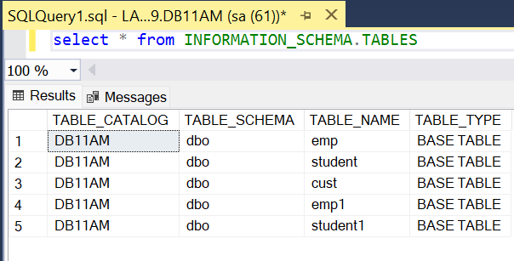

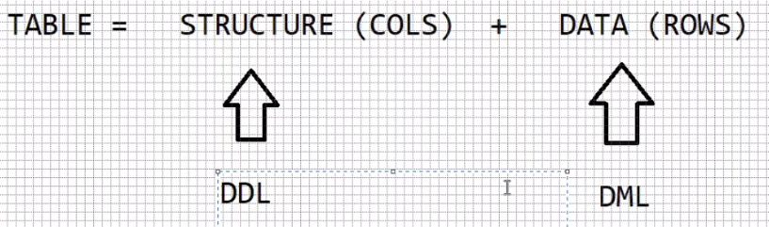

**DML commands: - (Data Manipulation Language)**

-------------------------

INSERT

UPDATE

DELETE

MERGE

=> all DML commands acts on table data.

=> all DML commands are auto committed (saved).

=> to stop auto commit execute the following command

SET IMPLICIT_TRANSACTIONS ON

=> **“SET IMPLICIT_TRANSACTIONS ON”** makes it auto commit off. i.e. we can manually save or rollback the changes.

=> to save the operation execute COMMIT

=> to cancel the operation, execute ROLLBACK

create table emp3(empno int,ename varchar(20),job varchar(20), mgr int, hiredate date, sal money, comm money, deptno int)

insert into emp3 values

(7369,'SMITH','CLERK',7902,'1980-12-17',800,NULL,20),

(7499,'ALLEN','SALESMAN',7698,'1981-02-20',1600,300,30),

(7521,'WARD','SALESMAN',7698,'1981-02-22',1250,500,30),

(7566,'JONES','MANAGER',7839,'1981-04-02',2975,NULL,20),

(7654,'MARTIN','SALESMAN',7698,'1981-09-28',1250,1400,30),

(7698,'BLAKE','MANAGER',7839,'1981-05-01',2850,NULL,30),

(7782,'CLARK','MANAGER',7839,'1981-06-09',2450,NULL,10),

(7788,'SCOTT','ANALYST',7566,'1982-12-09',3000,NULL,20),

(7839,'KING','PRESIDENT',NULL,'1981-11-17',5000,NULL,10),

(7844,'TURNER','SALESMAN',7698,'1981-09-08',1500,0,30),

(7876,'ADAMS','CLERK',7788,'1983-01-12',1100,NULL,20),

(7900,'JAMES','CLERK',7698,'1981-12-03',950,NULL,30),

(7902,'FORD','ANALYST',7566,'1981-12-03',3000,NULL,20),

(7934,'MILLER','CLERK',7782,'1982-01-23',1300,NULL,10)

**UPDATE command :-**

------------------------------

=> command used to modify table data.

=> we can update all rows or specific rows.

=> we can update single column or multiple columns.

**syntax :-**

UPDATE <tabname>

SET colname = value , colname = value , ----------

[WHERE cond]

**ex :-**

=> update all employees comm with 500?

UPDATE EMP SET COMM = 500

=> update employees comm with 500 for those who are not earning comm ?

UPDATE EMP SET COMM = 500 WHERE COMM IS NULL

=> update employees comm with null those who are earning comm ?

UPDATE EMP SET **COMM = NULL** WHERE **COMM IS NOT NULL**

**NULL assignment =**

**NULL comparison IS**

=> update employee sal with 1000 and comm with 500 whose empno = 7369 ?

UPDATE EMP SET SAL = 1000 , COMM = 500 WHERE EMPNO = 7369

=> increment sal by 20% and comm by 10% those working as salesman

and joined in 1981 year ?

UPDATE EMP

SET SAL = SAL + (SAL*0.2) , COMM = COMM + (COMM*0.1)

WHERE JOB='SALESMAN'

AND

HIREDATE LIKE '1981%'

20-JUN-24

=> increase price of samsung,redmi,realme mobiles by 10% ?

products

prodid pname price category brand

UPDATE PRODUCTS

SET PRICE = PRICE + (PRICE * 0.1)

WHERE BRAND IN ('samsung','redmi','realme')

AND

CATEGORY = 'mobiles'

**DELETE command :-**

-----------------------------

=> command used to delete row/rows from table based on a condition

**syntax**: - DELETE FROM <tabname> [WHERE cond]

=> delete all rows from emp table ?

DELETE FROM EMP

=> delete employees joined in 1980 year ?

DELETE FROM EMP WHERE HIREDATE LIKE '1980%'

=> delete employees working as salesman and manager belongs 30th dept ?

DELETE FROM EMP WHERE JOB IN ('SALESMAN','MANAGER')

AND

DEPTNO = 30

**DDL commands :- (Data Definition Lang)**

-------------------------

CREATE

ALTER

DROP

TRUNCATE

=> all DDL commands acts on table structure.

=> all DDL commands are auto committed.

=> to stop auto commit execute

**SET IMPLICIT_TRANSACTIONS ON**

ALTER command :-

--------------------------

=> command used to modify table structure.

=> using alter command we can

1 add columns

2 drop columns

3 modify a column (If there is appropriate data of targeted datatype and size)

changing datatype

changing size

**Adding columns :-**

-------------------------

ALTER TABLE <tabname>

ADD colname datatype(size) , -----------

ex :-

=> add column gender to emp table ?

ALTER TABLE EMP

ADD GENDER CHAR(1)

after adding by default the new column is filled with NULL values, to insert

data into the new column use update command.

UPDATE EMP SET GENDER='M' WHERE EMPNO = 7369

**Dropping column :-**

--------------------------

**ALTER TABLE <TABNAME>**

**DROP COLUMN COL1,COL2,-----**

**Limitations**

You can't delete a column that has a CHECK constraint. You must first delete the constraint.

You can't delete a column that has PRIMARY KEY or FOREIGN KEY constraints or other dependencies except when using the Table Designer in SSMS. When using Object Explorer in SSMS or Transact-SQL, you must first remove all dependencies on the column.

ex :-

=> drop column gender from emp ?

ALTER TABLE EMP

DROP COLUMN GENDER

**Modifying a column :-**

-----------------------------

1 changing datatype

2 changing size

**ALTER TABLE <tabname>**

**ALTER COLUMN COLNAME DATATYPE(SIZE)**

Ex :-

=> modify empno datatype to int ?

ALTER TABLE EMP

ALTER COLUMN EMPNO INT

**ALTER TABLE EMP**

**ALTER COLUMN EMPNO TINYINT => ERROR**

=> modify column comm datatype to smallmoney ?

ALTER TABLE EMP

ALTER COLUMN COMM SMALLMONEY

=> increase size of ename to 20 ?

ALTER TABLE EMP

ALTER COLUMN ENAME VARCHAR(20)

**ALTER TABLE EMP**

**ALTER COLUMN ENAME VARCHAR(5) => ERROR => some names**

**contains more than**

**5 chars.**

**DROP command :-**

---------------------------

=> command used to drop table from db.

=> drops structure along with data.

**Syntax :- DROP TABLE <TABNAME>**

Ex :- DROP TABLE EMP

**TRUNCATE command :-**

----------------------------------

=> deletes all the data but keeps structure

=> will make empty the current table

=> releases memory allocated for table

**Syntax :- TRUNCATE TABLE <TABNAME>**

ex :- TRUNCATE TABLE EMP

**=> SQL server goes to memory and releases all the pages allocated for table**

**when pages are released, data stored in pages also deleted.**

21-jun-24

**DELETE VS TRUNCATE :-**

-------------------------------------

|  |  |  |
| --- | --- | --- |
| **Sr No** | **DELETE** | **TRUNCATE** |
| 1 | DML | DDL |
| 2 | We can delete all rows and specific rows. | We can delete only all rows but cannot delete specific rows |
| 3 | Where condition can be used with delete. | Where condition cannot be used with truncate. |
| 4 | Deletes records row-by-row | Deletes all rows at a time |
| 5 | Slower | Faster |
| 6 | Will not release memory | Releases memory |
| 7 | Will not reset identity | Will reset identity |

**SP_RENAME** :- (sp => stored procedure)

----------------------

=> used to change tablename and column name

SP_RENAME 'oldname' , 'newname'

ex :-

=> rename table emp to employees?

SP_RENAME 'EMP','EMPLOYEES'

=> rename column comm to bonus ?

**SP_RENAME 'EMPLOYEES.COMM','BONUS'**

==============================================================

**Built-in Functions in SQL SERVER :-**

--------------------------------------------------

=> a function accepts some input performs some calculation and returns one value

=> functions are used for data processing, analysis, cleansing etc

Types of functions: -

---------------------------

1. Date
2. Character
3. Numeric
4. Conversion
5. Special
6. Analytical
7. Aggregate

**Date Functions: -**

-----------------------

**GETDATE() :-**

--------------------

=> returns date, time and also milliseconds.

Ex :-

SELECT GETDATE() => 2024-06-21 11:55:36.640

--------------- ----------- ------

DATE TIME MS

**DATEPART() :-**

---------------------

=> Used to extract part of the date

DATEPART(interval,date)

ex:-

SELECT DATEPART(YY,GETDATE()) => 2024

MM => 06

DD => 21

DW => 6 (1-7)

HH => 12

MI => minutes

SS => seconds

QQ => 2 (1-4)

jan-mar 1

apr-jun 2

jul-sep 3

oct-dec 4

DY => day of the year (1-366)

|  |  |
| --- | --- |
| select getdate()as [Full Date], | Full Date  2024-08-07 13:16:57.980 |
| DATEPART(YY,GETDATE()) as Year, | Year  2024 |
| DATEPART(YYYY,GETDATE()) as Year, | Year  2024 |
| DATEPART(MM,GETDATE()) as Month, | Month  8 |
| DATEPART(DD,GETDATE()) as [Day of Month], | Day of Month  7 |
| DATEPART(DW,GETDATE()) as [Day of Week], | Day of Week  4 |
| DATEPART(HH,GETDATE()) as [Hours of Day], | Hours of Day  13 |
| DATEPART(MI,GETDATE()) as [Minutes of Day], | Minutes of Day  16 |
| DATEPART(SS,GETDATE()) as [SECONDS of Minute], | SECONDS of Minute  57 |
| DATEPART(QQ,GETDATE()) as [Quarter of Year], | Quarter of Year  3 |
| DATEPART(DY,GETDATE()) as [Day of Year] | Day of Year  220 |

=> Show all employees

|  |  |  |  |  |  |  |  |  |
| --- | --- | --- | --- | --- | --- | --- | --- | --- |
| **EMP NO** | **ENAME** | **JOB** | **MGR** | **HIREDATE** | **SAL** | **COMM** | **DEPT NO** | **GENDER** |
| 7369 | SMITH | CLERK | 7902 | 17-12-1980 | 1000 | 500 | 20 | NULL |
| 7499 | ALLEN | SALESMAN | 7698 | 20-02-1981 | 1600 | 300 | 30 | NULL |
| 7521 | WARD | SALESMAN | 7698 | 22-02-1981 | 1250 | 500 | 30 | NULL |
| 7566 | JONES | MANAGER | 7839 | 02-04-1981 | 2975 | NULL | 20 | NULL |
| 7654 | MARTIN | SALESMAN | 7698 | 28-09-1981 | 1250 | 1400 | 30 | NULL |
| 7698 | BLAKE | MANAGER | 7839 | 01-05-1981 | 2850 | NULL | 30 | NULL |
| 7782 | CLARK | MANAGER | 7839 | 09-06-1981 | 2450 | NULL | 10 | NULL |
| 7788 | SCOTT | ANALYST | 7566 | 09-12-1982 | 3000 | NULL | 20 | NULL |
| 7839 | KING | PRESIDENT | NULL | 17-11-1981 | 5000 | NULL | 10 | NULL |
| 7844 | TURNER | SALESMAN | 7698 | 08-09-1981 | 1500 | 0 | 30 | NULL |
| 7876 | ADAMS | CLERK | 7788 | 12-01-1983 | 1100 | NULL | 20 | NULL |
| 7900 | JAMES | CLERK | 7698 | 03-12-1981 | 950 | NULL | 30 | NULL |
| 7902 | FORD | ANALYST | 7566 | 03-12-1981 | 3000 | NULL | 20 | NULL |
| 7934 | MILLER | CLERK | 7782 | 23-01-1982 | 1300 | NULL | 10 | NULL |

=> employees joined in 1980,1983,1985 ?

SELECT *

FROM EMP

WHERE DATEPART(YY,HIREDATE) IN (1980,1983,1985)

|  |  |  |  |  |  |  |  |  |
| --- | --- | --- | --- | --- | --- | --- | --- | --- |
| **EMPNO** | **ENAME** | **JOB** | **MGR** | **HIREDATE** | **SAL** | **COMM** | **DEPTNO** | **GENDER** |
| 7369 | SMITH | CLERK | 7902 | 17-12-1980 | 1000 | 500 | 20 | NULL |
| 7876 | ADAMS | CLERK | 7788 | 12-01-1983 | 1100 | NULL | 20 | NULL |

=> employees joined in leap year ?

SELECT *

FROM EMP

WHERE DATEPART(YY,HIREDATE) % 4 = 0

|  |  |  |  |  |  |  |  |  |
| --- | --- | --- | --- | --- | --- | --- | --- | --- |
| **EMPNO** | **ENAME** | **JOB** | **MGR** | **HIREDATE** | **SAL** | **COMM** | **DEPTNO** | **GENDER** |
| 7369 | SMITH | CLERK | 7902 | 17-12-1980 | 1000 | 500 | 20 | NULL |

=> employees joined in jan, apr, dec months ?

SELECT *

FROM EMP

WHERE DATEPART(MM,HIREDATE) IN (1,4,12)

|  |  |  |  |  |  |  |  |
| --- | --- | --- | --- | --- | --- | --- | --- |
| **EMPNO** | **ENAME** | **JOB** | **MGR** | **HIREDATE** | **SAL** | **COMM** | **DEPTNO** |
| 7369 | SMITH | CLERK | 7902 | 17-12-1980 | 1000 | 500 | 20 |
| 7566 | JONES | MANAGER | 7839 | 02-04-1981 | 2975 | NULL | 20 |
| 7788 | SCOTT | ANALYST | 7566 | 09-12-1982 | 3000 | NULL | 20 |
| 7876 | ADAMS | CLERK | 7788 | 12-01-1983 | 1100 | NULL | 20 |
| 7900 | JAMES | CLERK | 7698 | 03-12-1981 | 950 | NULL | 30 |
| 7902 | FORD | ANALYST | 7566 | 03-12-1981 | 3000 | NULL | 20 |
| 7934 | MILLER | CLERK | 7782 | 23-01-1982 | 1300 | NULL | 10 |

=> employees joined on sunday ?

SELECT *

FROM EMP

WHERE DATEPART(DW,HIREDATE) = 1

|  |  |  |  |  |  |  |  |
| --- | --- | --- | --- | --- | --- | --- | --- |
| **EMP NO** | **ENAME** | **JOB** | **MGR** | **HIREDATE** | **SAL** | **COMM** | **DEPT NO** |
| 7521 | WARD | SALESMAN | 7698 | 22-02-1981 | 1250 | 500 | 30 |

=> employees joined in 2nd quarter of 1981 year ?

SELECT *

FROM EMP

WHERE DATEPART(YY,HIREDATE) = 1981

AND

DATEPART(QQ,HIREDATE) = 2

|  |  |  |  |  |  |  |  |
| --- | --- | --- | --- | --- | --- | --- | --- |
| **EMP NO** | **ENAME** | **JOB** | **MGR** | **HIREDATE** | **SAL** | **COMM** | **DEPT NO** |
| 7566 | JONES | MANAGER | 7839 | 02-04-1981 | 2975 | NULL | 20 |
| 7698 | BLAKE | MANAGER | 7839 | 01-05-1981 | 2850 | NULL | 30 |
| 7782 | CLARK | MANAGER | 7839 | 09-06-1981 | 2450 | NULL | 10 |

**DATENAME() :-**

-----------------------

=> datename also returns part of the date

DATEPART DATENAME

MM 6 JUNE

DW 6 FRIDAY

|  |  |
| --- | --- |
| select  hiredate, | **HIREDATE**  1980-12-17  1981-02-20  1981-02-22 |
| DATENAME(YY,hiredate) AS YY, | **YY**  1980  1981  1981 |
| DATENAME(DY,hiredate) AS | **DY**  352  51  53 |
| DY,DATENAME(MM,hiredate) AS MM, | **MM**  December  February  February |
| DATENAME(DW,hiredate) AS DW, | **DW**  Wednesday  Friday  Sunday |
| DATENAME(QQ,hiredate) AS QQ from emp2 | **QQ**  4  1  1 |

=> display ENAME DAY ?

SELECT ENAME,DATENAME(DW,HIREDATE) AS DAY FROM EMP

|  |  |
| --- | --- |
| **ENAME** | **DAY** |
| SMITH | Wednesday |
| ALLEN | Friday |
| WARD | Sunday |

=> display on which day india got independence ?

SELECT DATENAME(DW,'1947-08-15') => Friday

**Format() :-**

-------------

=> Used to display dates in different formats

=> Displaying dates, currency, and numeric values in a specific format.

FORMAT(date,'format')

ex :-

SELECT FORMAT(getdate(), 'dd.MM.yyyy') => 21.06.2024

SELECT FORMAT(getdate(), 'MM/dd/yyyy') => 06/21/2024

SELECT FORMAT(getdate(), 'hh:mm:ss') => 12:36:51

SELECT FORMAT(getdate(), 'dd-MM-yyyy hh:mm:ss dddd') => 21-06-2024 12:38:27 Friday

|  |  |
| --- | --- |
| select getdate(), | 2024-08-07 16:02:03.697 |
| format(getdate(),'dd.MM.yyyy'), | 07.08.2024 |
| format(getdate(),'MM/dd/yyyy'), | 08/07/2024 |
| format(getdate(),'hh:mm:ss'), | 04:02:03 |
| format(getdate(),'dd-MM-yyyy hh:mm:ss dddd') | 07-08-2024 04:02:03 Wednesday |

**Scenario :-**

----------------

INSERT INTO EMP(EMPNO,ENAME,SAL,HIREDATE)

VALUES(999,'ABC',4000,GETDATE())

**List of employees joined today ?**

SELECT * FROM EMP WHERE HIREDATE = GETDATE()

2024-06-21 = 2024-06-21 12:45:20.123

SELECT *

FROM EMP

WHERE HIREDATE = FORMAT(GETDATE(),'yyyy-MM-dd')

2024-06-21 = 2024-06-21

22-jun-24

**DATEDIFF() :-**

-------------------

=> returns difference between two dates in years,months,days etc

DATEDIFF(interval,date1,date2)

ex :-

SELECT DATEDIFF(YY,'2023-06-22',GETDATE()) => 1

SELECT DATEDIFF(MM,'2023-06-22',GETDATE()) => 12

SELECT DATEDIFF(DD,'2023-06-22',GETDATE()) => 366

=> display ENAME EXPERIENCE in years ?

SELECT ENAME,DATEDIFF(YY,HIREDATE,GETDATE()) AS EXPR FROM EMP

=> display ENAME EXPERIENCE ?

M YEARS N MONTHS

experience = 40 months = 3 years 4 months

years = months/12 = 40/12 = 3

months = months%12 = 40%12 = 4

SELECT ENAME,

DATEDIFF(MM,HIREDATE,GETDATE())/12 AS YEARS,

DATEDIFF(MM,HIREDATE,GETDATE())%12 AS MONTHS

FROM EMP

|  |  |  |
| --- | --- | --- |
| **ENAME** | **YEARS** | **MONTHS** |
| SMITH | 43 | 8 |
| ALLEN | 43 | 6 |
| WARD | 43 | 6 |
| JONES | 43 | 4 |
| MARTIN | 42 | 11 |
| BLAKE | 43 | 3 |
| CLARK | 43 | 2 |
| SCOTT | 41 | 8 |
| KING | 42 | 9 |
| TURNER | 42 | 11 |
| ADAMS | 41 | 7 |
| JAMES | 42 | 8 |
| FORD | 42 | 8 |
| MILLER | 42 | 7 |

**DATEADD() :-**

-----------------

=> Used to add/subtract years/months/days to/from a date

DATEADD(interval,int,date)

ex :-

SELECT DATEADD(yy,1,getdate()) => 2025-06-22

SELECT DATEADD(yy,-1,getdate()) => 2023-06-22

SELECT DATEADD(mm,2,getdate()) => 2024-08-22

**Note : Decimal values not supported as it is int**

=>

**GOLD_RATES**

**DATEID RATE**

2020-01-01 ?

2020-01-02 ?

2024-06-22 ?

=> display today's gold rate ?

SELECT *

FROM GOLD_RATES

**WHERE DATEID = FORMAT(GETDATE(),'yyyy-MM-dd')**

2024-06-22

=> display yesterday's gold rate ?

SELECT *

FROM GOLD_RATES

**WHERE DATEID = FORMAT(DATEADD(DD,-1,GETDATE()),'yyyy-MM-dd')**

**2024-08-07**

=> display last month same day gold rate ?

SELECT *

FROM GOLD_RATES

**WHERE DATEID = FORMAT(DATEADD(MM,-1,GETDATE()),'yyyy-MM-dd')**

2024-07-08

=> display last year same day gold rate ?

WHERE DATEID = **FORMAT(DATEADD(YY,-1,GETDATE()),'yyyy-MM-dd')**

2023-08-08

=> display last 1 month gold rate?

SELECT *

FROM GOLD_RATES

WHERE DATEID >= **FORMAT(DATEADD(MM,-1,GETDATE()),'yyyy-MM-dd')**

2024-07-08

**EOMONTH() :-**

-------------------

=> returns end of month i.e. last day of the month

EOMONTH(date,int) -

Ex :-

**SELECT EOMONTH(GETDATE(),0) => 2024-06-30 => Current month last Day**

**SELECT EOMONTH(GETDATE(),-1) => 2024-05-31 => Previous month last Day**

**SELECT EOMONTH(GETDATE(), 1) => 2024-07-31 => Next month last Day**

=> display current month 1st day?

SELECT DATEADD(month, DATEDIFF(month, 0, GETDATE()), 0) AS StartOfMonth

=> display next month 1st day?

SELECT DATEADD(mm, DATEDIFF(m,0,GETDATE())+1,0)

=> display current year 1st day?

SELECT CONVERT (DATE,DATEADD(YEAR,DATEDIFF(YEAR,0,GETDATE()),0))

=> Display current year last day?

SELECT CONVERT (DATE,DATEADD(YEAR, DATEDIFF(YEAR,0,GETDATE()) + 1, -1))

=> display next year 1st day?

SELECT DATEADD(year, DATEDIFF(year, -1, GETDATE()), 0)

=> Display end of month

SELECT DATEADD(d, -1, DATEADD(m, DATEDIFF(m, 0, GETDATE()) + 1, 0))

**CHARACTER FUNCTIONS :-**

---------------------------

**UPPER() :-**

---------------

=> converts string to uppercase

UPPER(arg)

ex :-

SELECT UPPER('hello') => HELLO

**LOWER() :-**

-----------------

=> converts string to lowercase

LOWER(arg)

ex :-

SELECT LOWER('HELLO') => hello

=> display EMPNO ENAME SAL ?

display names in lowercase ?

SELECT EMPNO,LOWER(ENAME) AS ENAME,SAL FROM EMP

=> convert names to lowercase in table ?

UPDATE EMP SET ENAME = LOWER(ENAME)

**LEN() :-**

-----------

=> returns string length i.e. no of chars

LEN(arg)

ex :-

SELECT LEN('HELLO WELCOME') => 13

=> employees name contains more than 5 chars ?

SELECT *

FROM EMP

WHERE LENGTH(ENAME) > 5

|  |  |  |  |  |  |  |  |
| --- | --- | --- | --- | --- | --- | --- | --- |
| **EMPNO** | **ENAME** | **JOB** | **MGR** | **HIREDATE** | **SAL** | **COMM** | **DEPTNO** |
| 7654 | MARTIN | SALESMAN | 7698 | 28-09-1981 | 1250 | 1400 | 30 |
| 7844 | TURNER | SALESMAN | 7698 | 08-09-1981 | 1500 | 0 | 30 |
| 7934 | MILLER | CLERK | 7782 | 23-01-1982 | 1300 | NULL | 10 |

**LEFT() :-**

------------

=> returns chars starting from left side

LEFT(string,no of chars)

ex :-

SELECT LEFT('HELLO WELCOME',5) => HELLO

=> employees name starts with 's' ?

SELECT * FROM EMP WHERE **LEFT(ENAME,1) = 's'**

|  |  |  |  |  |  |  |  |
| --- | --- | --- | --- | --- | --- | --- | --- |
| **EMPNO** | **ENAME** | **JOB** | **MGR** | **HIREDATE** | **SAL** | **COMM** | **DEPTNO** |
| 7369 | SMITH | CLERK | 7902 | 17-12-1980 | 1000 | 500 | 20 |
| 7788 | SCOTT | ANALYST | 7566 | 09-12-1982 | 3000 | NULL | 20 |

24-jun-24

**RIGHT() :-**

--------------

=> returns chars starting from right side

RIGHT(string,length)

ex :-

SELECT RIGHT('HELLO WELCOME',7) => WELCOME

=> employees name ends with 's' ?

SELECT * FROM EMP WHERE **RIGHT(ENAME,1) = 's'**

|  |  |  |  |  |  |  |  |
| --- | --- | --- | --- | --- | --- | --- | --- |
| **EMPNO** | **ENAME** | **JOB** | **MGR** | **HIREDATE** | **SAL** | **COMM** | **DEPTNO** |
| 7566 | JONES | MANAGER | 7839 | 02-04-1981 | 2975 | NULL | 20 |
| 7876 | ADAMS | CLERK | 7788 | 12-01-1983 | 1100 | NULL | 20 |
| 7900 | JAMES | CLERK | 7698 | 03-12-1981 | 950 | NULL | 30 |

=> employees name starts and ends with same char ?

SELECT * FROM EMP WHERE ENAME LIKE 'a%'

OR

ENAME LIKE 'b%b'

**SELECT * FROM EMP WHERE LEFT(ENAME,1) = RIGHT(ENAME,1)**

=> Show only last characters except, i.e except first character

SELECT RIGHT(ENAME, LEN(ENAME)-1) FROM EMP2

|  |
| --- |
| **NAME** |
| MITH |
| LLEN |
| ARD |
| ONES |
| ARTIN |
| LAKE |

=> update employee names with initial letter capital?

**UPDATE EMP SET ENAME = UPPER(LEFT(ENAME,1)) + RIGHT(ename,LEN(ename)-1)**

=> display EMPNO ENAME EMAILID ? generate emailid as follows

EMPNO ENAME EMAILID

7369 smith smi736@tcs.com

7499 allen all749@tcs.com

SELECT EMPNO,ENAME,

LEFT(ENAME,3) + LEFT(EMPNO,3) + '@tcs.com' AS EMAILID FROM EMP

=> store emailids in db ?

step 1 :- add emailid column to emp table

ALTER TABLE EMP

ADD EMAILID VARCHAR(20)

step 2 :- update the column with emailids

UPDATE EMP

SET EMAILID = LEFT(ENAME,3) + LEFT(EMPNO,3) + '@tcs.com'

**SUBSTRING() :-**

----------------------

=> returns chars starting from specific position

SUBSTRING(string,start,no of chars)

ex :-

SELECT SUBSTRING('HELLO WELCOME',1,5) => HELLO

SELECT SUBSTRING('HELLO WELCOME',7,4) => WELC

SELECT SUBSTRING('HELLO WELCOME',10,3) => COM

SELECT SUBSTRING('HELLO WELCOME',0,5) => HELL

SELECT SUBSTRING('HELLO WELCOME',-1,5) => HEL

SELECT SUBSTRING('HELLO WELCOME',-2,5) => HE

SELECT SUBSTRING('HELLO WELCOME',10,4) => COME

SELECT SUBSTRING('HELLO WELCOME',10,5) => COME

**CHARINDEX() :-**

----------------------

=> returns position of a char in a string

charindex(char,string,[start])

ex :-

SELECT CHARINDEX('o','hello welcome') => 5

SELECT CHARINDEX('o','hello welcome',6) => 11

SELECT CHARINDEX('e','hello welcome',10) => 13

SELECT CHARINDEX('O','HELLO WELCOME') => 5

SELECT CHARINDEX('O','HELLO WELCOME',7) => 11

SELECT CHARINDEX('e','HELLO WELCOME',10) => 13

SELECT CHARINDEX('e','HELLO WELCOME',15) => 0

SELECT CHARINDEX('e','HELLO WELCOME',0) => 2

SELECT CHARINDEX('e','HELLO WELCOME',-1) => 2

SELECT CHARINDEX('e','HELLO WELCOME',-5) => 2

=> display CID FNAME LNAME ?

CUST

CID CNAME

10 sachin tendulkar

11 virat kohli

FNAME = SUBSTRING(CNAME,1,CHARINDEX(' ',CNAME)-1)

LNAME = SUBSTRING(CNAME,CHARINDEX(' ',CNAME)+1,LEN(CNAME))

**SELECT CID,**

**SUBSTRING(CNAME,1,CHARINDEX(' ',CNAME)-1) AS FNAME,**

**SUBSTRING(CNAME,CHARINDEX(' ',CNAME)+1,LEN(CNAME)) AS LNAME**

**FROM CUST**

**REPLICATE() :-**

--------------------

=> repeats given char for number of times

replicate(char,length)

ex :-

SELECT REPLICATE('*',10) => **********

=> display ENAME SAL ? display salaries in '*' ?

SELECT ENAME, REPLICATE('*',LEN(SAL)) AS SAL FROM EMP

=> your a/c no XXXX9572 debited?

ACCOUNTS

ACCNO BAL

123456789572 10000

REPLICATE('X',4) + RIGHT(accno,4)

=> Display first 2 digit with ‘X’ and remaining as it is values for sal column

select SAL, REPLICATE('X', len(sal)-5)+right(sal,LEN(SAL)-2) NEWSAL from emp2

|  |  |
| --- | --- |
| **SAL** | **NEWSAL** |
| 5000.00 | XX00.00 |
| 1500.00 | XX00.00 |
| 1100.00 | XX00.00 |
| 950.00 | X0.00 |
| 3000.00 | XX00.00 |
| 1300.00 | XX00.00 |

=> Show empno with left 2 digit hidden and right 2 digit visible

select REPLICATE('X', len(empno)-2)+right(empno,2) EMPNO from emp2

|  |
| --- |
| **EMPNO** |
| XX69 |
| XX99 |
| XX21 |

**REPLACE() :-**

------------------

=> Used to replace one complete string with another complete string only.

=> If no matching string is found then keeps original string as it is.

REPLACE(str1,str2,str3)

Ex :-

SELECT REPLACE('hello','ell','abc') => habco

SELECT REPLACE('hello','l','abc') => heabcabco

SELECT REPLACE('hello','elo','abc') => hello

SELECT REPLACE('@@he@@ll@@o@@','@','') => hello

Example :

select REPLACE(ename,'SMith','pqr') as [NEWNAME] from emp2

|  |
| --- |
| **NEWNAME** |
| pqr |
| ALLEN |
| WARD |
| JONES |

select REPLACE('Hello Welcome','abc','pqr') as [New String]

|  |
| --- |
| **New String** |
| Hello Welcome |

select REPLACE('Hello Welcome','el','am') as [New String]

|  |
| --- |
| **New String** |
| Hamlo Wamcome |

select REPLACE('Hello Welcome','l','tt') as [New String]

|  |
| --- |
| **New String** |
| Hetttto Wettcome |

**TRANSLATE() :-**

----------------------

=> Used to translate one char position with another char on the same position

=> str1 Source String

=> str2 string letters that to be searched in str1 and replaced into str1 with str3 exactly matching pair of str2.

=> str2 and str3 should be of equal length. Searching doesn’t matter upper or lower case.

=> translate function can be used to encrypt data i.e. converting plain text to

cipher text.

**Syntax:** **TRANSLATE(str1,str2,str3)**

ex :-

TRANSLATE('hello','elo','abc') => habbc

E => a

l => b

o => c

**select translate('Hello','ElH','abD') => Dabbo**

SELECT ENAME,SAL, TRANSLATE(SAL,'0123456789.','$Kb*T@#&^%!') AS SAL FROM EMP2

|  |  |  |
| --- | --- | --- |
| **ENAME** | **SAL** | **SAL** |
| SMITH | 1000 | K$$$!$$ |
| ALLEN | 1600 | K#$$!$$ |
| WARD | 1250 | Kb@$!$$ |

=>Remove all special chars from '@#HE&^LL!%O$*' ?

SELECT REPLACE(TRANSLATE( '@#HE&^LL!%O$*','@#&^!%$*','********'),'*','')

--------------------------------------------------------------------------

**HE**LL**O**

**STUFF() :-**

---------------

=> Used to replace one string with another sting based on start and length

=> str1 string in which start and length to be marked. After marking start and Length characters to be replaced with str2.

**Syntax:** STUFF(str1,start,length,str2)

**Ex :-**

SELECT STUFF('HELLO WELCOME',7,7,'WORLD') => HELLO WORLD

**Ex :**

select ENAME, STUFF(ename,3,3,'ABC') AS [NEW NAME] from emp2

|  |  |
| --- | --- |
| **ENAME** | **NEW NAME** |
| SMITH | SMABC |
| ALLEN | ALABC |
| WARD | WAABC |
| JONES | JOABC |
| MARTIN | MAABCN |
| BLAKE | BLABC |
| CLARK | CLABC |
| SCOTT | SCABC |
| KING | KIABC |
| TURNER | TUABCR |
| ADAMS | ADABC |

25-jun-24

**Numeric Functions :-**

----------------------------

**Rounding Numbers :-**

------------------------------

ROUND

FLOOR

CEILING

**ROUND:-**

-------------

=> Rounds number to integer or to decimal places based on avg

=> Positive Value at the decimal places makes impact on numbers after decimal places and Negative Value at the decimal places makes impact on numbers before decimal places.

**Syntax:** ROUND(number, decimal places)

**Ex :-**

SELECT ROUND(38.45896,0) => 38

38-----------------------------38.5----------------------------------39

number < avg => rounded to lowest

number >= avg => rounded to highest

SELECT ROUND(38.55896,0) => 39

SELECT ROUND(38.45896,2) => 38.46

SELECT ROUND(38.45896,3) => 38.459

SELECT ROUND(38.45896,4) => 38.4590

SELECT ROUND(34.699873845,2) => 34.700000000

|  |  |  |  |  |  |
| --- | --- | --- | --- | --- | --- |
| ROUND(38.55896,0) | ROUND(38.45896,2) | ROUND(38.45896,3) | ROUND(38.45896,4) | ROUND(34.699873845,2) | ROUND(386,-2) |
| 39.00000 | 38.46000 | 38.45900 | 38.45900 | 34.700000000 | 400 |

SELECT ROUND(386,-2) => 400

300--------------------------350-----------------------------400

SELECT ROUND(386,-1) => 390

380------------------------385----------------------------390

SELECT ROUND(386,-3) => 0

000---------------------------500-----------------------------1000

SELECT ROUND(4567,-1),ROUND(4567,-2),ROUND(4567,-3)

o/p :- 4570 4600 5000

=> round sal to hundreds in table ?

select SAL, round(SAL,-2)AS ROUNDSAL from emp2

|  |  |
| --- | --- |
| **SAL** | **ROUNDSAL** |
| 1000 | 1000 |
| 1600 | 1600 |
| 1250 | 1300 |
| 2975 | 3000 |
| 1250 | 1300 |
| 2850 | 2900 |
| 2450 | 2500 |

**FLOOR() :-**

-------------

=> Rounds number always to lowest

FLOOR(number)

**Ex :-**

SELECT FLOOR(3.9), FLOOR(3.01)

3 3

**CEILING() :-**

-----------------

=> Rounds number always to highest

CEILING(number)

**Ex :-**

SELECT CEILING(3.1), CEILING(3.9)

4 4

**CONVERSION FUNCTIONS:-**

-------------------------------

=> Functions used to convert one type to another type

1 CAST

2 CONVERT

**CAST :-**

------------

CAST(expr **AS** target-type)

**Ex :-**

SELECT CAST(10.5 AS INT) => 10

=> display smith earns 800 ?

SELECT ename + ' earns ' + sal FROM emp => ERROR

SELECT ename + ' earns ' + CAST(sal AS VARCHAR) FROM emp

=> display smith joined on 1980-dec-17 as clerk ?

SELECT ename + ' joined on ' + CAST(hiredate AS VARCHAR) + ' as ' + job

FROM emp

CONVERT() :-

-------------------

CONVERT(target-type , expr)

**Ex :-**

SELECT CONVERT(INT,10.5) => 10

**=> difference between CAST & CONVERT?**

1 Using **CONVERT** we can display dates in different formats but not possible using **CAST**.

2 Using **CONVERT** we can display numbers in different formats but not possible using **CAST**.

Displaying dates in different formats :-

----------------------------------------------------

=> To display dates in different formats first convert date to char type.

CONVERT(VARCHAR,DATE,STYLE-NUMBER)

Ex :-

SELECT CONVERT(VARCHAR,GETDATE(),101) => 06/25/2024

102 => 2024.06.25

110 => 06-25-2024

114 => 12:21:32:900

120 =>

121 =>

126

127

|  |  |
| --- | --- |
| SELECT CONVERT(VARCHAR,GETDATE(),101), | 08-09-2024 |
| CONVERT(VARCHAR,GETDATE(),102), | 2024.08.09 |
| CONVERT(VARCHAR,GETDATE(),103), | **09-08-2024** |
| CONVERT(VARCHAR,GETDATE(),104), | **09.08.2024** |
| CONVERT(VARCHAR,GETDATE(),105), | **09-08-2024** |
| CONVERT(VARCHAR,GETDATE(),106), | **09-Aug-24** |
| CONVERT(VARCHAR,GETDATE(),107), | **Aug 09, 2024** |
| CONVERT(VARCHAR,GETDATE(),108), | 23:12:07 |
| CONVERT(VARCHAR,GETDATE(),109), | Aug 9 2024 11:12:07:243PM |
| CONVERT(VARCHAR,GETDATE(),110), | 08-09-2024 |
| CONVERT(VARCHAR,GETDATE(),111), | 09-08-2024 |
| CONVERT(VARCHAR,GETDATE(),112), | 20240809 |
| CONVERT(VARCHAR,GETDATE(),113), | 09 Aug 2024 23:12:07:243 |
| CONVERT(VARCHAR,GETDATE(),114), | 23:12:07:243 |
| CONVERT(VARCHAR,GETDATE(),115), | 231207 |
| CONVERT(VARCHAR,GETDATE(),120), | 09-08-2024 23:12 |
| CONVERT(VARCHAR,GETDATE(),121), | 12:07.2 |
| CONVERT(VARCHAR,GETDATE(),126), | 2024-08-09T23:12:07.243 |
| CONVERT(VARCHAR,GETDATE(),127) | 2024-08-09T23:12:07.243 |

=> display ENAME HIREDATE in yyyymmdd ?

SELECT ENAME,CONVERT(VARCHAR,HIREDATE,112) AS HIREDATE FROM EMP

|  |  |
| --- | --- |
| **ENAME** | **HIREDATE** |
| SMITH | 19801217 |
| ALLEN | 19810220 |
| WARD | 19810222 |
| JONES | 19810402 |
| MARTIN | 19810928 |
| BLAKE | 19810501 |
| CLARK | 19810609 |

**MONEY STYLES :-**

---------------------

CONVERT(VARCHAR,MONEY,STYLE-NUMBER)

**Ex :-**

style-number

0

1 => displays number with thousand separator

2

=> display ENAME SAL ?

display salaries with thousand separator ?

SELECT ENAME,

CONVERT(VARCHAR, SAL,1) AS SAL

FROM EMP

**SPECIAL FUNCTIONS:-**

--------------------------

**ISNULL() :-**

---------------

=> Used to convert null values

ISNULL(arg1,arg2)

if arg1 = null returns arg2

if arg1 <> null returns arg1 only

**Ex :-**

select ISNULL(mgr,comm) from emp2 where empno=7839 --Both null => NULL

NULL , NULL => NULL

select ISNULL(mgr,comm) from emp2 where empno=7788 --not null attribute will be returned

7566, NULL => 7566

select ISNULL(comm,deptno) from emp2 where empno=7788 --not null will be returned

NULL, 20 => 20

SELECT

ISNULL(100,200) AS **CASE1**, ISNULL(NULL,30) AS **CASE2**,ISNULL(40,NULL) AS **CASE3**

|  |  |  |
| --- | --- | --- |
| **CASE1** | **CASE2** | **CASE3** |
| 100 | 30 | 40 |

=> Display ENAME SAL BONUS TOTSAL ?

TOTSAL = SAL + BONUS -- Without ISNULL returns null sal incase of null value

* Mark value as 0 incase of null in a SAL OR BONUS(COMM)

SELECT

ENAME, SAL, BONUS, SAL+ISNULL(BONUS,0) AS TOTSAL

FROM EMP

=> display ENAME SAL BONUS ?

if bonus = NULL display NO COMM ?

SELECT ENAME,SAL,

ISNULL(CAST(BONUS AS VARCHAR),'NO COMM') AS COMM

FROM EMP

26-JUN-24

**Analytical Functions :-** Analytical functions mainly used for analysis.

------------------------------

1. RANK
2. DENSE_RANK
3. ROW_NUMBER
4. LAG
5. LEAD

**Rank & Dense_Rank :-**

---------------------------

=> Both functions are used to find ranks

=> Ranks are always based on some field

=> For rank functions data must be sorted

rank() over (order by colname asc/desc)

dense_rank() over (order by colname asc/desc)

**Ex:-**

=> find ranks of the employees based on sal and highest paid should

get 1st rank ?

SELECT ENAME,SAL,

RANK() OVER (ORDER BY SAL DESC) AS RNK

FROM EMP

|  |  |  |
| --- | --- | --- |
| **ENAME** | **SAL** | **RNK** |
| KING | 5000 | 1 |
| FORD | 3000 | 2 |
| SCOTT | 3000 | 2 |
| JONES | 2975 | 4 |
| BLAKE | 2850 | 5 |
| CLARK | 2450 | 6 |
| ALLEN | 1600 | 7 |

SELECT ENAME,SAL,

DENSE_RANK() OVER (ORDER BY SAL DESC) AS RNK

FROM EMP

|  |  |  |
| --- | --- | --- |
| **ENAME** | **SAL** | **RNK** |
| KING | 5000 | 1 |
| FORD | 3000 | 2 |
| SCOTT | 3000 | 2 |
| JONES | 2975 | 4 |
| BLAKE | 2850 | 5 |
| CLARK | 2450 | 6 |
| ALLEN | 1600 | 7 |

select ENAME, SAL, **RANK**() over (order by sal desc) as **RANK** ,**DENSE_RANK**() over (order by sal desc) as **DENSERANK** from emp2

|  |  |  |  |
| --- | --- | --- | --- |
| **ENAME** | **SAL** | **RANK** | **DENSERANK** |
| KING | 5000 | 1 | 1 |
| FORD | 3000 | 2 | 2 |
| SCOTT | 3000 | 2 | 2 |
| JONES | 2975 | 4 | 3 |
| BLAKE | 2850 | 5 | 4 |
| CLARK | 2450 | 6 | 5 |
| ALLEN | 1600 | 7 | 6 |
| TURNER | 1500 | 8 | 7 |
| MILLER | 1300 | 9 | 8 |
| WARD | 1250 | 10 | 9 |
| MARTIN | 1250 | 10 | 9 |
| ADAMS | 1100 | 12 | 10 |
| SMITH | 1000 | 13 | 11 |
| JAMES | 950 | 14 | 12 |

Difference between rank & dense_rank ?

1 rank function generates gaps but dense_rank will not generate gaps.

2 in rank functions ranks may not be in sequence but in dense_rank

ranks are always in sequence.

**SAL RNK DRNK**

5000 1 1

4000 2 2

3000 3 3

3000 3 3

3000 3 3

2000 6 4

2000 6 4

1000 8 5

=> find ranks of the employees based on sal , if salaries are same then

ranking should be based on hiredate?

SELECT ENAME,HIREDATE,SAL, DENSE_RANK() OVER (ORDER BY SAL DESC,HIREDATE ASC) AS RNK FROM EMP

|  |  |  |  |
| --- | --- | --- | --- |
| **ENAME** | **HIREDATE** | **SAL** | **RNK** |
| KING | 17-11-1981 | 5000 | 1 |
| FORD | 03-12-1981 | 3000 | 2 |
| SCOTT | 09-12-1982 | 3000 | 3 |
| JONES | 02-04-1981 | 2975 | 4 |
| BLAKE | 01-05-1981 | 2850 | 5 |
| CLARK | 09-06-1981 | 2450 | 6 |
| ALLEN | 20-02-1981 | 1600 | 7 |
| TURNER | 08-09-1981 | 1500 | 8 |
| MILLER | 23-01-1982 | 1300 | 9 |
| WARD | 22-02-1981 | 1250 | 10 |
| MARTIN | 28-09-1981 | 1250 | 11 |
| ADAMS | 12-01-1983 | 1100 | 12 |
| SMITH | 17-12-1980 | 1000 | 13 |
| JAMES | 03-12-1981 | 950 | 14 |

**PARTITION BY clause :-**

--------------------------------

=> Partition by clause is used to divide the table based on one or more fields.

=> Used to find ranks with in group, Ex to find ranks with in dept first we need to divide the table dept wise using partition by and apply rank functions on each partition.

SELECT ENAME,SAL,DEPTNO,DENSE_RANK() OVER (PARTITION BY DEPTNO ORDER BY SAL DESC) AS RNK FROM EMP

**ROW_NUMBER() :-**

---------------------------

=> Returns record numbers

=> It is also based on some field

=> For ROW_NUMBER also data must be sorted

ROW_NUMBER() OVER (ORDER BY COLNAME ASC/DESC)

ex :- row number based on empno

SELECT EMPNO,ENAME,SAL, ROW_NUMBER() OVER (ORDER BY EMPNO ASC) AS RNO FROM EMP

|  |  |  |  |
| --- | --- | --- | --- |
| **EMPNO** | **ENAME** | **SAL** | **RNO** |
| 7369 | SMITH | 1000 | 1 |
| 7499 | ALLEN | 1600 | 2 |
| 7521 | WARD | 1250 | 3 |
| 7566 | JONES | 2975 | 4 |
| 7654 | MARTIN | 1250 | 5 |
| 7698 | BLAKE | 2850 | 6 |
| 7782 | CLARK | 2450 | 7 |
| 7788 | SCOTT | 3000 | 8 |
| 7839 | KING | 5000 | 9 |
| 7844 | TURNER | 1500 | 10 |
| 7876 | ADAMS | 1100 | 11 |
| 7900 | JAMES | 950 | 12 |
| 7902 | FORD | 3000 | 13 |
| 7934 | MILLER | 1300 | 14 |

SELECT EMPNO, ENAME,JOB, ROW_NUMBER() OVER (ORDER BY JOB ASC) AS ROWNUMBER FROM EMP2

|  |  |  |  |
| --- | --- | --- | --- |
| **EMPNO** | **ENAME** | **JOB** | **ROWNUMBER** |
| 7788 | SCOTT | ANALYST | 1 |
| 7902 | FORD | ANALYST | 2 |
| 7934 | MILLER | CLERK | 3 |
| 7876 | ADAMS | CLERK | 4 |
| 7900 | JAMES | CLERK | 5 |
| 7369 | SMITH | CLERK | 6 |
| 7566 | JONES | MANAGER | 7 |
| 7698 | BLAKE | MANAGER | 8 |
| 7782 | CLARK | MANAGER | 9 |
| 7839 | KING | PRESIDENT | 10 |
| 7844 | TURNER | SALESMAN | 11 |
| 7654 | MARTIN | SALESMAN | 12 |
| 7499 | ALLEN | SALESMAN | 13 |
| 7521 | WARD | SALESMAN | 14 |

**LAG & LEAD :-**

--------------------

LAG(colname,int) OVER (ORDER BY ) => returns previous value

LEAD(colname,int) OVER (-----) => returns next value

**EX :-**

SELECT EMPNO,ENAME,SAL, LAG(SAL,1) OVER (ORDER BY EMPNO ASC) AS PREV_SAL FROM EMP

7369 smith 1000.00 NULL

7499 allen 1600.00 1000.00

7521 ward 1300.00 1600.00

7566 jones 3000.00 1300.00

=>

GOLD_RATES

DATEID RATE

2024-06-01 6800

2024-06-02 6850

2024-06-03 6700

2024-06-26 6600

display DATEID RATE CHANGE

2024-06-01 6800 NULL

2024-06-02 6850 50

03 6700 -150

=> Find rate difference between yesterdays rate and current gold rate?

SELECT DATEID,RATE, RATE - LAG(RATE,1) OVER (ORDER BY DATEID ASC) AS CHANGE FROM GOLD_RATES

=> Display ENAME HIREDATE DAYS ?

SELECT EMPNO,ENAME,HIREDATE, DATEDIFF(DD,LAG(HIREDATE,1) OVER (ORDER BY HIREDATE ASC), HIREDATE) AS DAYS FROM EMP

|  |  |  |  |
| --- | --- | --- | --- |
| **EMPNO** | **ENAME** | **HIREDATE** | **DAYS** |
| 7369 | SMITH | 17-12-1980 | NULL |
| 7499 | ALLEN | 20-02-1981 | 65 |
| 7521 | WARD | 22-02-1981 | 2 |
| 7566 | JONES | 02-04-1981 | 39 |
| 7698 | BLAKE | 01-05-1981 | 29 |
| 7782 | CLARK | 09-06-1981 | 39 |
| 7844 | TURNER | 08-09-1981 | 91 |
| 7654 | MARTIN | 28-09-1981 | 20 |
| 7839 | KING | 17-11-1981 | 50 |
| 7900 | JAMES | 03-12-1981 | 16 |
| 7902 | FORD | 03-12-1981 | 0 |
| 7934 | MILLER | 23-01-1982 | 51 |
| 7788 | SCOTT | 09-12-1982 | 320 |
| 7876 | ADAMS | 12-01-1983 | 34 |

SELECT EMPNO, ENAME, SAL AS CURRENTSAL, LAG(SAL,2) OVER (ORDER BY EMPNO ASC) AS PREVSAL, LEAD(SAL,2) OVER (ORDER BY EMPNO ASC) AS NEXTSAL FROM EMP2

|  |  |  |  |  |
| --- | --- | --- | --- | --- |
| **EMPNO** | **ENAME** | **CURRENTSAL** | **PREVSAL** | **NEXTSAL** |
| 7369 | SMITH | 1000 | NULL | 1250 |
| 7499 | ALLEN | 1600 | NULL | 2975 |
| 7521 | WARD | 1250 | 1000 | 1250 |
| 7566 | JONES | 2975 | 1600 | 2850 |
| 7654 | MARTIN | 1250 | 1250 | 2450 |
| 7698 | BLAKE | 2850 | 2975 | 3000 |
| 7782 | CLARK | 2450 | 1250 | 5000 |
| 7788 | SCOTT | 3000 | 2850 | 1500 |
| 7839 | KING | 5000 | 2450 | 1100 |
| 7844 | TURNER | 1500 | 3000 | 950 |
| 7876 | ADAMS | 1100 | 5000 | 3000 |
| 7900 | JAMES | 950 | 1500 | 1300 |
| 7902 | FORD | 3000 | 1100 | NULL |
| 7934 | MILLER | 1300 | 950 | NULL |

27-jun-24

**AGGREGATE FUNCTIONS :-**

-------------------------------

=> An aggregate function is a function that performs a calculation on a set of values, and returns a single value.

=> Aggregate functions are often used with the GROUP BY clause of the SELECT statement. The GROUP BY clause splits the result-set into groups of values and the aggregate function can be used to return a single value for each group.

1. MAX
2. MIN
3. SUM
4. AVG
5. COUNT
6. COUNT(*)

**MAX() :-**

-----------

=> Returns maximum value from the specified column.

=> It takes only one argument.

MAX(arg)

**Ex :-**

|  |  |  |
| --- | --- | --- |
| **Query** | **Output** | **Description** |
| SELECT MAX(SAL) FROM EMP | 5000 | Maximum salary |
| SELECT MAX(HIREDATE) FROM EMP | 1983-01-12 | Old Date |
| SELECT MAX(ENAME) FROM EMP | WARD | Alphabet wise maximum |

**MIN() :-**

-----------

=> Returns the smallest value within the selected column.

=> It takes only one argument

MIN(arg)

**Ex :-**

|  |  |  |
| --- | --- | --- |
| **Query** | **Output** | **Description** |
| SELECT MIN(SAL) FROM EMP2 | 950 | Maximum salary |
| SELECT MIN(HIREDATE) FROM EMP2 | 1980-12-17 | Old Date |
| SELECT MIN(ENAME) FROM EMP2 | ADAMS | Alphabet wise maximum |

**SUM() :-**

------------

=> Returns the total sum of a numerical column.

=> It is only applicable to number, decimal, money datatype.

=> It takes only one argument.

SUM(arg)

**Ex :-**

SELECT SUM(SAL) FROM EMP => 29225

=> Round total sal to thousands ?

SELECT ROUND(SUM(SAL),-3) FROM EMP => 29000

29000-------------------29500-----------------------------30000

=> after rounding display total sal with thousand seperator ?

SELECT CONVERT(VARCHAR,ROUND(SUM(SAL),-3),1) FROM EMP => 29,000.00

=> calculate total sal including comm ?

SELECT **SUM(SAL) + SUM(COMM) AS SUM1** ,**SUM(SAL + COMM) AS SUM2**, **SUM(SAL + ISNULL(COMM,0)) AS SUM3** FROM EMP2

|  |  |  |
| --- | --- | --- |
| **SUM1** | **SUM2** | **SUM3** |
| 31925 | 9300 | 31925 |

**AVG() :-**

----------

=> Returns average value of specified column.

=> It takes only one argument.

AVG(arg)

**Ex :-**

SELECT AVG(SAL) FROM EMP => 2087.50

=> Round avg(sal) to highest ?

SELECT CEILING(AVG(SAL)) FROM EMP => 2088

**NOTE :-**

=> sum,avg functions cannot be applied on char,date columns

**COUNT() :-**

---------------

=> Returns no of values present in a column

COUNT(arg)

**Ex :-**

SELECT COUNT(EMPNO) FROM EMP => 14

SELECT COUNT(COMM) FROM EMP => 5 => NULL values are not counted

**COUNT(*) :-**

------------------

=> Returns no of rows in a table.

**Ex :-**

SELECT COUNT(*) FROM EMP => 14

Table1

F1 <= Column Name

10

NULL

20

NULL

30

COUNT(F1) => 3

COUNT(*) => 5

=> No of employees joined in 1981 year ?

SELECT COUNT(*) FROM EMP WHERE DATEPART(YY,HIREDATE)=1981; => 10

|  |  |  |  |  |  |  |  |
| --- | --- | --- | --- | --- | --- | --- | --- |
| **EMPNO** | **ENAME** | **JOB** | **MGR** | **HIREDATE** | **SAL** | **COMM** | **DEPTNO** |
| 7499 | ALLEN | SALESMAN | 7698 | 20-02-1981 | 1600 | 300 | 30 |
| 7521 | WARD | SALESMAN | 7698 | 22-02-1981 | 1250 | 500 | 30 |
| 7566 | JONES | MANAGER | 7839 | 02-04-1981 | 2975 | NULL | 20 |
| 7654 | MARTIN | SALESMAN | 7698 | 28-09-1981 | 1250 | 1400 | 30 |
| 7698 | BLAKE | MANAGER | 7839 | 01-05-1981 | 2850 | NULL | 30 |
| 7782 | CLARK | MANAGER | 7839 | 09-06-1981 | 2450 | NULL | 10 |
| 7839 | KING | PRESIDENT | NULL | 17-11-1981 | 5000 | NULL | 10 |
| 7844 | TURNER | SALESMAN | 7698 | 08-09-1981 | 1500 | 0 | 30 |
| 7900 | JAMES | CLERK | 7698 | 03-12-1981 | 950 | NULL | 30 |
| 7902 | FORD | ANALYST | 7566 | 03-12-1981 | 3000 | NULL | 20 |

=> No of employees joined on Sunday ?

SELECT COUNT(*) FROM EMP WHERE DATENAME(DW,HIREDATE)='SUNDAY' =>1

|  |  |  |  |  |  |  |  |
| --- | --- | --- | --- | --- | --- | --- | --- |
| **EMPNO** | **ENAME** | **JOB** | **MGR** | **HIREDATE** | **SAL** | **COMM** | **DEPTNO** |
| 7521 | WARD | SALESMAN | 7698 | 22-02-1981 | 1250 | 500 | 30 |

=> No of employees joined in 2nd quarter of 1981 year ?

SELECT COUNT(*)

FROM EMP

WHERE DATEPART(YY,HIREDATE) = 1981

AND

DATEPART(QQ,HIREDATE) = 2

|  |  |  |  |  |  |  |  |
| --- | --- | --- | --- | --- | --- | --- | --- |
| **EMPNO** | **ENAME** | **JOB** | **MGR** | **HIREDATE** | **SAL** | **COMM** | **DEPTNO** |
| 7566 | JONES | MANAGER | 7839 | 02-04-1981 | 2975 | NULL | 20 |
| 7698 | BLAKE | MANAGER | 7839 | 01-05-1981 | 2850 | NULL | 30 |
| 7782 | CLARK | MANAGER | 7839 | 09-06-1981 | 2450 | NULL | 10 |

**NOTE :-**

SELECT COL1,COL2 FROM TABNAME

No of values return by col1 = No of values return by col2

SELECT ENAME,COUNT(*) FROM EMP => ERROR

----------- --------------

14 1

SELECT ENAME,ROUND(SAL,-2) AS SAL FROM EMP => EXECUTED

------------ ---------------------

14 14

SELECT MIN(SAL),MAX(SAL) FROM EMP => EXECUTED

------------ ---------------

1 1

**SUMMARY :-**

DATE :- Datepart, Datename, Dateadd, Datediff, Eomonth

CHAR :- Upper,Lower,Len,Left,Right,Substring,Charindex,Replicate,Replace,Translate,Stuff

NUMERIC :- Round, Ceiling, Floor

CONVERSION :- cast,convert

SPECIAL :- isnull

ANALYTICAL :- rank,dense_rank,row_number,lag,lead

AGGREGATE :- max,min,sum,avg,count,count(*)

**CASE statement :-**

--------------------------

=> Similar to switch case and used to implement IF-ELSE in SQL queries

=> Using case we can return values based on condition

=> Case statements are 2 types

1. Simple case
2. Searched case

**Simple Case :-**

------------------

=> Use simple case when conditions based on "=" operator

**Syntax:**

CASE COLNAME / EXPR

WHEN VALUE1 THEN RETURN EXPR1

WHEN VALUE2 THEN RETURN EXPR2

-------------------

ELSE RETURN EXPR

END

**Ex :-**

=> Display ENAME JOB ?

IF JOB=CLERK DISPLAY WORKER

MANAGER BOSS

PRESIDENT BIG BOSS

ELSE EMPLOYEE

SELECT ENAME, JOB, CASE JOB

WHEN 'CLERK' THEN 'WORKER'

WHEN 'MANAGER' THEN 'BOSS'

WHEN 'PRESIDENT' THEN 'BIG-BOSS'

ELSE 'EMPLOYEE'

END AS NEWJOB

FROM EMP2

|  |  |  |
| --- | --- | --- |
| **ENAME** | **JOB** | **NEWJOB** |
| SMITH | CLERK | WORKER |
| ALLEN | SALESMAN | EMPLOYEE |
| WARD | SALESMAN | EMPLOYEE |
| JONES | MANAGER | BOSS |
| MARTIN | SALESMAN | EMPLOYEE |
| BLAKE | MANAGER | BOSS |
| CLARK | MANAGER | BOSS |
| SCOTT | ANALYST | EMPLOYEE |
| KING | PRESIDENT | BIG-BOSS |
| TURNER | SALESMAN | EMPLOYEE |
| ADAMS | CLERK | WORKER |
| JAMES | CLERK | WORKER |
| FORD | ANALYST | EMPLOYEE |
| MILLER | CLERK | WORKER |

28-jun-24

=> increment salaries as follows ?

if deptno = 10 incr sal by 10%

20 15%

30 20%

others 5%

UPDATE EMP

SET SAL = CASE DEPTNO

WHEN 10 THEN SAL+(SAL*0.1)

WHEN 20 THEN SAL+(SAL*0.15)

WHEN 30 THEN SAL+(SAL*0.2)

ELSE SAL+(SAL*0.05)

END

|  |  |  |  |  |  |  |  |
| --- | --- | --- | --- | --- | --- | --- | --- |
| **EMPNO** | **ENAME** | **JOB** | **MGR** | **HIREDATE** | **SAL** | **COMM** | **DEPTNO** |
| 7369 | SMITH | CLERK | 7902 | 17-12-1980 | 1150.00 | 500.00 | 20 |
| 7499 | ALLEN | SALESMAN | 7698 | 20-02-1981 | 1920.00 | 300.00 | 30 |
| 7521 | WARD | SALESMAN | 7698 | 22-02-1981 | 1500.00 | 500.00 | 30 |
| 7566 | JONES | MANAGER | 7839 | 02-04-1981 | 3421.25 | NULL | 20 |
| 7654 | MARTIN | SALESMAN | 7698 | 28-09-1981 | 1500.00 | 1400.00 | 30 |
| 7698 | BLAKE | MANAGER | 7839 | 01-05-1981 | 3420.00 | NULL | 30 |
| 7782 | CLARK | MANAGER | 7839 | 09-06-1981 | 2695.00 | NULL | 10 |
| 7788 | SCOTT | ANALYST | 7566 | 09-12-1982 | 3450.00 | NULL | 20 |
| 7839 | KING | PRESIDENT | NULL | 17-11-1981 | 5500.00 | NULL | 10 |
| 7844 | TURNER | SALESMAN | 7698 | 08-09-1981 | 1800.00 | 0 | 30 |
| 7876 | ADAMS | CLERK | 7788 | 12-01-1983 | 1265.00 | NULL | 20 |
| 7900 | JAMES | CLERK | 7698 | 03-12-1981 | 1140.00 | NULL | 30 |
| 7902 | FORD | ANALYST | 7566 | 03-12-1981 | 3450.00 | NULL | 20 |
| 7934 | MILLER | CLERK | 7782 | 23-01-1982 | 1430.00 | NULL | 10 |

=> Update gender 'M' TO 'F' AND 'F' TO 'M' ?

UPDATE EMP

SET GENDER = CASE GENDER

WHEN 'M' THEN 'F'

WHEN 'F' THEN 'M'

END

**Searched Case :-**

---------------------

=> Use searched case when conditions **not** based on "=" operator

=> A searched CASE statement uses one or more Boolean expressions to determine which statements to execute.

CASE

WHEN COND1 THEN RETURN EXPR1

WHEN COND2 THEN RETURN EXPR2

--------------------

ELSE RETURN EXPR

END

=> display ENAME SAL SALRANGE ?

0-2000

2001-4000

>4000

SELECT ENAME,SAL,

CASE

WHEN SAL BETWEEN 0 AND 2000 THEN '0-2000'

WHEN SAL BETWEEN 2001 AND 4000 THEN '2001-4000'

ELSE '>4000'

END AS SALRANGE

FROM EMP

|  |  |  |
| --- | --- | --- |
| **ENAME** | **SAL** | **SALRANGE** |
| SMITH | 1150 | 0-2000 |
| ALLEN | 1920 | 0-2000 |
| WARD | 1500 | 0-2000 |
| JONES | 3421.25 | 2001-4000 |
| MARTIN | 1500 | 0-2000 |
| BLAKE | 3420 | 2001-4000 |
| CLARK | 2695 | 2001-4000 |
| SCOTT | 3450 | 2001-4000 |
| KING | 5500 | >4000 |
| TURNER | 1800 | 0-2000 |
| ADAMS | 1265 | 0-2000 |
| JAMES | 1140 | 0-2000 |
| FORD | 3450 | 2001-4000 |
| MILLER | 1430 | 0-2000 |

=> display SNO TOTAL AVG RESULT ?

STUDENT

SNO SNAME S1 S2 S3

1 A 80 90 70

2 B 30 60 50

SELECT SNO,

S1+S2+S3 AS TOTAL,

(S1+S2+S3)/3 AS AVG,

CASE

WHEN S1>=35 AND S2>=35 AND S3>=35 THEN 'PASS'

ELSE 'FAIL'

END AS RESULT

FROM STUDENT

|  |  |  |  |
| --- | --- | --- | --- |
| **SID** | **TOTAL** | **AVRG** | **RESULT** |
| 1 | 240 | 80 | PASS |
| 2 | 140 | 46 | FAIL |

==========================================================================

**INTEGRITY CONSTRAINTS**

=====================

=> Integrity constraints are rules to maintain data integrity i.e. data quality or data consistency.

=> Integrity constraints are used to prevent users from entering invalid data.

=> Integrity constraints are used to enforce rules like min balance must be 1000.

**Types of constraints :-**

----------------------------

1. NOT NULL
2. UNIQUE
3. PRIMARY KEY
4. CHECK
5. FOREIGN KEY
6. DEFAULT

=> Above constraints can be declared in two ways

1. Column level
2. Table level

**Column level :-**

-------------------

=> if constraints are declared immediately after declaring column then it is called column level

CREATE TABLE <TABNAME>

(

COLNAME DATATYPE(SIZE) CONSTRAINT ,

--------------------------------

)

**NOT NULL :-**

-----------------

=> Not null constraint doesn't accept null values or it restrict to not to accept null values.

**Ex 1 :- At the time of table creation**

CREATE TABLE EMP11

(

EMPID INT ,

ENAME VARCHAR(10) NOT NULL

)

**Ex 2 :- After Table creation**

ALTER TABLE EMP11  
ALTER COLUMN ENAME int NOT NULL;

INSERT INTO EMP11 VALUES(100,NULL) => ERROR

INSERT INTO EMP11 VALUES(101,'A')

**UNIQUE :-**

----------------

=> Unique Constraint Doesn't Accept Duplicates

=> It accepts only single null value.

ex :-

CREATE TABLE CUST

(

CID INT ,

CNAME VARCHAR(10) NOT NULL,

EMAILID VARCHAR(20) UNIQUE

)

INSERT INTO CUST VALUES(10,'A','abc@gmail.com') => Accepted

INSERT INTO CUST VALUES(11,'B','abc@gmail.com') => ERROR

INSERT INTO CUST VALUES(12,'C','') => Accepted single Null value

INSERT INTO CUST VALUES(13,'D','') => ERROR

29-jun-24

**PRIMARY KEY :-**

----------------------

=> Primary key doesn't accept duplicates and null values at all

=> It is combination of unique and not null

=> In tables one column must be there to uniquely identify every record and into that column duplicates and nulls are not allowed, so declare that column with primary key.

**Ex :-**

CREATE TABLE EMP12

(

EMPID INT PRIMARY KEY,

ENAME VARCHAR(10) NOT NULL

)

INSERT INTO EMP12 VALUES(100,'A')

INSERT INTO EMP12 VALUES(100,'B') => ERROR

INSERT INTO EMP12 VALUES(NULL,'B') => ERROR

**NOTE :-**

=> only one primary key is allowed per table, if we want multiple primary keys then declare one column with primary key and other columns with unique not null.

CREATE TABLE CUST

(

CUSTID INT PRIMARY KEY ,

CNAME VARCHAR(10) NOT NULL,

AADHARNO BIGINT UNIQUE NOT NULL ,

PANNO CHAR(10) UNIQUE NOT NULL

)

=> columns declared with UNIQUE NOT NULL are called secondary keys or alternate keys

**Difference between UNIQUE & PRIMARY KEY ?**

|  |  |
| --- | --- |
| **UNIQUE KEY** | **PRIMARY KEY** |
| Allows one null value only | Doesn't allow null values. |
| A table can have multiple unique keys. | A table can have only one primary key |
| SQL server creates non clustered index on unique column. | SQL server creates clustered index on primary key column. |

**CHECK :-**

-------------

=> The CHECK constraint is used to limit the value range that can be placed in a column.

=> If you define a CHECK constraint on a column it will allow only certain values for this column.

CHECK(condition)

**Ex** 1 :- sal must be min 3000

CREATE TABLE EMP13

(

EMPNO INT PRIMARY KEY,

ENAME VARCHAR(10) NOT NULL,

**SAL MONEY CHECK(SAL>=3000)**

)

INSERT INTO EMP13 VALUES(100,'A',1000) => ERROR

INSERT INTO EMP13 VALUES(101,'B',5000)

INSERT INTO EMP13 VALUES(102,'C',NULL)

**NOTE :- check constraint allows nulls**

**Ex** 2 :- Gender must be 'M','F' ?

**GENDER CHAR(1) CHECK(GENDER IN ('M','F'))**

**Ex** 3 :- Amt must be multiple of 100

**AMT MONEY CHECK(AMT%100=0)**

**Ex** 4 :- Password must be min 6 chars

PWD VARCHAR(12) CHECK(LEN(PWD) >= 6)

**Ex** 5 :- Emailid must contain '@'

must end with '.com' or '.co' or '.in'

**EMAILID VARCHAR(20) CHECK(EMAILID LIKE '%@%'**

**AND**

**(**

**EMAILID LIKE '%.com'**

**OR**

**EMAILID LIKE '%.co'**

**OR**

**EMAILID LIKE '%.in'**

**))**

**FOREIGN KEY :-**

-----------------------

=> Foreign key is used to establish relationship between two tables

=> To establish relationship, take primary key / unique of one table and add it to another table as foreign key and declare with references constraint.

**Ex** :-

**DEPT**

DNO DNAME

10 HR

20 IT

30 SALES

**EMP**

EMPNO ENAME SAL DNO REFERENCES DEPT(DNO)

1 A 3000 10

2 B 5000 20

3 C 4000 90 => ERROR

4 D 3000 10

5 E 2000 NULL

=> Values entered in FK column should match with values entered in PK/UNIQUE COLUMN.

=> FK Allows Duplicates And Nulls.

=> After declaring FK a relationship is created between two tables called parent / child relationship

=> PK table is parent and FK table is child

CREATE TABLE DEPT55

(

**DNO INT PRIMARY KEY,**

**DNAME VARCHAR(10) UNIQUE NOT NULL**

)

INSERT INTO DEPT55 VALUES(10,'HR'),(20,'IT')

CREATE TABLE EMP55

(

EMPNO INT PRIMARY KEY,

ENAME VARCHAR(10) NOT NULL,

SAL MONEY CHECK(SAL>=3000),

**DNO INT REFERENCES DEPT55(DNO)**

)

INSERT INTO EMP55 VALUES(1,'A',4000,10)

INSERT INTO EMP55 VALUES(2,'B',5000,90) => ERROR

INSERT INTO EMP55 VALUES(3,'C',3000,10)

INSERT INTO EMP55 VALUES(4,'D',3000,NULL)

01-jul-24

**Relationship Types :-**

---------------------------

1. One To One (1:1)
2. One To Many (1:m)
3. Many To One (m:1)
4. Many To Many (m:n)

=> by default SQL server creates one to many relationship between tables

**1:1 Relationship :-**

-----------------------

=> To establish 1:1 Relationship declare FK with Unique constraint

=> Ex : One Department One HOD

=> One Building One Address

**Ex :-**

**DEPT**

DNO DNAME

10 HR

20 IT

**MGR**

MGRNO MNAME DNO **REFERENCES DEPT(DNO) UNIQUE**

1 A 10

2 B 20

**Many To Many Relationship :-**

---------------------------------------

=> If relationship is **Many To Many** then create 3rd table and add primary keys of both tables as foreign keys.

**Ex :-**

**Student**  **Course**

SID SNAME CID CNAME

1 A 10 .NET

2 B 11 SQL SERVER

**Registrations**

SID CID DOR FEE

1 10 ? 2000

1 11 ? 2000

2 10 ? 2000

**RELATIONAL MODEL :-**

-----------------------------------

**BANK**

CODE NAME ADDR

---------

**BRANCH**

BRANCH_ID NAME ADDR CODE (FK)

----------------

**ACCOUNT**

ACCNO ACTYPE BAL BRANCH_ID(FK) CUSTID(FK)

-----------

**LOAN**

LOAN_ID LOAN_TYPE AMOUNT BRANCH_ID(FK) CUSTID(FK)

-------------

**CUSTOMER**

CUSTID NAME ADDR PHONE

------------

**DEFAULT :-**

---------------

=> A column can be declared with default value as follows

**Ex :-** HIREDATE **DATE DEFAULT GETDATE()**

=> While inserting if we **skip hiredate then** SQL server inserts **default value**

**Ex :-**

CREATE TABLE EMP44

(

EMPID INT PRIMARY KEY,

ENAME VARCHAR(10) NOT NULL,

**HIREDATE DATE DEFAULT GETDATE()**

)

INSERT INTO EMP44(EMPID, ENAME) VALUES(100,'A')

INSERT INTO EMP44 VALUES(101,'B','2024-01-01')

INSERT INTO EMP44 VALUES(102,'C',NULL)

SELECT * FROM EMP44

|  |  |  |  |
| --- | --- | --- | --- |
| **EMPID** | **ENAME** | **HIREDATE** | **Observation** |
| 100 | A | 14-08-2024 | => Default Date as we skipped |
| 101 | B | 01-01-2024 | => Manually mentioned value |
| 102 | C | NULL | => NULL as we mentioned NULL |

=> Create following tables with given rules?

**ACCOUNTS**

ACCNO ACTYPE BAL

**Rules :-**

1. Accno should not be duplicate & null
2. Actype must be 'S' OR 'C'
3. Bal must be min 1000

CREATE TABLE ACCOUNTS (ACCNO INT UNIQUE NOT NULL, ACTYPE CHAR(1) CHECK (ACTYPE IN ('S','C')) NOT NULL,BAL MONEY CHECK(BAL>=1000) NOT NULL)

|  |  |
| --- | --- |
| INSERT INTO ACCOUNTS VALUES(123,NULL,NULL) | BOTH NOT NULL VOILATION |
| INSERT INTO ACCOUNTS VALUES(123,'S',NULL) | ACTYPE NOT NULL VOILATION |
| INSERT INTO ACCOUNTS VALUES(123,'S',999) | CHECK CONSTRAINT VOILATION |
| INSERT INTO ACCOUNTS VALUES(123,'S',9990) | INSERTED |
| INSERT INTO ACCOUNTS VALUES(123,'S',9990) | UNIQUE CONSTRAINT VOILATION |

TRANSACTIONS

TRID TTYPE TDATE TAMT ACCNO

**Rules :-**

1. TRID should not be duplicate & null
2. TTYPE must be 'w' or 'd'
3. TDATE must be always current date
4. TAMT must be multiple of 100
5. ACCNO should match with accounts table accno

CREATE TABLE TRANSACTIONS (TRID INT **UNIQUE NOT NULL**,TTYPE **CHAR(1) CHECK(TTYPE IN ('W','D')**) NOT NULL, TDATE DATE **DEFAULT GETDATE(),**

TAMT MONEY **CHECK(TAMT%100=0),** **ACCNO INT REFERENCES ACCOUNTS(ACCNO)**)

|  |  |
| --- | --- |
| **QUERY** | **RESULT** |
| INSERT INTO TRANSACTIONS (TRID,TTYPE,TAMT,ACCNO)VALUES(45634252,'W',9933,123) | TAMT is not in multiple of 100 |
| INSERT INTO TRANSACTIONS (TRID,TTYPE,TAMT,ACCNO)VALUES(45634252,'T',9933,123) | CHECK constraint CK__TRANSACTI__TTYPE |
| INSERT INTO TRANSACTIONS (TRID,TTYPE,TDATE,TAMT,ACCNO)VALUES(45634252,'W',DATEADD(DD,1, GETDATE()),9933,123) | CHECK constraint CK__TRANSACTI__TDATE |
| INSERT INTO TRANSACTIONS (TRID,TTYPE,TDATE,TAMT,ACCNO)VALUES(45634252,'W',FORMAT (GETDATE(),'yyyy-MM-yy'),9933,123) | INSERTED |
| INSERT INTO TRANSACTIONS (TRID,TTYPE,TDATE,TAMT,ACCNO)VALUES(45634252,'W',FORMAT (GETDATE(),'yyyy-MM-yy'),9933,123) | DUPLICATE TRID |
| INSERT INTO TRANSACTIONS (TRID,TTYPE,TDATE,TAMT,ACCNO)VALUES(45634253,'W',FORMAT (GETDATE(),'yyyy-MM-yy'),3400,123) | INSERTED |
| INSERT INTO TRANSACTIONS (TRID,TTYPE,TDATE,TAMT,ACCNO)VALUES(45634254,'W',FORMAT (GETDATE(),'yyyy-MM-yy'),3400,1234) | FOREIGN KEY constraint FK__TRANSACTI__ACCNO |

02-jul-24

**TABLE LEVEL :-**

----------------------

=> Table level constraints are declared after declaring all columns

=> Use table level to declare constraints for multiple or combination of columns

CREATE TABLE <tabname>

(

colname datatype(size),

colname datatype(size),

------------------------------,

constraint

)

**Declaring check constraint at table level :-**

---------------------------------------------------------

**Products**

PRODID PNAME PRICE MFD_DT EXP_DT

100 A 50 2024-06-01 2024-01-01 => INVALID

**Rule :**- exp_dt > mfd_dt

CREATE TABLE PRODUCTS

(

PRODID INT PRIMARY KEY,

PNAME VARCHAR(10),

PRICE SMALLMONEY,

MFD_DT DATE ,

EXP_DT DATE ,

**CHECK(EXP_DT > MFD_DT)**

)

INSERT INTO PRODUCTS VALUES(100,'A',50,GETDATE(),'2024-01-01') => ERROR

INSERT INTO PRODUCTS VALUES(100,'A',50,'2024-01-01',GETDATE())

**Composite primary key :-**

-----------------------------------

=> If combination of columns declared primary key then it is called composite primary key.

=> In some tables we may not be able uniquely identify using single column and we need combination of columns to uniquely identify and that combination should be declared primary key at table level.

=> In composite primary key combination should not be duplicate.

**Ex :-**

**STUDENT COURSE**

SID SNAME CID CNAME

1 A 10 .NET

2 B 11 SQL SERVER

**REGISTRATIONS**

SID CID DOR FEE

1 10 ? ?

1 11 ?

2 10 ? ?

=> In the above table **SID, CID** combination uniquely identifies so declare this combination as primary key at table level.

create table **STUDENT3**

(

sid int **Primary Key,**

sname varchar(10) **Not Null**

)

insert into **STUDENT3** values(1,'A') , (2,'B')

create table **COURSE**

(

CID int **Primary Key**,

CNAME varchar(10) **NOT NULL**

)

insert into **COURSE** values(10,'.net'),(11,'sql server')

create table **REGISTRATIONS**

(

SID int **REFERENCES STUDENT3(SID) ,**

CID int **REFERENCES COURSE(CID),**

DOR date ,

FEE money,

**PRIMARY KEY(SID,CID)**

)

insert into **REGISTRATIONS** values(1,10,getdate(),5000)

insert into **REGISTRATIONS** values(1,11,getdate(),5000)

insert into **REGISTRATIONS** values(2,10,getdate(),5000)

insert into **REGISTRATIONS** values(**1,10**,getdate(),5000) => **ERROR PK VOILATION**

=> identify pk and write create table script ?

**SALES**

DATEID PRODID CUSTID QTY AMT

2024-07-01 100 10 1 2000

2024-07-01 100 11 1 2000

2024-07-01 101 10 1 1000

2024-07-02 100 10 1 2000

In SALES table as there is no column with unique values to make PK, we have to consider **COMPOSITE PRIMARY KEY** of 3 columns wisely **DATEID, PRODID, CUSTID.**

create table SALES(DATEID DATE DEFAULT FORMAT(GETDATE(), 'yyyy-MM-dd'),

PRODID varchar(10) not null,

CUSTID varchar(10) not null,

QTY int not null,

AMT money,

**PRIMARY KEY (DATEID, PRODID, CUSTID)**

);

**Composite Foreign Key :-**

----------------------------------

=> If combination of columns declared foreign key then it is called composite foreign key.

=> a composite foreign key refers composite primary key.

**Ex :-**

**REGISTRATIONS**

SID CID DOR FEE

1 10 ? ?

1 11 ?

2 10 ? ?

**CERTIFICATES**

CERTNO DOI SID CID

1000 ?? 1 10

1001 ? 1 11

1002 ? 2 11

=> In the above table **SID, CID** combination should match with registrations table **SID, CID** combination, so declare this combination as **FK** at table level.

create table **CETIFICATES**

(

CERTNO int **PRIMARY KEY**,

DOI date,

SID int,

CID int,

**FOREIGN KEY(SID,CID) REFERENCES REGISTRATIONS(SID,CID)**

)

INSERT INTO CERTIFICATES VALUES(1000,GETDATE(),2,11) => ERROR

Which of the following constraint cannot be declared at **table level** ?

1. UNIQUE
2. CHECK
3. NOT NULL
4. PRIMARY KEY
5. FOREIGN KEY

ANS :- C

Which statements are true regarding constraints?

1. A foreign key cannot contain NULL value F
2. A column with UNIQUE constraint can contain NULL value T
3. A constraint is enforced only for the INSERT operation on a table F
4. All constraints can be defined at column level and table level. F

Which CREATE TABLE statement is valid?

1. CREATE TABLE ord_details

(ord_no INT PRIMARY KEY,

item_no INT PRIMARY KEY,

ord_date DATE NOT NULL);

1. CREATE TABLE ord_details

(ord_no INT UNIQUE, NOT NULL,

item_no INT,

ord_date DATE DEFAULT GETDATE() NOT NULL);

1. CREATE TABLE ord_details

(ord_no INT,

item_no INT,

ord_date DATE DEFAULT NOT NULL,

UNIQUE (ord_no),

PRIMARY KEY (ord_no));

1. CREATE TABLE ord_details

(ord_no INT,

item_no INT,

ord_date DATE DEFAULT GETDATE() NOT NULL,

PRIMARY KEY (ord_no, item_no));

3-JUL-24

**Adding constraints to existing table :-**

-------------------------------------------------

=> **"ALTER"** command is used to add constraints to existing table.

create table **EMP66**

(

EMPNO int,

ENAME varchar(10) ,

SAL money,

EMAILID varchar(20),

DNO int

)

**Adding primary key :-**

---------------------------

=> Primary key cannot be added to nullable column, to add primary key first change the column to not null.

Add primary key to empno ?

**STEP 1 :-**

ALTER TABLE EMP66 ALTER COLUMN EMPNO INT NOT NULL

**STEP 2 :-**

ALTER TABLE EMP66 ADD PRIMARY KEY(EMPNO)

**Adding Check Constraint :-**

-----------------------------------

=> Add check constraint with condition sal>=3000 ?

ALTER TABLE EMP66 ADD CHECK(SAL>=3000)

ALTER TABLE EMP ADD CHECK(SAL>=3000) => ERROR => some employee salaries are less than 3000

**Note :-** While adding constraint SQL server also validates existing data

**WITH NOCHECK :-**

---------------------------

=> If check constraint added **"WITH NOCHECK"** then SQL server will **not validate existing** data and it validates only new data.

**ALTER TABLE EMP WITH NOCHECK ADD CHECK(SAL>=3000)**

**Adding Foreign Key :-**

----------------------------

=> Add FK to DNO that should match with dept table Primary key i.e. DEPTNO ?

ALTER TABLE EMP66 ADD FOREIGN KEY(DNO) REFERENCES DEPT(DEPTNO)

**Adding Unique :-**

----------------------

=> Add Unique constraint to EMAILID ?

**ALTER TABLE EMP66 ADD UNIQUE(EMAILID)**

**Changing from NULL to NOT NULL :-**

-----------------------------------------------------

=> Modify The Column Ename To Not Null ?

**ALTER TABLE EMP66 ALTER COLUMN ENAME VARCHAR(10) NOT NULL**

**Dropping Constraints :-**

------------------------------

ALTER TABLE <TABNAME> DROP CONSTRAINT <NAME>

**Ex :-**

=> Drop check constraint in EMP66 table ?

**ALTER TABLE EMP66 DROP CONSTRAINT CK__emp66__sal__08B54D69**

=> Drop Primary Key in dept table?

ALTER TABLE DEPT DROP CONSTRAINT PK__DEPT__E0EB08D76A0CED27 => **ERROR**

DROP TABLE DEPT => **ERROR**

TRUNCATE TABLE DEPT => **ERROR**

**NOTE :-**

=> PK cannot be dropped if referenced by some FK

=> PK table cannot be dropped if referenced by some FK

=> PK table cannot be truncated if referenced by some FK

**DELETE Rules :-**

----------------------

1. ON DELETE NO ACTION (DEFAULT)
2. ON DELETE CASCADE
3. ON DELETE SET NULL
4. ON DELETE SET DEFAULT

=> These rules are declared with foreign key

=> These rules **specify how child rows are affected if parent row is deleted**

**ON DELETE NO ACTION (DEFAULT):-**

-----------------------------------------------

=> Parent row cannot be deleted if associated with child rows

create table **DEPT99**

(

DNO int PRIMARY KEY,

DNAME varchar(10)

)

insert into **DEPT99** values(10,'hr'),(20,'it')

create table **EMP99**

(

EMPNO int PRIMARY KEY,

ENAME varchar(10),

DNO int **REFERENCES DEPT99(DNO)**

)

insert into **EMP99** values(1,'A',10)

DELETE FROM **DEPT99** WHERE DNO=10 => ERROR

**SCENARIO :-**

**ACCOUNTS**

ACCNO ACTYPE BAL

100 S 10000

101 S 20000

**LOANS**

ID TYPE AMT ACCNO **REFERENCES ACCOUNTS(ACCNO)**

1 H 40 100

2 C 10 100

**ON DELETE CASCADE :-**

-----------------------------------

=> Parent row is deleted along with child rows.

create table **DEPT99**

(

DNO int PRIMARY KEY,

DNAME varchar(10)

)

insert into **DEPT99** values(10,'hr'),(20,'it')

create table **EMP99**

(

EMPNO int PRIMARY KEY,

ENAME varchar(10),

DNO int **REFERENCES DEPT99(DNO) ON DELETE CASCADE**

)

insert into **EMP99** values(1,'A',10)

DELETE FROM **DEPT99** WHERE DNO = 10 => 1 row affected

SELECT * FROM **EMP99** => no rows

**SCENARIO :-**

**ACCOUNTS**

ACCNO ACTYPE BAL

100 S 10000

101 S 20000

**TRANSACTIONS**

TRID TTYPE TDATE TAMT ACCNO REFERENCES ACCOUNTS(ACCNO)

1 W ? 2000 100 ON DELETE CASCADE

2 D ? 3000 100

**ON DELETE SET NULL :-**

----------------------------------

=> Parent row is deleted without deleting child rows but **FK** will be set to null

create table **DEPT99**

(

DNO int PRIMARY KEY,

DNAME varchar(10)

)

insert into **DEPT99** values(10,'hr'),(20,'it')

create table **EMP99**

(

EMPNO int PRIMARY KEY,

ENAME varchar(10),

DNO int **REFERENCES DEPT99(DNO) ON DELETE SET NULL**

)

insert into **EMP99** values(1,'A',10)

DELETE FROM **DEPT99** WHERE DNO = 10 => 1 Row Affected

SELECT * FROM **EMP99**

1 A NULL

**SCENARIO :-**

**PROJECTS**

PROJID NAME DURATION

100

101

**EMP**

Empno Ename **Projid References Projects(Projid) On Delete Set Null**

1 100

2 101

**ON DELETE SET DEFAULT :-**

-----------------------------------------

=> Parent row is deleted without deleting child rows but FK will be set to default value

create table **DEPT99**

(

DNO int PRIMARY KEY,

DNAME varchar(10)

)

insert into DEPT99 values(10,'hr'),(20,'it')

create table **EMP99**

(

EMPNO int PRIMARY KEY,

ENAME varchar(10),

DNO int default 20

**REFERENCES DEPT99(DNO) ON DELETE SET DEFAULT**

)

insert into **EMP99** values(1,'A',10)

DELETE FROM DEPT99 WHERE DNO = 10 => 1 Row Affected

SELECT * FROM **EMP99**

1 A 20

**Summary :-**

---------------

IMPORTANCE OF CONSTRAINTS

TYPES OF CONSTRAINTS

DECLARING CONSTRAINTS

COLUMN LEVEL

TABLE LEVEL

ADDING CONSTRAINTS

DROPING CONSTRAINTS

DELETE RULES

===============================================================

**JOINS**

=====

=> Join is an operation performed to display data from two or more tables.

=> In DB related data stored in multiple tables; to gather or to combine data stored in multiple tables we need to join those tables.

**Ex :-**

-------

**ORDERS CUST**

ORDID ORDDT DELDT CID CID CNAME ADDR

1000 01/ 05/ 10 10 A HYD

1001 02/ 07/ 11 11 B HYD

1002 03/ 10/ 12 12 C HYD

**OUTPUT :-**

ORDID ORDDT DELDT CNAME ADDR

1000 01/ 05/ A HYD

1001 02/ 07/ B HYD

1002 03/ 10/ C HYD

**TYPES OF JOINS :-**

------------------------

1 INNER / EQUI JOIN

2 OUTER JOIN

LEFT JOIN

RIGHT JOIN

FULL JOIN

3 NON EQUI

4 SELF JOIN

5 CROSS JOIN / CARTESIAN JOIN

**INNER / EQUI JOIN :-**

----------------------------

=> To perform inner join between the tables there must be a common field.

=> Name of the common field need not to be same but values should have same datatype.

=> PK-FK relationship is not compulsory.

=> Inner join is performed on common field with same datatype.

**Syntax :-**

SELECT columns

FROM Table1 **INNER JOIN** Table2

**ON join condition**

**JOIN CONDITION :-**

-------------------------

=> Join condition specifies which record of Table1 joined with which record of Table2

=> SQL server joins the records of two tables based on given join condition.

**Table1.Commonfield = Table2.Commonfield**

**Ex :-**

**EMP33 DEPT**

EMPNO ENAME SAL DEPTNO DEPTNO DNAME LOC

1 A 3000 10 10 ACCT NEW YORK

2 B 4000 20 20 RESEARCH

3 C 5000 30 30 SALES

4 D 3000 20 40 OPERATIONS

5 E 2000 NULL

(CONSIDER EXISTING EMP2 TABLE)

|  |  |  |  |  |  |  |  |  |
| --- | --- | --- | --- | --- | --- | --- | --- | --- |
| **EMP NO** | **ENAME** | **JOB** | **MGR** | **HIREDATE** | **SAL** | **COMM** | **DEPT NO** | **GENDER** |
| 7369 | SMITH | CLERK | 7902 | 17-12-1980 | 1000 | 500 | 20 | NULL |
| 7499 | ALLEN | SALESMAN | 7698 | 20-02-1981 | 1600 | 300 | 30 | NULL |
| 7521 | WARD | SALESMAN | 7698 | 22-02-1981 | 1250 | 500 | 30 | NULL |
| 7566 | JONES | MANAGER | 7839 | 02-04-1981 | 2975 | NULL | 20 | NULL |
| 7654 | MARTIN | SALESMAN | 7698 | 28-09-1981 | 1250 | 1400 | 30 | NULL |
| 7698 | BLAKE | MANAGER | 7839 | 01-05-1981 | 2850 | NULL | 30 | NULL |
| 7782 | CLARK | MANAGER | 7839 | 09-06-1981 | 2450 | NULL | 10 | NULL |
| 7788 | SCOTT | ANALYST | 7566 | 09-12-1982 | 3000 | NULL | 20 | NULL |
| 7839 | KING | PRESIDENT | NULL | 17-11-1981 | 5000 | NULL | 10 | NULL |
| 7844 | TURNER | SALESMAN | 7698 | 08-09-1981 | 1500 | 0 | 30 | NULL |
| 7876 | ADAMS | CLERK | 7788 | 12-01-1983 | 1100 | NULL | 20 | NULL |
| 7900 | JAMES | CLERK | 7698 | 03-12-1981 | 950 | NULL | 30 | NULL |
| 7902 | FORD | ANALYST | 7566 | 03-12-1981 | 3000 | NULL | 20 | NULL |
| 7934 | MILLER | CLERK | 7782 | 23-01-1982 | 1300 | NULL | 10 | NULL |

CREATE TABLE **DEPT** ( DEPTNO INT PRIMARY KEY, DNAME VARCHAR(10) UNIQUE NOT NULL, LOC VARCHAR(10))

INSERT INTO DEPT VALUES

(10, 'ACCOUNTS', 'NEW YORK'),

(20,'RESEARCH',NULL),

(30,'SALES',NULL),

(40,'OPERATIONS',NULL)

=> Display ENAME, SAL, DNAME, LOC?

SELECT ENAME, SAL, DNAME, LOC

**FROM EMP2 INNER JOIN DEPT**

**ON EMP2.DEPTNO = DEPT.DEPTNO**

OUTPUT WHEN JOINED WITH EXISTING **EMP2**

|  |  |  |  |
| --- | --- | --- | --- |
| **ENAME** | **SAL** | **DNAME** | **LOC** |
| SMITH | 1150 | RESEARCH | NULL |
| ALLEN | 1920 | SALES | NULL |
| WARD | 1500 | SALES | NULL |
| JONES | 3421.25 | RESEARCH | NULL |
| MARTIN | 1500 | SALES | NULL |
| BLAKE | 3420 | SALES | NULL |
| CLARK | 2695 | ACCOUNTS | NEW YORK |
| SCOTT | 3450 | RESEARCH | NULL |
| KING | 5500 | ACCOUNTS | NEW YORK |
| TURNER | 1800 | SALES | NULL |
| ADAMS | 1265 | RESEARCH | NULL |
| JAMES | 1140 | SALES | NULL |
| FORD | 3450 | RESEARCH | NULL |
| MILLER | 1430 | ACCOUNTS | NEW YORK |

OUTPUT WHEN JOINED WITH **EMP33**

A 3000 ACCT NEW YORK

B 4000 RESEARCH ?

C 5000 SALES ?

D 3000 RESEARCH ?

**Note :-**

=> In join queries declare table alias and prefix column names with table alias for two reasons

1 To avoid ambiguity

2 For faster execution

**SELECT E.ENAME,E.SAL,**

**D.DEPTNO,D.DNAME,D.LOC**

**FROM EMP AS E INNER JOIN DEPT AS D**

**ON E.DEPTNO = D.DEPTNO**

=> Display ENAME DNAME working at NEW YORK loc ?

SELECT E.ENAME,D.DNAME

FROM EMP AS E INNER JOIN DEPT AS D

ON E.DEPTNO = D.DEPTNO /* join condition */

**WHERE D.LOC = 'NEW YORK' /* filter condition */**

**Joining More Than 2 Tables :-**

-------------------------------------

=> If no of tables increases no of join conditions also increases

=> To join N tables N-1 join conditions required

SELECT columns

FROM tab1 **INNER JOIN tab2**

**ON join condition**

INNER JOIN tab3

ON join condition

INNER JOIN tab4

ON join condition

05-jul-24

**Ex :-** Consider following schema structure and apply join on it for below requirement.

**EMP DEPT LOCATIONS COUNTRIES**

EMPNO DEPTNO LOCID COUNTRY_ID

ENAME DNAME CITY COUNTRY_NAME

SAL LOCID STATE

DEPTNO COUNTRY_ID

=> display ENAME DNAME CITY STATE COUNTRY ?

---------- ----------- -------------------- ---------------

**EMP DEPT LOCATIONS COUNTRIES**

SELECT E.ENAME,

D.DNAME,

L.CITY,L.STATE,

C.COUNTRY_NAME

FROM EMP AS E INNER JOIN DEPT AS D

ON E.DEPTNO = D.DEPTNO

INNER JOIN LOCATIONS AS L

ON D.LOCID = L.LOCID

INNER JOIN COUNTRIES AS C

ON L.COUNTRY_ID = C.COUNTRY_ID

**OUTER JOIN :-**

---------------------

=> Inner join returns only matching records but cannot return unmatched records.

=> **To display unmatched records, perform outer join.**

**Ex :-**

**EMP DEPT**

EMPNO ENAME SAL DEPTNO DEPTNO DNAME LOC

1 A 3000 10 10 ACCT NEW YORK

2 B 4000 20 20 RESEARCH NULL

3 C 5000 30 30 SALES NULL

4 D 3000 20 40 OPERATIONS**=>Unmatched Record**

5 E 2000 NULL **=> Unmatched Record**

**=> Outer Join Is 3 Types**

1 LEFT JOIN

2 RIGHT JOIN

3 FULL JOIN

**LEFT JOIN :-**

------------------

=> Returns all rows **(Matched + Unmatched)** from left side table and matching rows from right side table.

SELECT E.ENAME,D.DNAME

FROM **EMP AS E LEFT JOIN DEPT AS D**

**ON E.DEPTNO = D.DEPTNO**

=> Returns all rows from emp table and matching rows from dept table

**E.DEPTNO D.DEPTNO**

A ACCOUNTS

B RESEARCH

C SALES

D RESEARCH

E NULL => unmatched from **EMP**

**RIGHT JOIN :-**

------------------

=> Returns all rows from right side table and matching rows from left side table.

SEECT E.ENAME, D.DNAME

FROM **EMP AS E RIGHT JOIN DEPT AS D**

**ON E.DEPTNO = D.DEPTNO**

=> Returns all rows from dept table and matching rows from emp table

**E.DEPTNO D.DEPTNO**

A ACCOUNTS

B RESEARCH

C SALES

D RESEARCH

NULL OPERATIONS => unmatched from **DEPT**

**FULL JOIN :-**

------------------

=> Returns all rows from both tables

SELECT E.ENAME,D.DNAME

FROM **EMP AS E FULL JOIN DEPT AS D**

**ON E.DEPTNO = D.DEPTNO**

=> Returns all rows from emp & dept tables

**E.DEPTNO D.DEPTNO**

A ACCOUNTS

B RESEARCH

C SALES

D RESEARCH

E NULL => unmatched from **EMP**

NULL OPERATIONS => unmatched from **DEPT**

**Displaying only unmatched records :-**

--------------------------------------------------

**LEFT SIDE TABLE :-**

---------------------

SELECT E.ENAME, D.DNAME

FROM EMP AS E LEFT JOIN DEPT AS D

ON E.DEPTNO = D.DEPTNO

**WHERE D.DNAME IS NULL**

**E.DEPTNO D.DEPTNO**

E NULL

**RIGHT SIDE TABLE :-**

----------------------

SELECT E.ENAME,D.DNAME

FROM EMP AS E RIGHT JOIN DEPT AS D

ON E.DEPTNO = D.DEPTNO

**WHERE E.ENAME IS NULL**

**E.DEPTNO D.DEPTNO**

NULL OPERATIONS

**Both Tables :-**

------------------

SELECT E.ENAME, D.DNAME

FROM EMP AS E **FULL JOIN** DEPT AS D

ON E.DEPTNO = D.DEPTNO

**WHERE E.ENAME IS NULL**

**OR**

**D.DNAME IS NULL**

**E.DEPTNO D.DEPTNO**

E NULL

NULL OPERATIONS

**=> Exercise 2\***

**T1 T2**

F1 C1

1 1

2 2

1 1

2 2

NULL NULL

NULL NULL

=> Number of rows return by each join?

INNER JOIN => 8

LEFT JOIN => 10

RIGHT JOIN => 10

FULL JOIN => 12

=>

**EMP PROJECTS**

EMPID ENAME SAL PROJID PROJID PNAME CLIENT

1 100 100

2 101 101

3 null 102

CREATE TABLE EMPLOYEE(EMPID INT PRIMARY KEY,ENAME VARCHAR(10) NOT NULL,SAL MONEY,PROJID INT)

INSERT INTO EMPLOYEE VALUES(1,'ARJUN',10000,100),(2,'MAHESH',10000,101),(3,'RUPALI',10000,NULL),(4,'PRANITI',10000,NULL)

CREATE TABLE PROJECTS(PROJID INT PRIMARY KEY,PROJNAME VARCHAR(10) NOT NULL,CLIENTNAME VARCHAR(10))

INSERT INTO PROJECTS VALUES(100,'JEEVAN','SBIL'),(101,'PLUS','ICICI'),(102,'SWARNGANGA','TATA')

|  |  |  |  |
| --- | --- | --- | --- |
| **EMPID** | **ENAME** | **SAL** | **PROJID** |
| 1 | ARJUN | 10000 | 100 |
| 2 | MAHESH | 10000 | 101 |
| 3 | RUPALI | 10000 | NULL |
| 4 | PRANITI | 10000 | NULL |

|  |  |  |
| --- | --- | --- |
| **PROJID** | **PROJNAME** | **CLIENTNAME** |
| 100 | JEEVAN | SBIL |
| 101 | PLUS | ICICI |
| 102 | SWARNGANGA | TATA |

=> display employee details with project details?

select E.EMPID, E.ENAME,P.PROJNAME, P.CLIENTNAME FROM EMPLOYEE E INNER JOIN PROJECTS P ON E.PROJID = P.PROJID

|  |  |  |  |
| --- | --- | --- | --- |
| **EMPID** | **ENAME** | **PROJNAME** | **CLIENTNAME** |
| 1 | ARJUN | JEEVAN | SBIL |
| 2 | MAHESH | PLUS | ICICI |

=> Display employee details with project details and also display employee not assigned to any project?

select E.EMPID, E.ENAME,P.PROJNAME, P.CLIENTNAME FROM EMPLOYEE AS E LEFT JOIN PROJECTS AS P ON E.PROJID = P.PROJID

|  |  |  |  |
| --- | --- | --- | --- |
| **EMPID** | **ENAME** | **PROJNAME** | **CLIENTNAME** |
| 1 | ARJUN | JEEVAN | SBIL |
| 2 | MAHESH | PLUS | ICICI |
| 3 | RUPALI | NULL | NULL |
| 4 | PRANITI | NULL | NULL |

=> Display only the projects where no employee assigned to it?

select E.EMPID, E.ENAME,P.PROJID,P.PROJNAME, P.CLIENTNAME FROM EMPLOYEE AS E RIGHT JOIN PROJECTS AS P ON E.PROJID = P.PROJID where E.PROJID IS NULL

|  |  |  |  |  |
| --- | --- | --- | --- | --- |
| **EMPID** | **ENAME** | **PROJID** | **PROJNAME** | **CLIENTNAME** |
| NULL | NULL | 102 | SWARNGANGA | TATA |

**NON EQUI JOIN :-**

--------------------------

=> **NON EQUI JOIN** is performed between the **tables not sharing a common field**

**=> Non-Equi Join** is also a type of INNER Join in which we need to retrieve data from multiple tables.

=> **Non-Equi Join** matches the column values from different tables based on an **inequality** based on the operators like <,>,<=,>=,!=, BETWEEN, etc.

=> **Non-Equi Join** in SQL retrieves data using any operator or condition **except the equality** condition.

=> The value of the column in each row from the source table is compared with the corresponding value of the target table. If the data matches in the source and target table, the comparison returns true, and therefore that data is retrieved from the table.

However, we use the **Non-Equi joins** for the below-mentioned **reasons**-

1. Retrieving data matching in a range of values.
2. Checking for duplicate data between tables.
3. For calculating totals.

**Syntax:**

SELECT */List of columns

FROM Table1 JOIN Table2

ON TableName1.columnName [> | < | >= | <= | != | BETWEEN ] table_name2.column;

**OR**

SELECT * FROM TableName1, TableName2

WHERE TableName1.columnName [> | < | >= | <= | != | BETWEEN ] table_name2.column;

**Ex :-**

CREATE TABLE EMP11 (EMPNO INT PRIMARY KEY, ENAME VARCHAR(5) NOT NULL, SAL MONEY)

INSERT INTO EMP11 VALUES(1, 'A', 3000),(2, 'B', 1000),(3, 'C', 5000),(4, 'D', 2500),(5, 'E',1500),(6,'F',500)

CREATE TABLE SALGRADE(GRADE INT PRIMARY KEY,LOSAL MONEY, HISAL MONEY)

INSERT INTO SALGRADE VALUES(1, 700, 1000),(2,1001, 2000),(3, 2001, 3000),(4, 3001,4000),(5,4001,9999)

**EMP SALGRADE**

|  |  |  |  |  |  |  |
| --- | --- | --- | --- | --- | --- | --- |
| **EMPNO** | **ENAME** | **SAL** |  | **GRADE** | **LOSAL** | **HISAL** |
| 1 | A | 3000 |  | 1 | 700 | 1000 |
| 2 | B | 1000 |  | 2 | 1001 | 2000 |
| 3 | C | 5000 |  | 3 | 2001 | 3000 |
| 4 | D | 2500 |  | 4 | 3001 | 4000 |
| 5 | E | 1500 |  | 5 | 4001 | 9999 |
| 6 | F | 500 |  |  |  |  |

=> Display ENAME, SAL, GRADE?

SELECT E.ENAME,E.SAL,S.GRADE

**FROM EMP11 AS E JOIN SALGRADE AS S**

**ON E.SAL BETWEEN S.LOSAL AND S.HISAL => Join Condition**

|  |  |  |
| --- | --- | --- |
| **ENAME** | **SAL** | **GRADE** |
| B | 1000 | 1 |
| E | 1500 | 2 |
| A | 3000 | 3 |
| D | 2500 | 3 |
| C | 5000 | 5 |

=> display grade 4 employee list ?

SELECT E.ENAME,E.SAL,S.GRADE

**FROM EMP11 AS E JOIN SALGRADE AS S**

**ON E.SAL BETWEEN S.LOSAL AND S.HISAL**

**WHERE S.GRADE = 4**

As there is no record for GRADE 4, will get no records, and for grade 3 will get below records.

SELECT E.ENAME,E.SAL,S.GRADE

**FROM EMP11 AS E JOIN SALGRADE AS S**

**ON E.SAL BETWEEN S.LOSAL AND S.HISAL**

**WHERE S.GRADE = 3**

|  |  |  |
| --- | --- | --- |
| **ENAME** | **SAL** | **GRADE** |
| A | 3000 | 3 |
| D | 2500 | 3 |

=> Display ENAME DNAME GRADE ?

SELECT E.ENAME, D.DNAME, S.GRADE

**FROM EMP1 AS E INNER JOIN DEPT AS D**

**ON E.DEPTID = D.DEPTNO**

**JOIN SALGRADE AS S**

**ON E.SAL BETWEEN S.LOSAL AND S.HISAL**

|  |  |  |
| --- | --- | --- |
| **ENAME** | **DNAME** | **GRADE** |
| A | RESEARCH | 3 |
| G | OPERATIONS | 3 |
| D | RESEARCH | 4 |
| F | SALES | 4 |
| B | ACCOUNTS | 5 |
| C | SALES | 5 |
| E | ACCOUNTS | 5 |

Query Execution as per the plan:

How to include actual execution plan:

1. Write query
2. Select query menu and then click on Include Actual Execution Plan
3. Click on Execute Query

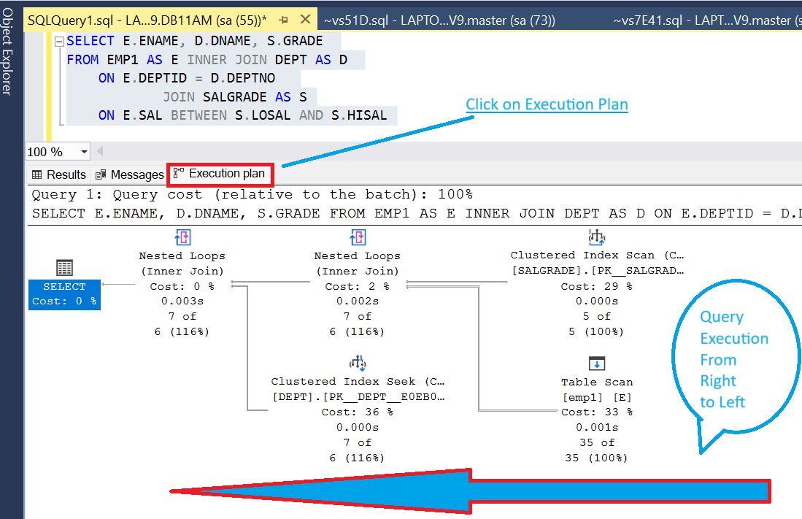

**ON E.SAL BETWEEN S.LOSAL AND S.HISAL :-**

------------------------------------------------------------------

**EMP1 SALGRADE**

|  |  |  |  |  |  |  |  |
| --- | --- | --- | --- | --- | --- | --- | --- |
| **EMPNO** | **ENAME** | **DEPTNO** | **SAL** |  | **GRADE** | **LOSAL** | **HISAL** |
| 1 | A | 10 | 3000 |  | 1 | 700 | 1000 |
| 2 | B | 20 | 1000 |  | 2 | 2000 | 1001 |
| 3 | C | 30 | 5000 |  | 3 | 3000 | 2001 |
| 4 | D | 10 | 2000 |  | 4 | 3001 | 4000 |
|  |  |  |  |  | 5 | 4001 | 9999 |

**OUTPUT of first half Query:-**  **DEPT**

|  |  |  |  |  |  |  |  |
| --- | --- | --- | --- | --- | --- | --- | --- |
| EMPNO | ENAME | DEPTNO | SAL | GRADE |  | DEPTNO | DNAME |
| 1 | A | 10 | 3000 | 3 |  | 10 | ACCT |
| 2 | B | 20 | 1000 | 1 |  | 20 | RESEARCH |
| 3 | C | 30 | 5000 | 5 |  | 30 | SALES |
| 4 | D | 10 | 2000 | 2 |  |  |  |

Apply Condition on Output + DEPT table

**ON E.DEPTNO = D.DEPTNO :-**

-------------------------------------------

|  |  |  |
| --- | --- | --- |
| **ENAME** | **DNAME** | **GRADE** |
| A | ACCT | 3 |
| B | RESEARCH | 1 |
| C | SALES | 5 |
| D | ACCT | 2 |

**SELF JOIN :-**

------------------

=> Joining a table to itself is called **SELF JOIN Or Recursive Join**.

=> In **SELF JOIN** a record in one table joined with another record of same table.

=> To perform **SELF JOIN** the same table must be declared two times with different alias

=> You can join a table to itself even if the table does not have a reflexive relationship in the database. For example, you can use a self-join to find pairs of authors living in the same city.

As with any join, a self-join requires at least two tables. The difference is that, instead of adding a second table to the query, you add a second instance of the same table. That way, you can compare a column in the first instance of the table to the same column in the second instance, which allows you to compare the values in a column to each other. The Query and View Designer assigns an alias to the second instance of the table.

For example, if you are creating a self-join to find all pairs of authors within Berkeley, you compare the city column in the first instance of the table against the city column in the second instance.

FROM EMP AS X JOIN EMP AS Y

**EMP X EMP Y**

EMPNO ENAME MGR EMPNO ENAME MGR

7369 SMITH 7902 7369 SMITH 7902

7499 ALLEN 7698 7499 ALLEN 7698

7698 BLAKE 7839 7698 BLAKE 7839

7839 KING NULL 7839 KING NULL

7902 FORD 7566 7902 FORD 7566

=> Display ENAME MGRNAME?

SELECT X.ENAME, Y.ENAME AS MANAGER

**FROM EMP2 AS X JOIN EMP2 AS Y**

**ON X.MGR = Y.EMPNO**

|  |  |
| --- | --- |
| **ENAME** | **MANAGER** |
| SMITH | FORD |
| ALLEN | BLAKE |
| WARD | BLAKE |
| JONES | KING |
| MARTIN | BLAKE |
| BLAKE | KING |
| CLARK | KING |
| SCOTT | JONES |
| TURNER | BLAKE |
| ADAMS | SCOTT |
| JAMES | BLAKE |
| FORD | JONES |
| MILLER | CLARK |

=> Employees reporting to blake ?

SELECT X.ENAME,Y.ENAME AS MANAGER

FROM **EMP AS X JOIN EMP AS Y**

**ON X.MGR = Y.EMPNO**

**WHERE Y.ENAME='blake'**

|  |  |
| --- | --- |
| **ENAME** | **MANAGER** |
| ALLEN | BLAKE |
| WARD | BLAKE |
| MARTIN | BLAKE |
| TURNER | BLAKE |
| JAMES | BLAKE |

=> Blake's manager name?

SELECT X.ENAME,Y.ENAME

FROM **EMP AS X JOIN EMP AS Y**

**ON X.MGR = Y.EMPNO**

**WHERE X.ENAME='blake'**

|  |  |
| --- | --- |
| **ENAME** | **ENAME** |
| BLAKE | KING |

=> Employees earning more than their managers?

SELECT X.ENAME,X.SAL,

Y.ENAME AS MANAGER,Y.SAL AS MGRSAL

FROM EMP AS X JOIN EMP AS Y

ON X.MGR = Y.EMPNO

WHERE X.SAL > Y.SAL

|  |  |  |  |
| --- | --- | --- | --- |
| **ENAME** | **SAL** | **MANAGER** | **MGRSAL** |
| SCOTT | 3450 | JONES | 3421.25 |
| FORD | 3450 | JONES | 3421.25 |

=> Employees who are senior to their managers?

SELECT X.ENAME,X.HIREDATE,

Y.ENAME AS MGR,Y.HIREDATE AS MGRHIRE

FROM EMP AS X JOIN EMP AS Y

ON X.MGR = Y.EMPNO

WHERE X.HIREDATE < Y.HIREDATE

|  |  |  |  |
| --- | --- | --- | --- |
| **ENAME** | **HIREDATE** | **MGR** | **MGRHIRE** |
| SMITH | 17-12-1980 | FORD | 03-12-1981 |
| ALLEN | 20-02-1981 | BLAKE | 01-05-1981 |
| WARD | 22-02-1981 | BLAKE | 01-05-1981 |
| JONES | 02-04-1981 | KING | 17-11-1981 |
| BLAKE | 01-05-1981 | KING | 17-11-1981 |
| CLARK | 09-06-1981 | KING | 17-11-1981 |

=>

**TEAMS**

ID COUNTRY

1 IND

2 AUS

3 ENG

=> Write a query to display following output ?

IND VS AUS

IND VS ENG

AUS VS ENG

**TEAMS A TEAMS B**

ID COUNTRY ID COUNTRY

1 IND 1 IND

2 AUS 2 AUS

3 ENG 3 ENG

SELECT A.COUNTRY + ' VS ' + B.COUNTRY

FROM TEAMS AS A JOIN TEAMS AS B

ON A.ID < B.ID

IND AUS

IND ENG

AUS ENG

08-jul-24

**CROSS JOIN / CARTESIAN JOIN :-**

---------------------------------------------

=> **Cross join** returns cross product or cartesian product of two tables.

=> The CARTESIAN JOIN is also known as CROSS JOIN. In a CARTESIAN JOIN there is a join for each row of one table to every row of another table. This usually happens when the matching column or WHERE condition is not specified.

* In the absence of a WHERE condition the CARTESIAN JOIN will behave like a CARTESIAN PRODUCT . i.e., the number of rows in the result-set is the product of the number of rows of the two tables.
* In the presence of WHERE condition this JOIN will function like a INNER JOIN.
* Generally speaking, Cross join is similar to an inner join where the join-condition will always evaluate to True

**Ex:-**

A = 1,2

B = 3,4

AXB = (1,3) (1,4) (2,3) (2,4)

=> If cross join performed between two tables then all records of 1st table joined with all the records of second table.

=> To perform cross join submit the join query without join condition.

**Ex :-**

**SELECT E.ENAME,D.DNAME FROM EMP AS E CROSS JOIN DEPT AS D**

==========================================================================

**PERSONAL NOTES START:**

*****************************

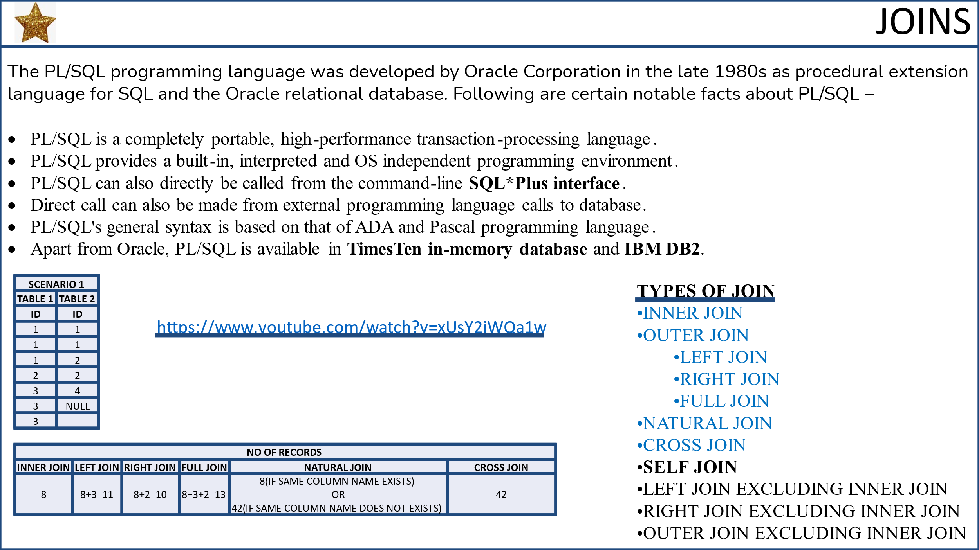

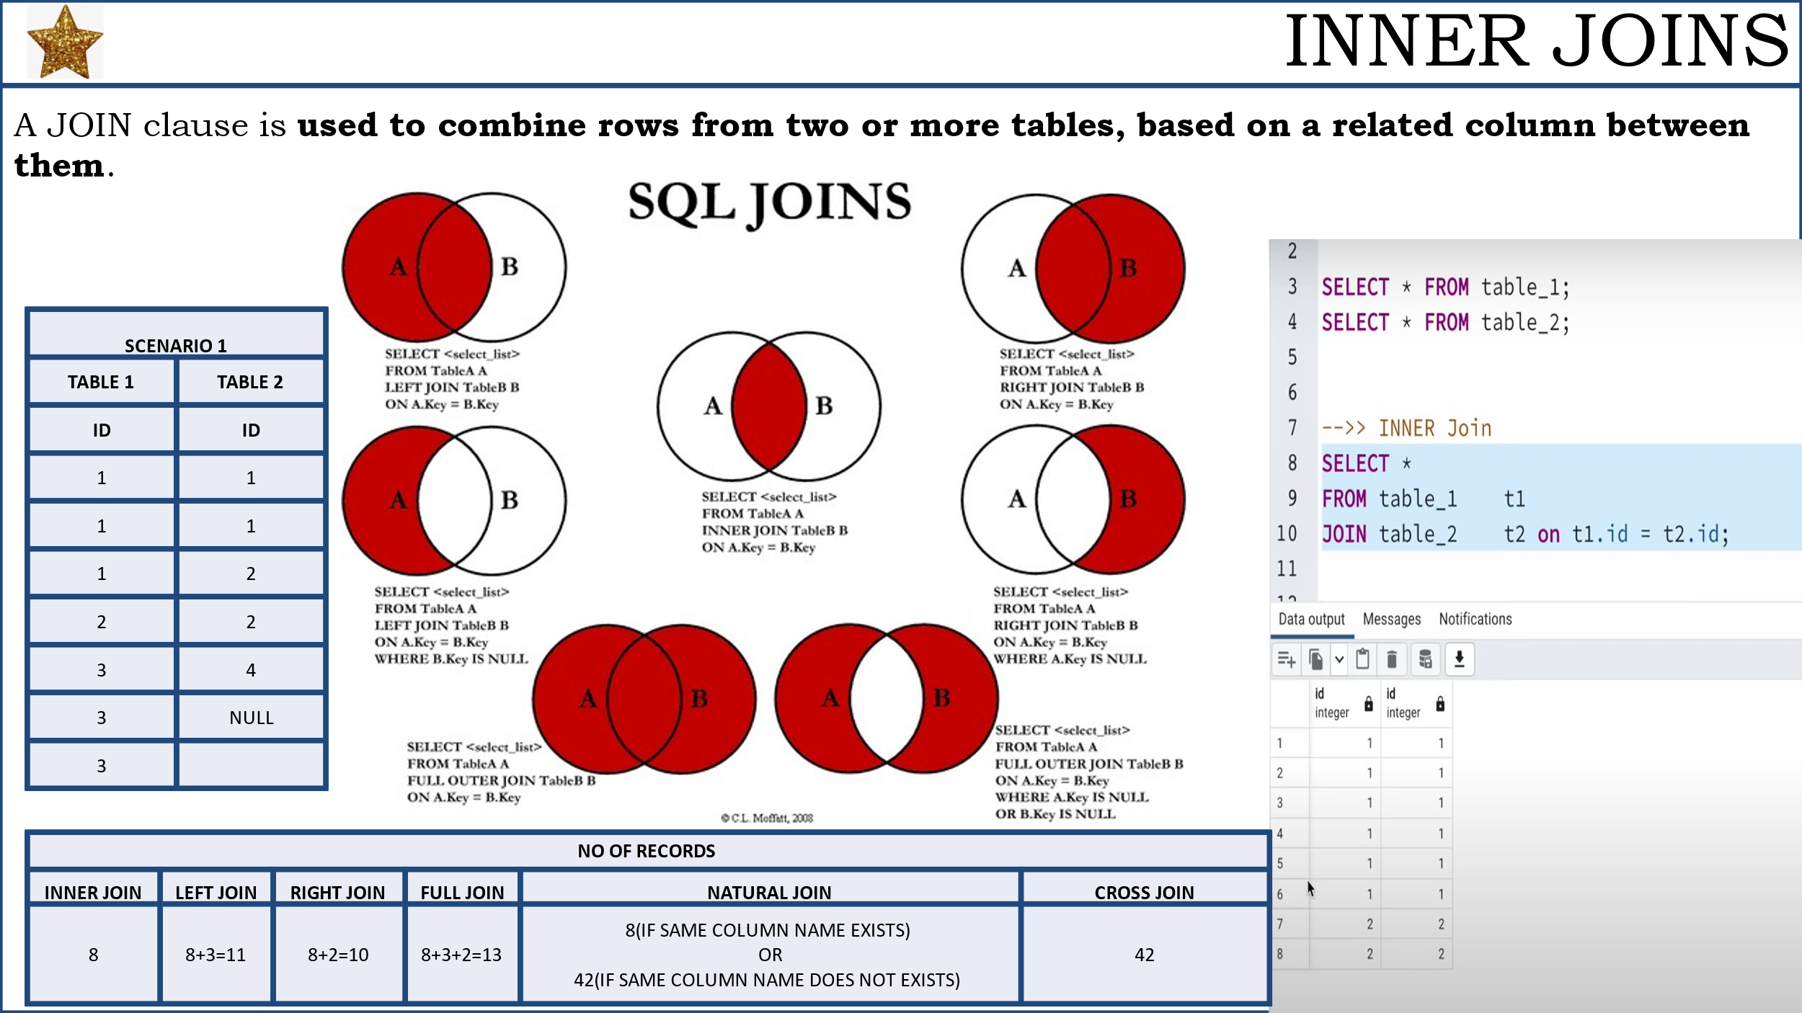

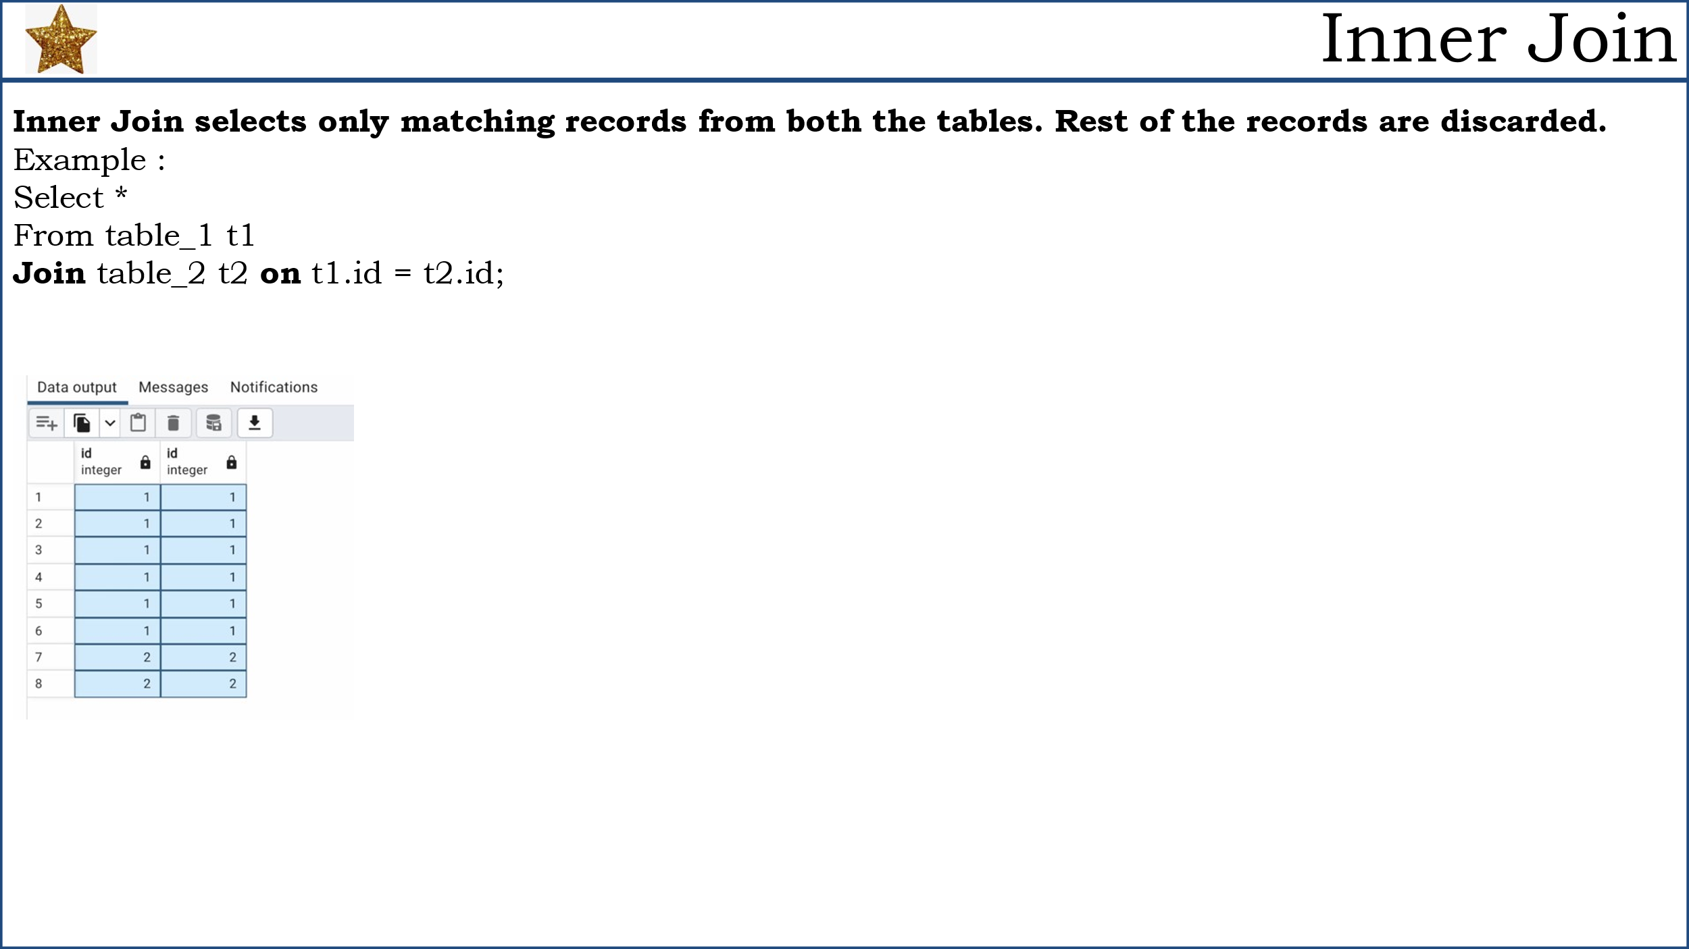

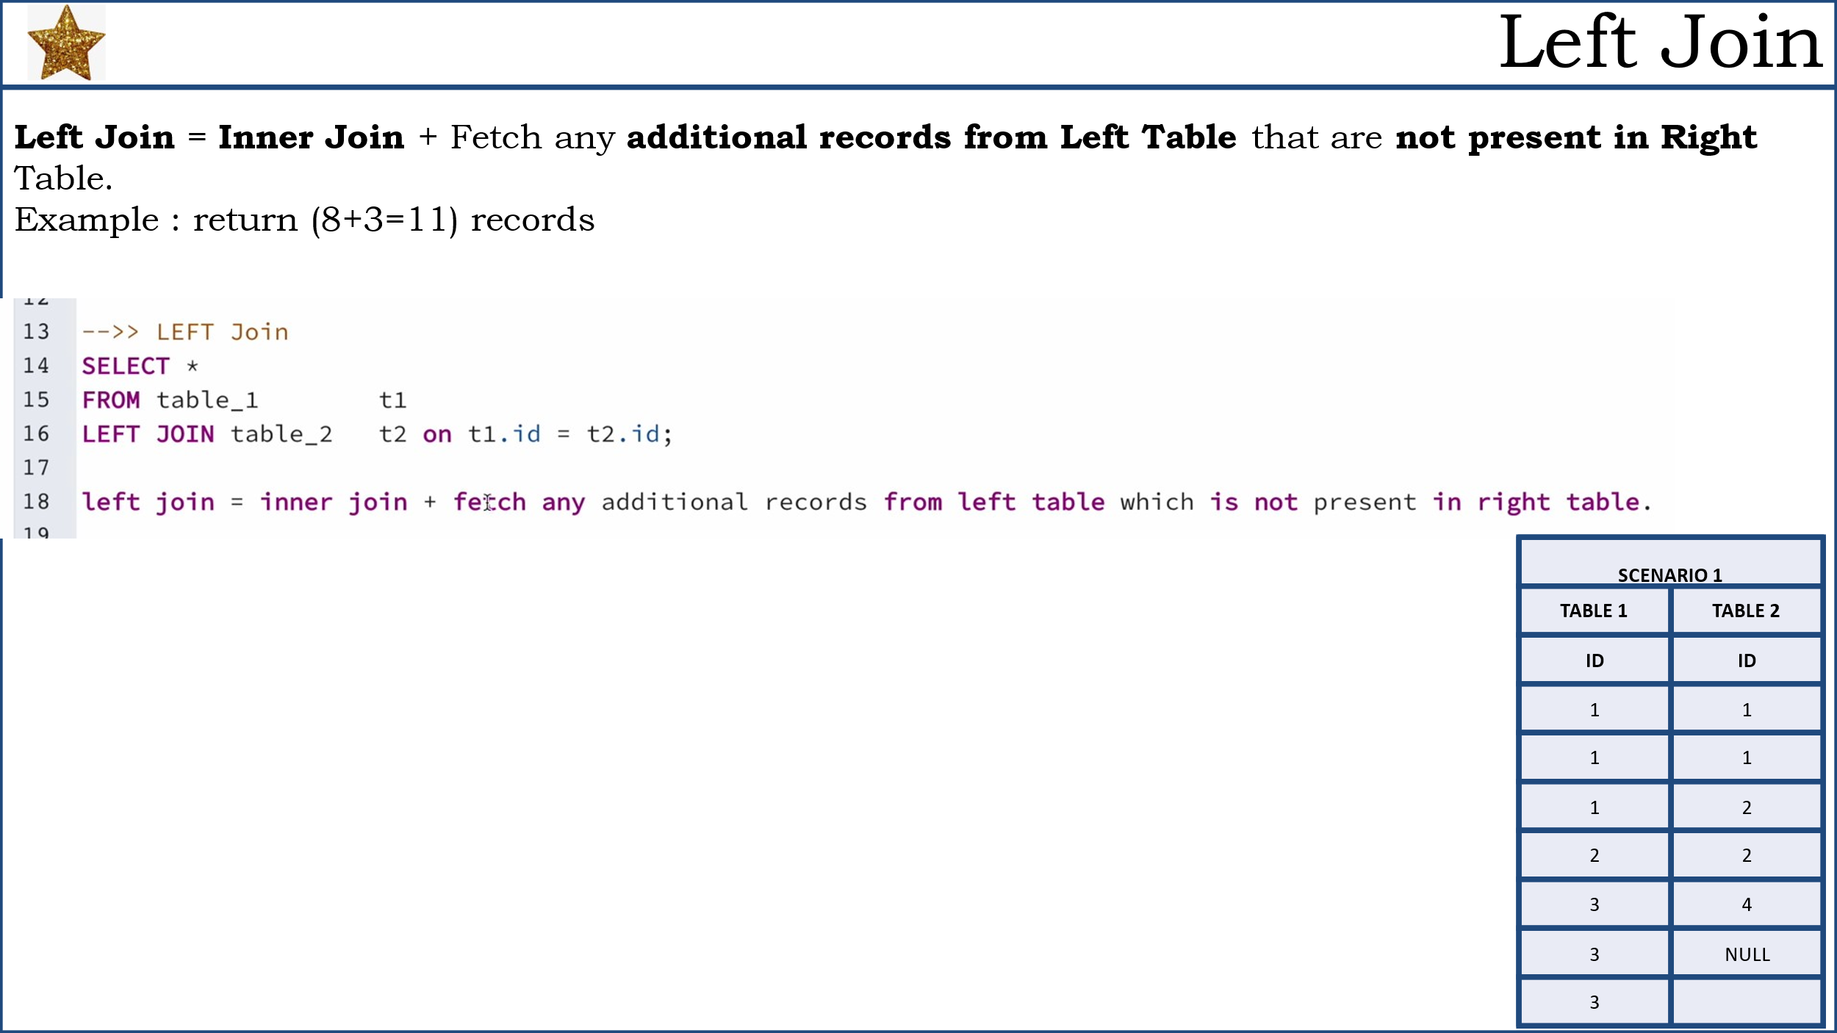

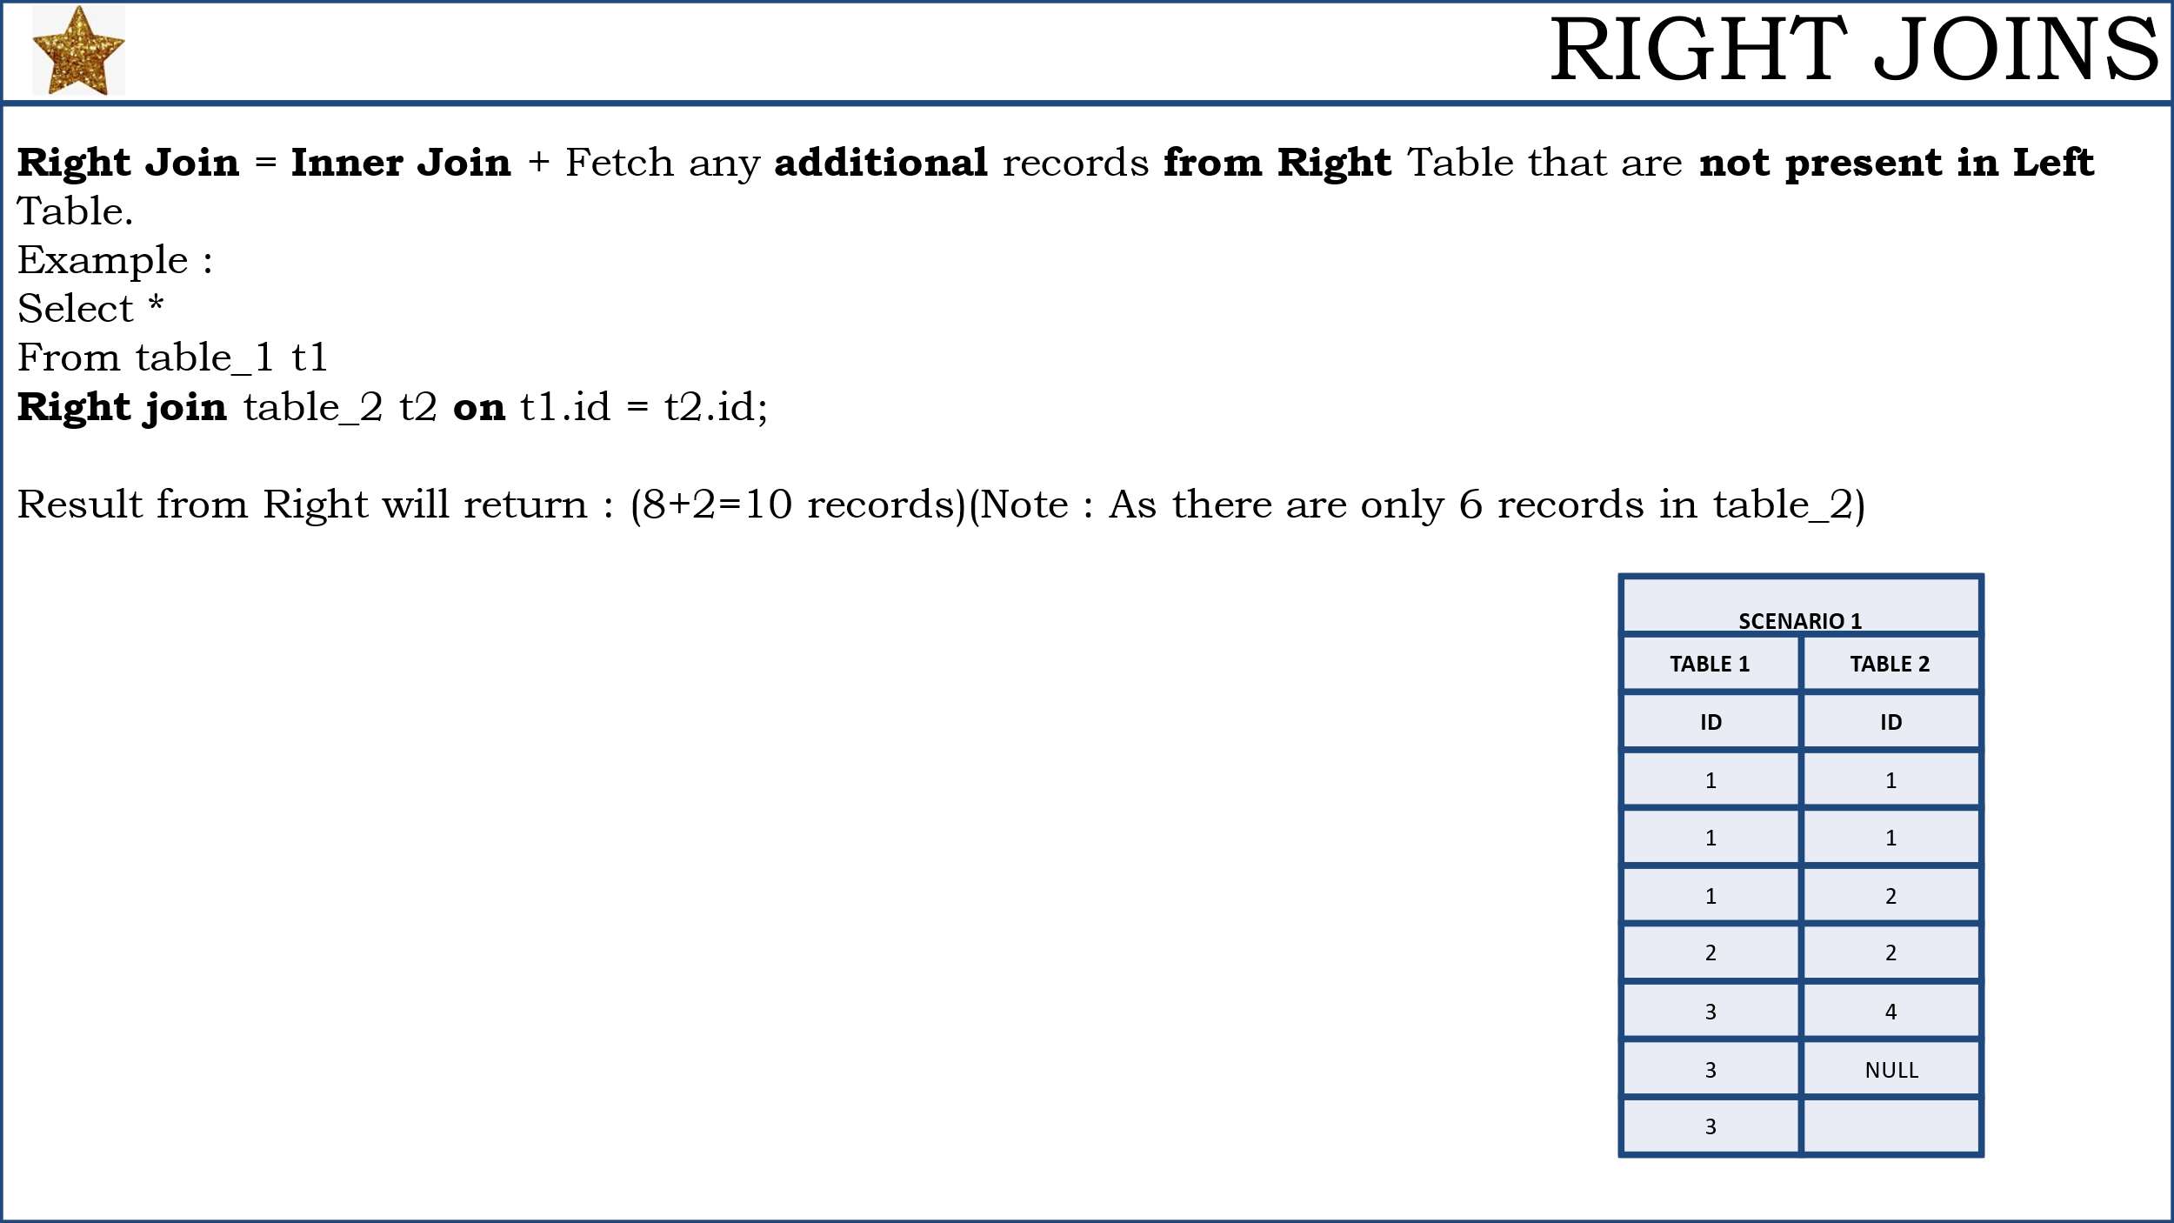

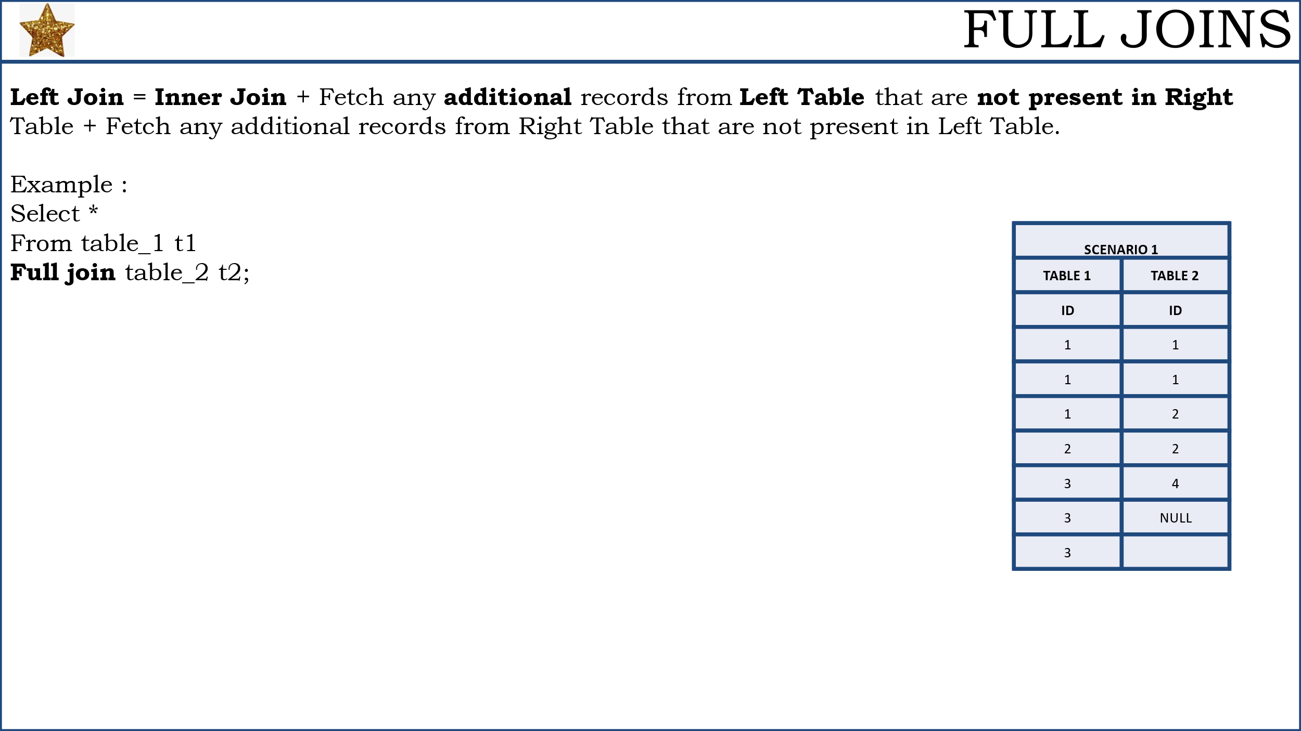

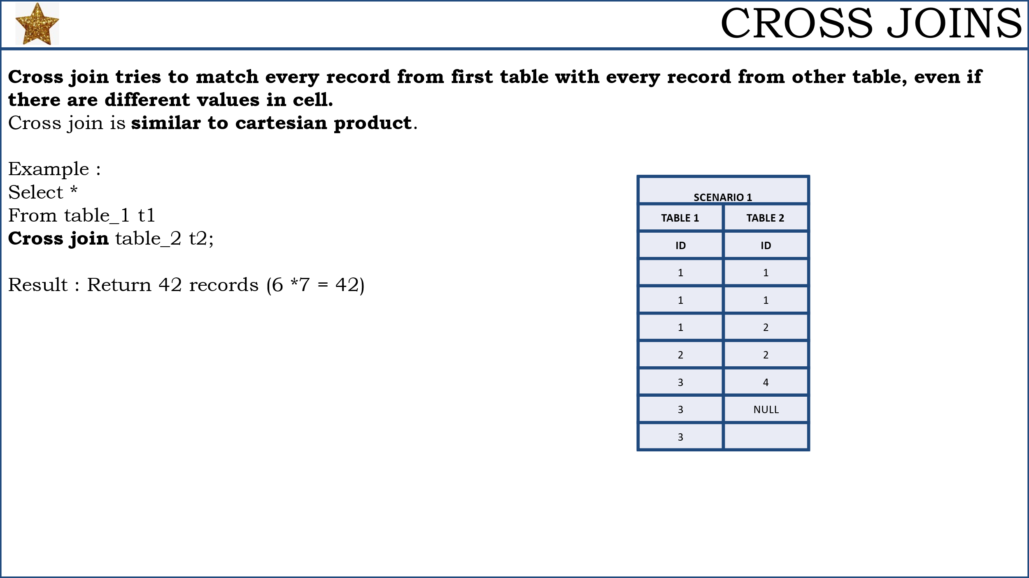

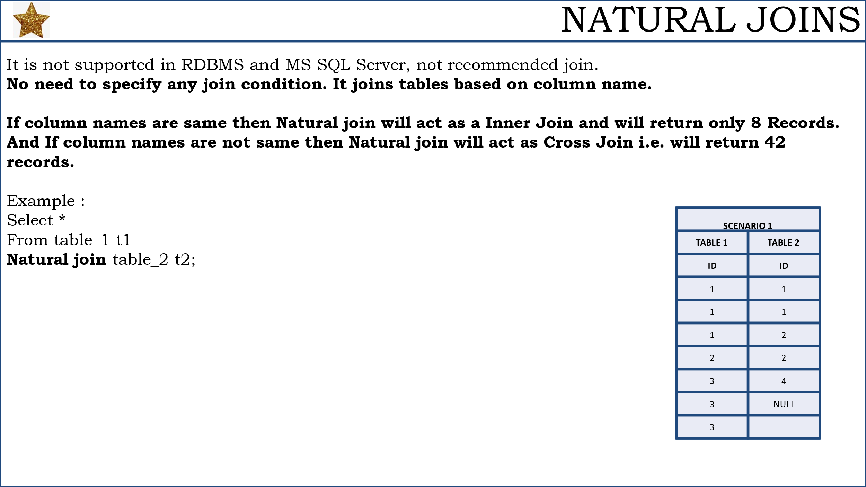

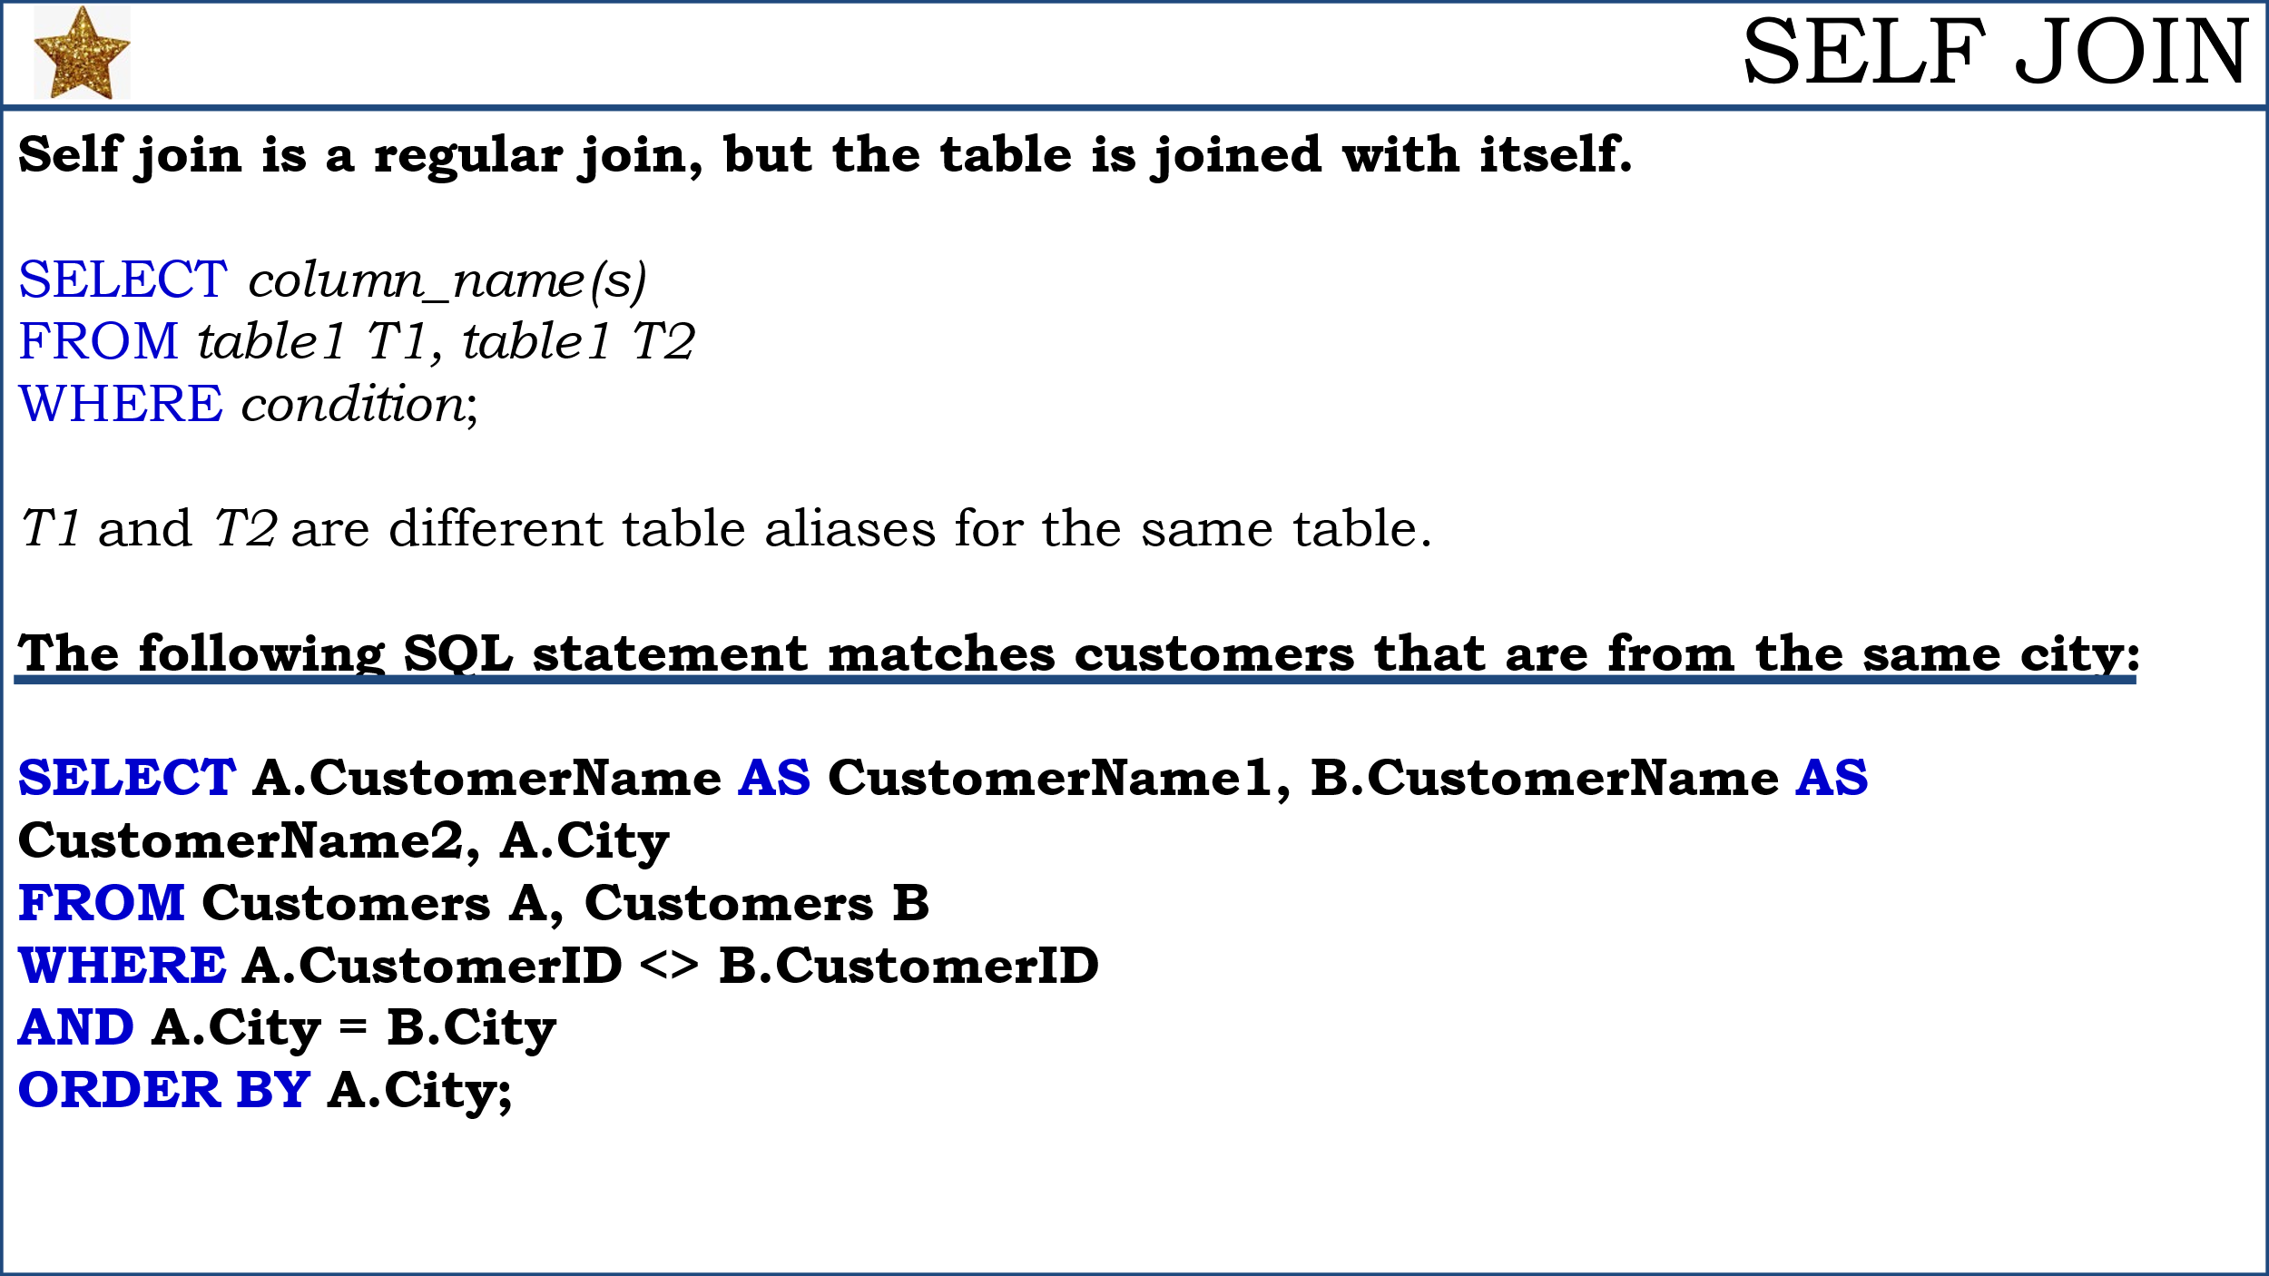

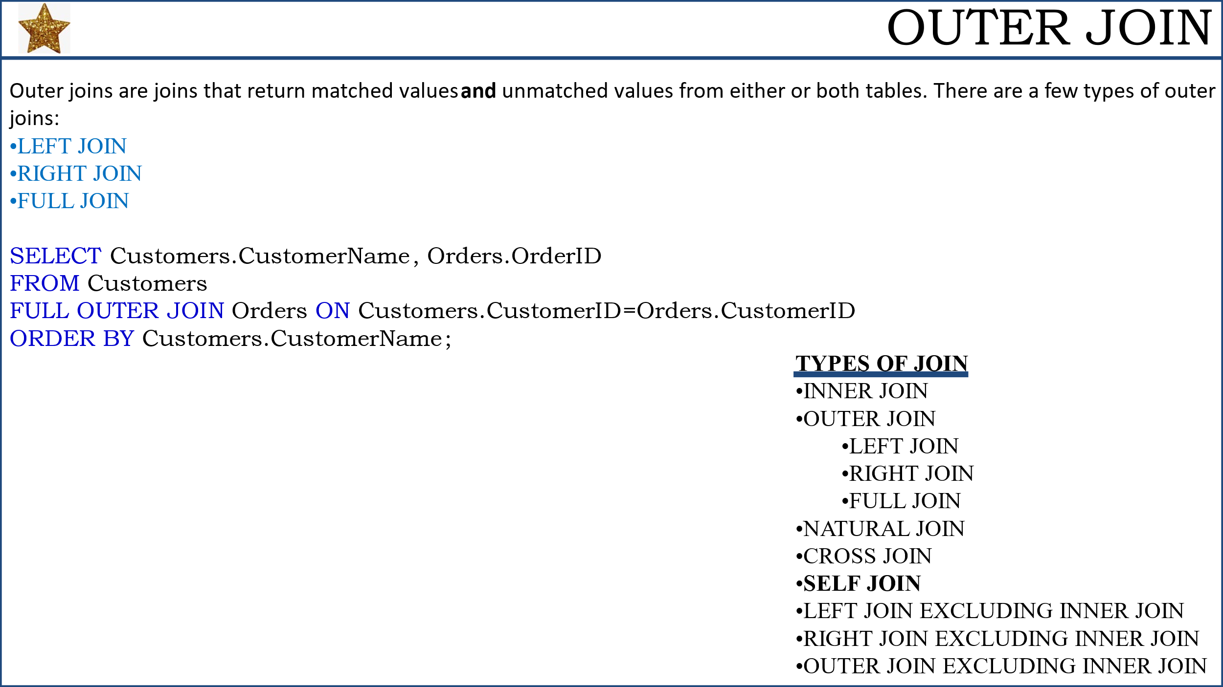

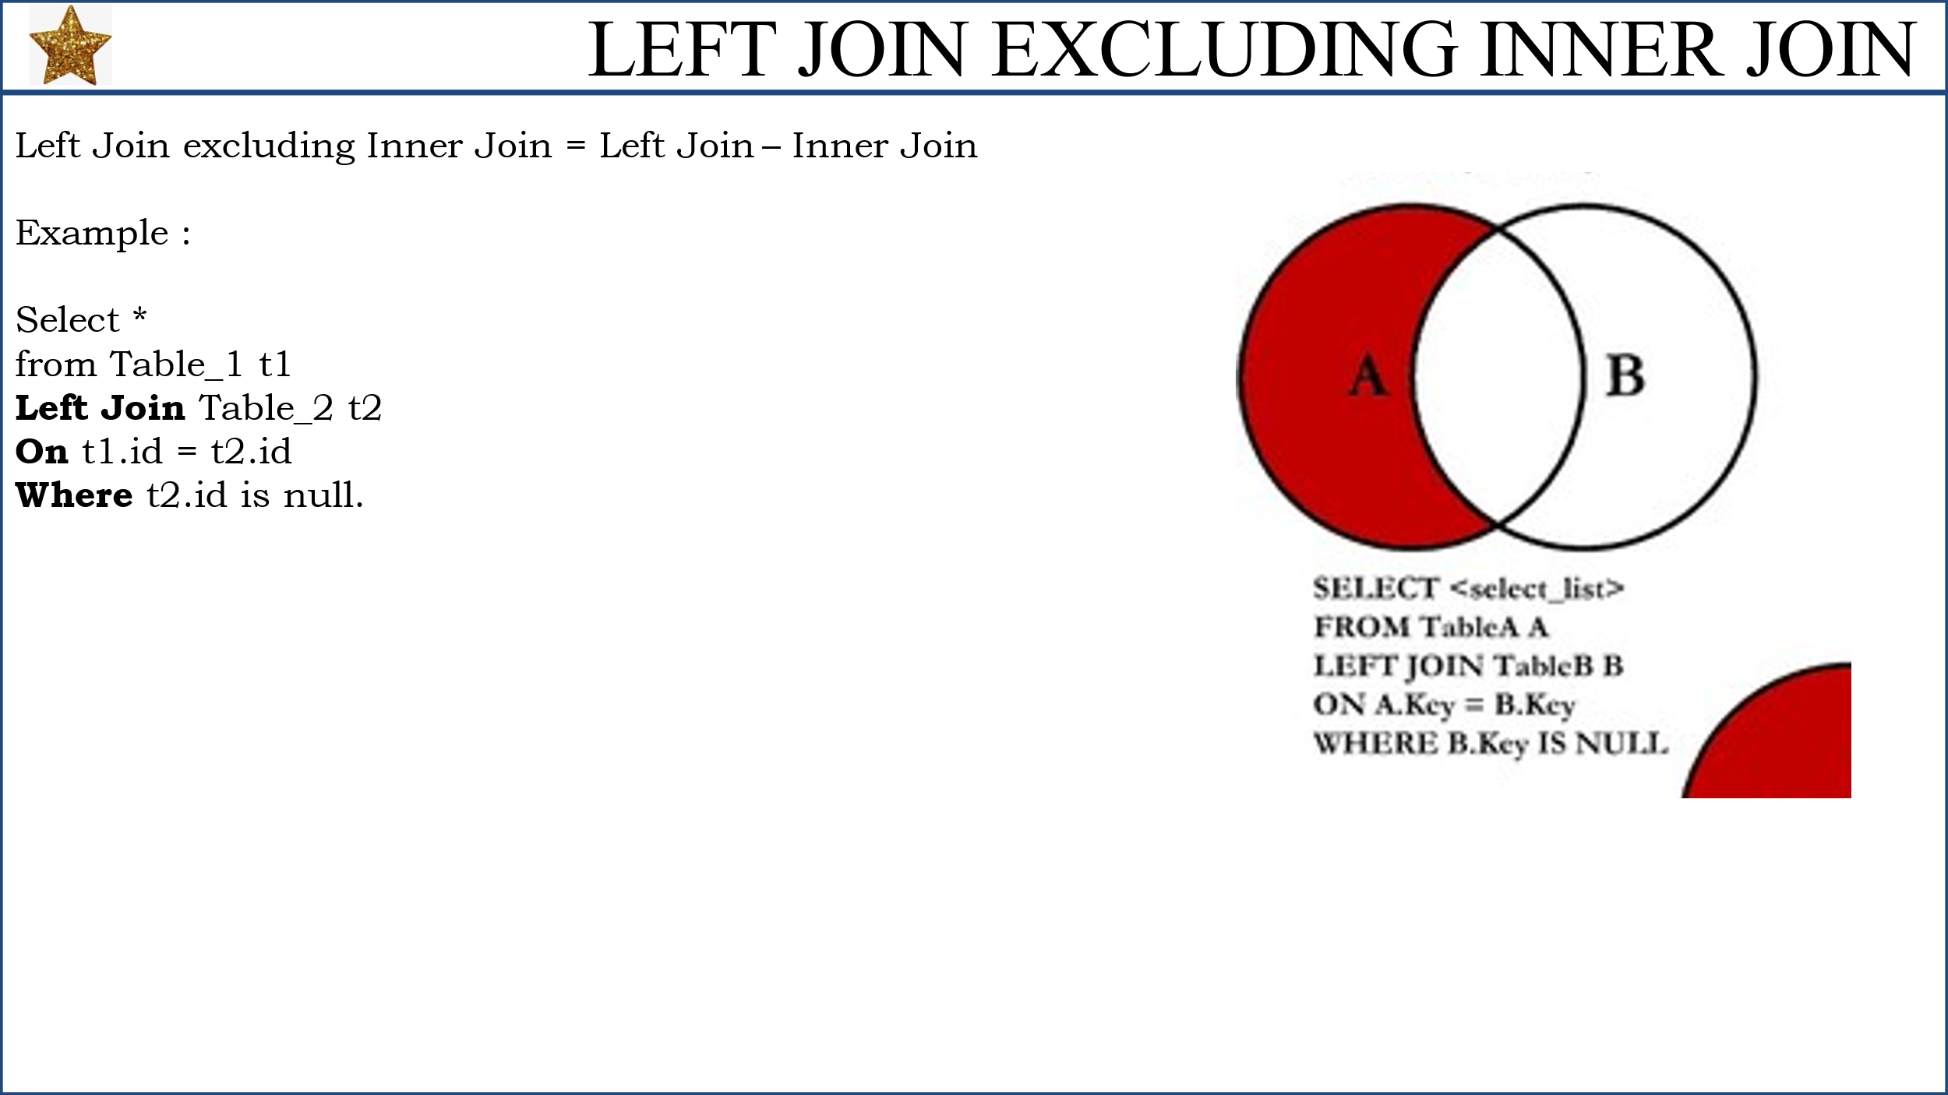

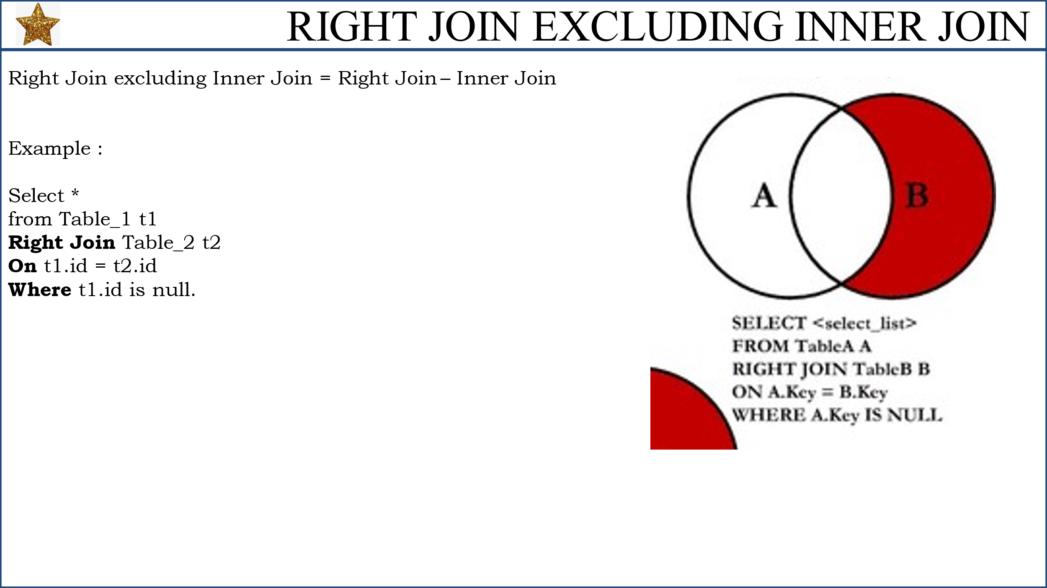

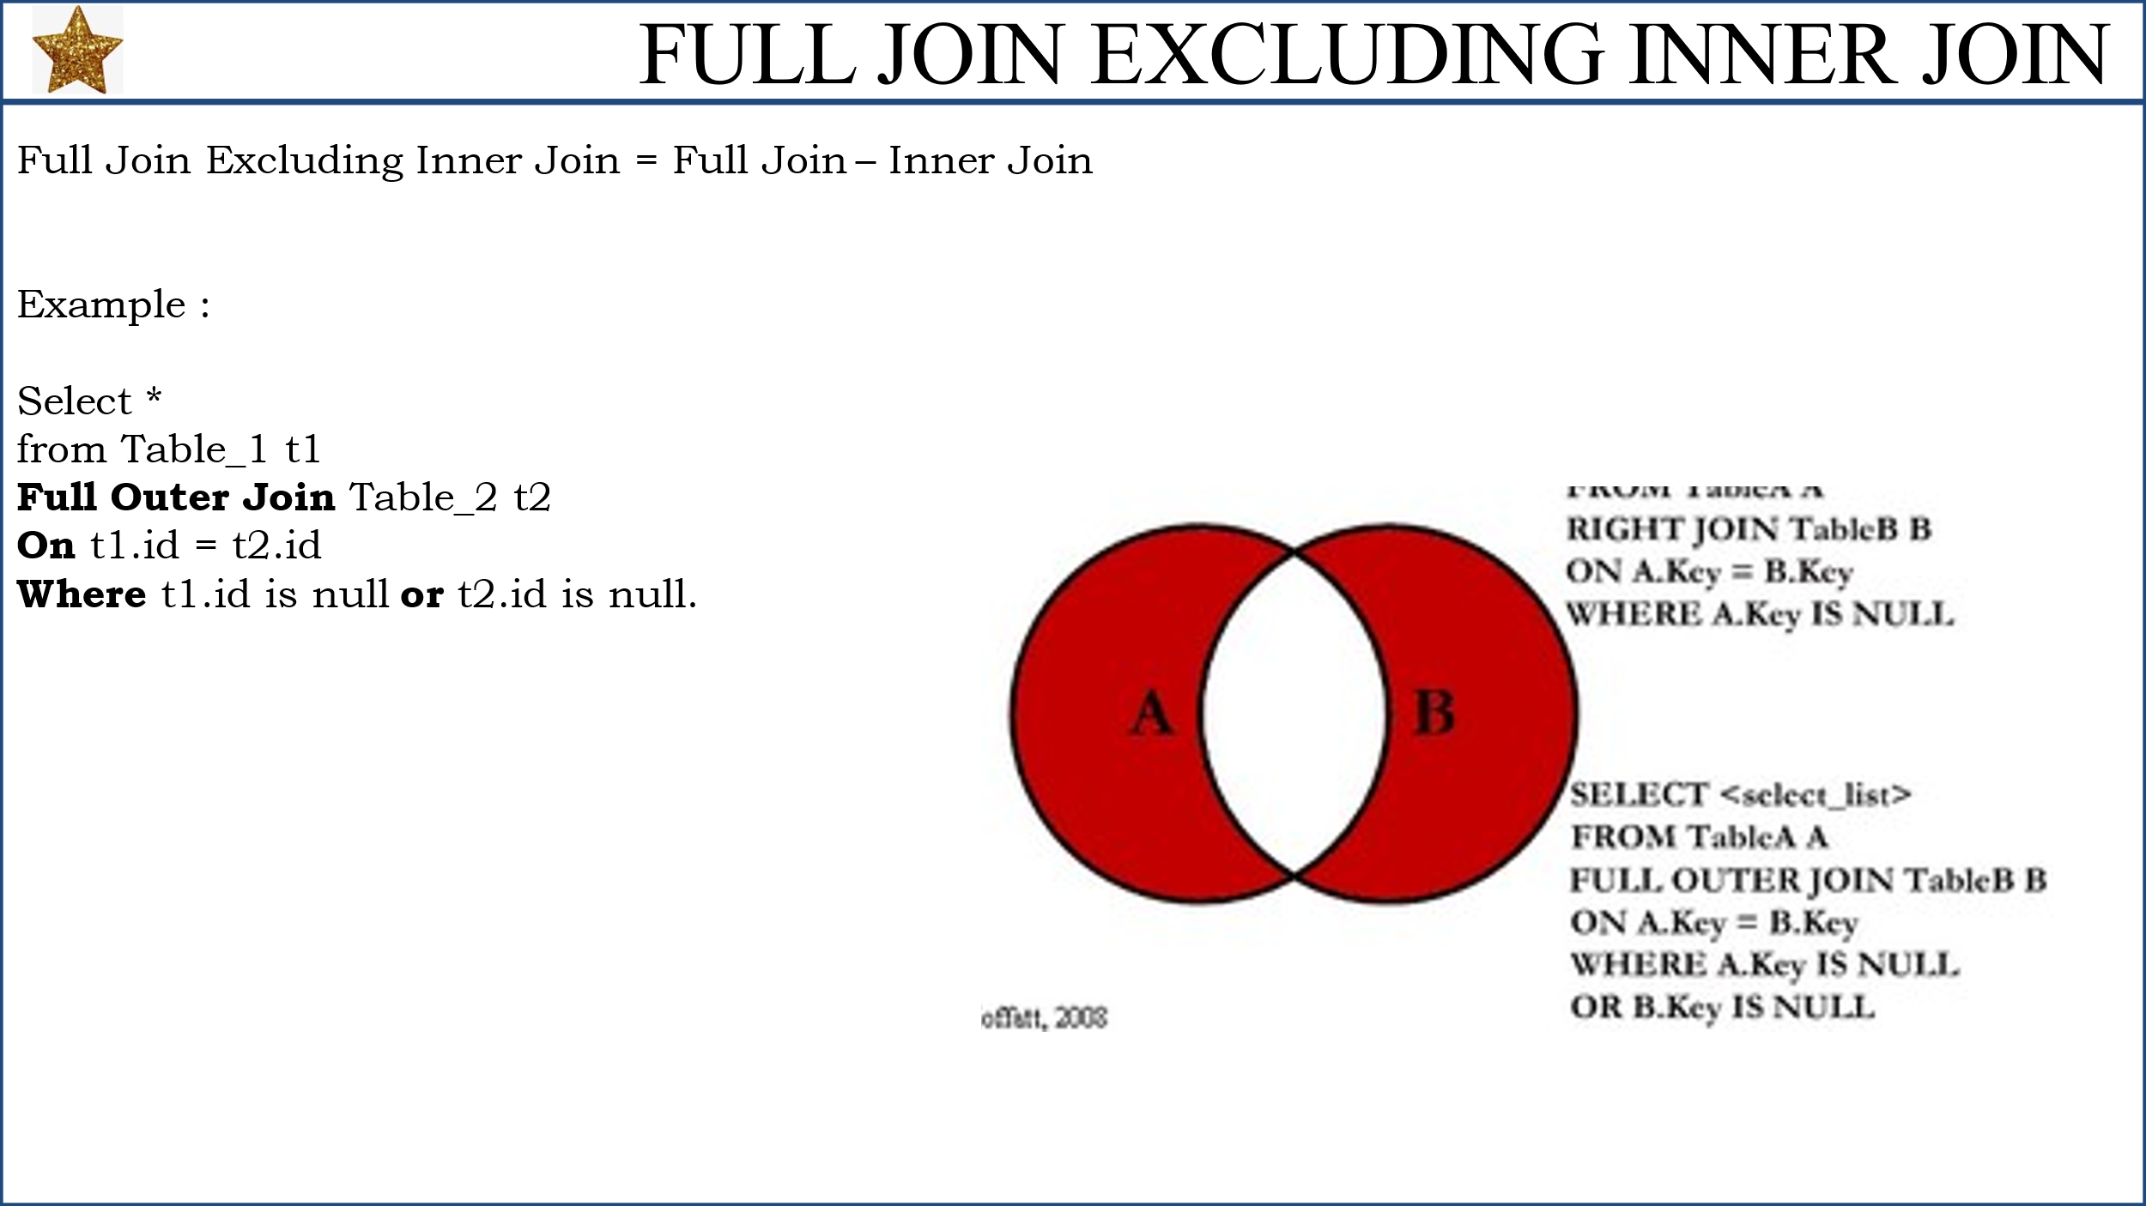

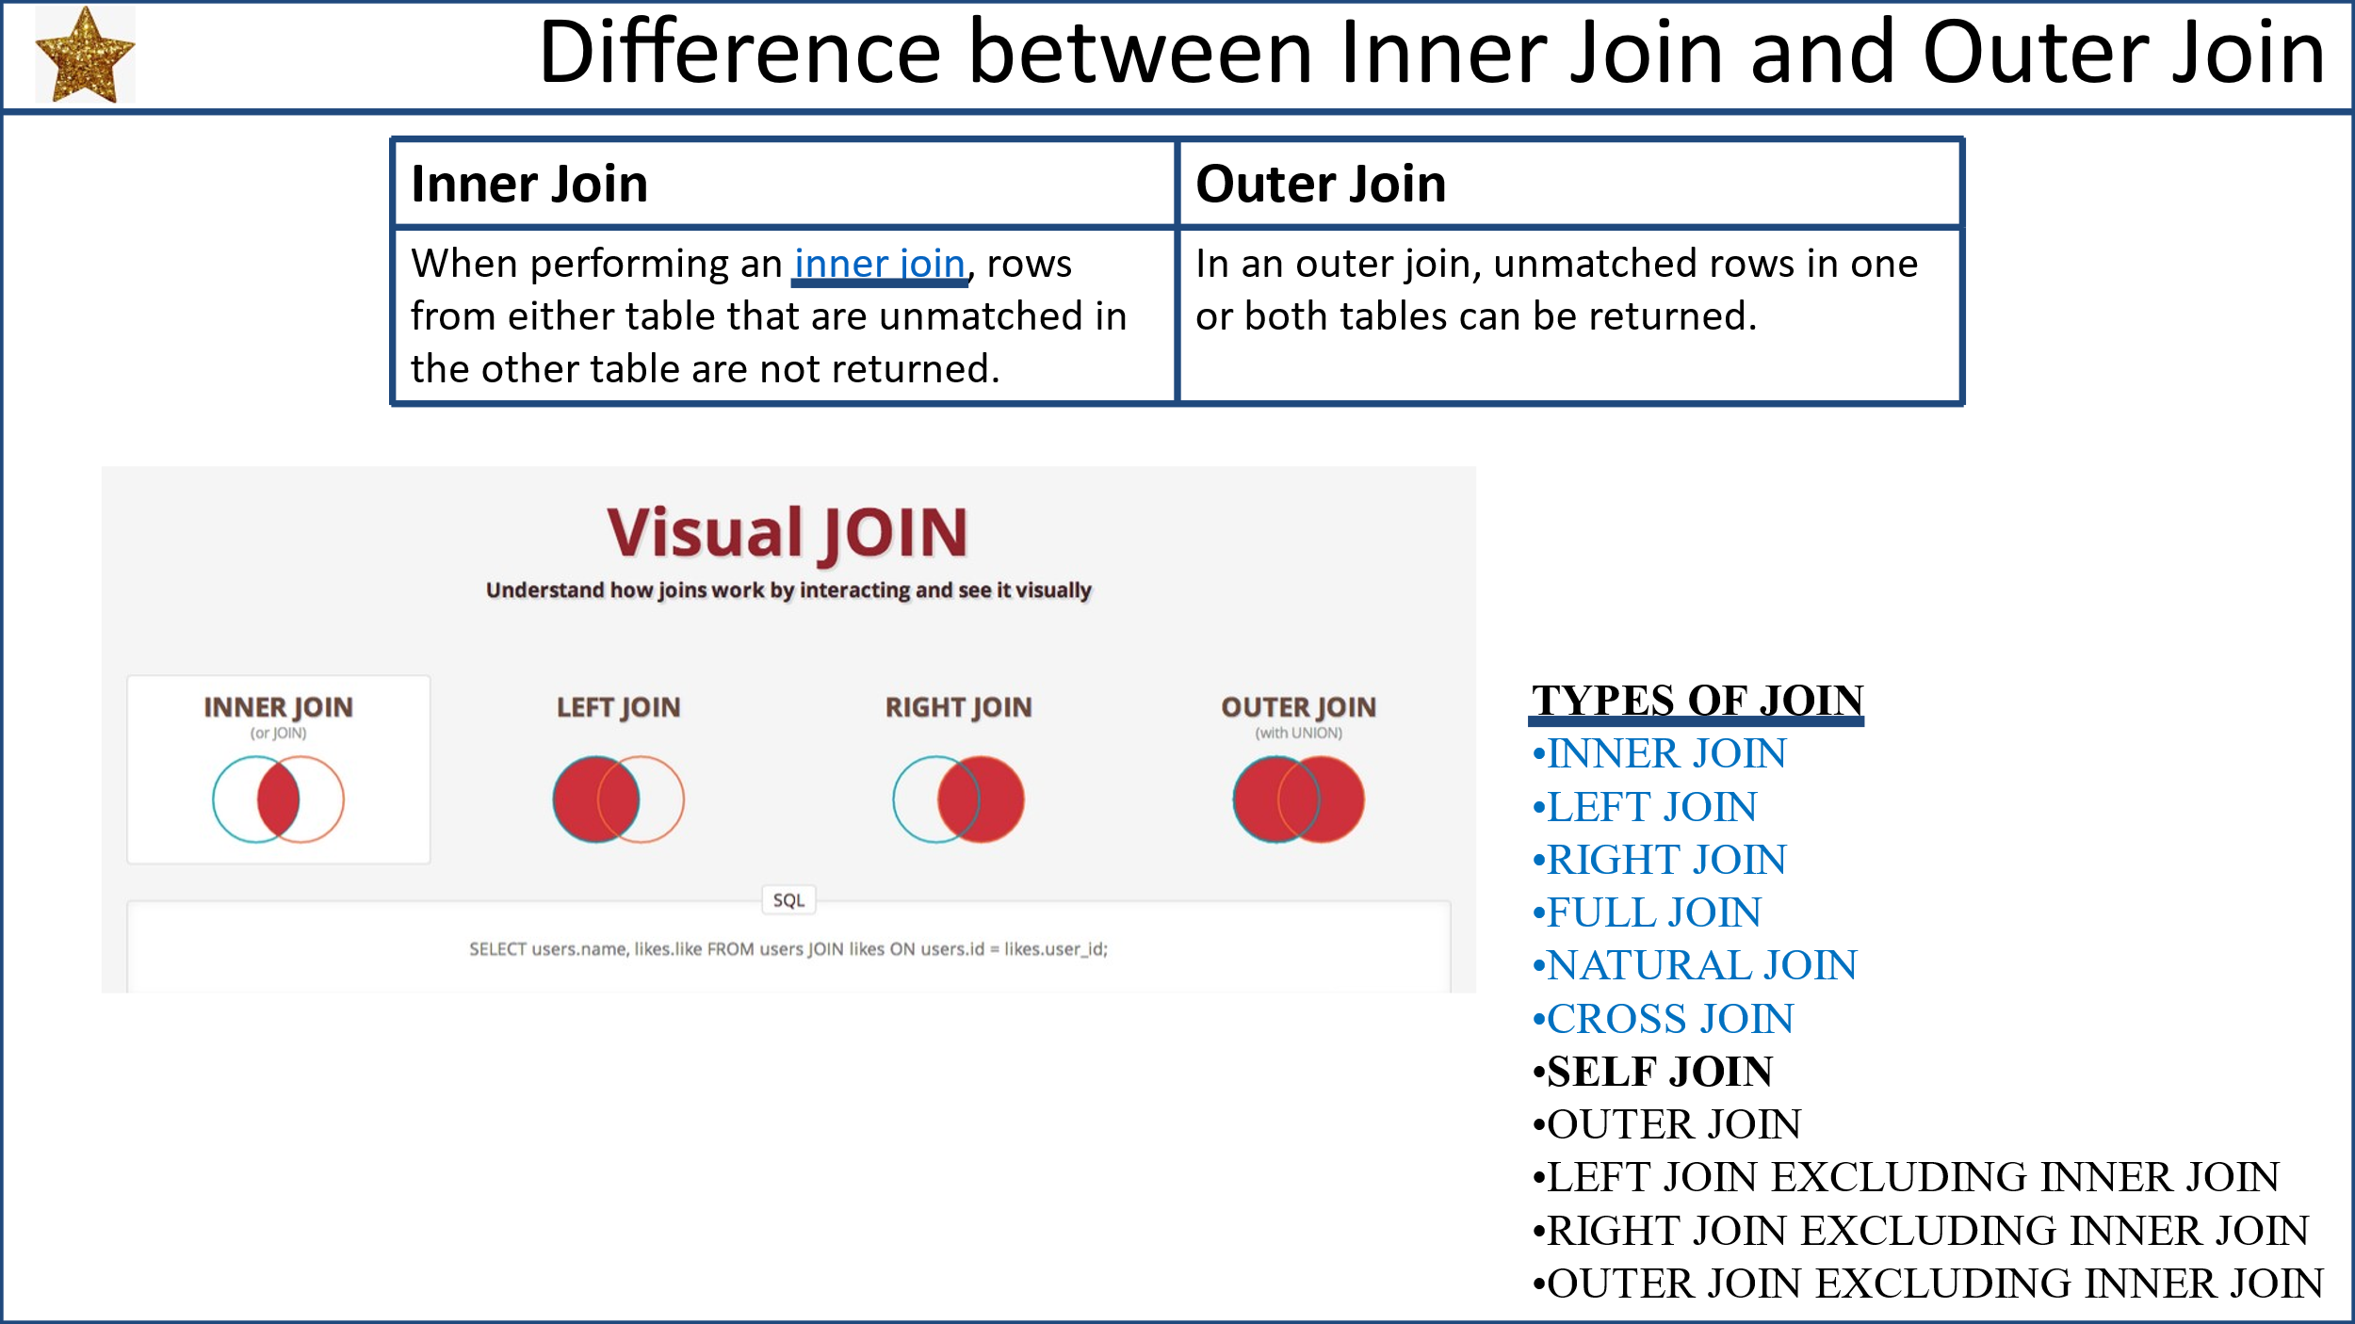

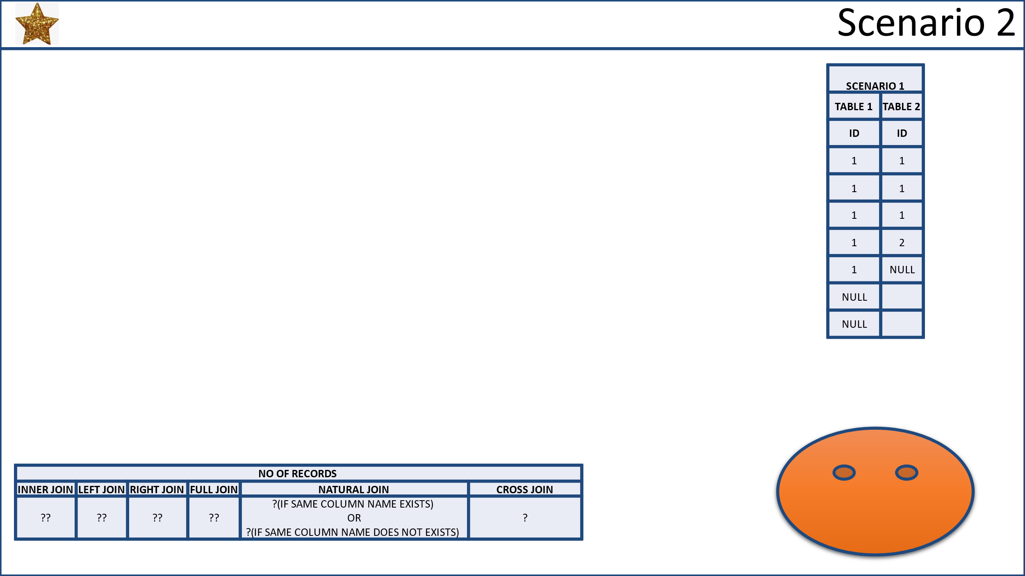

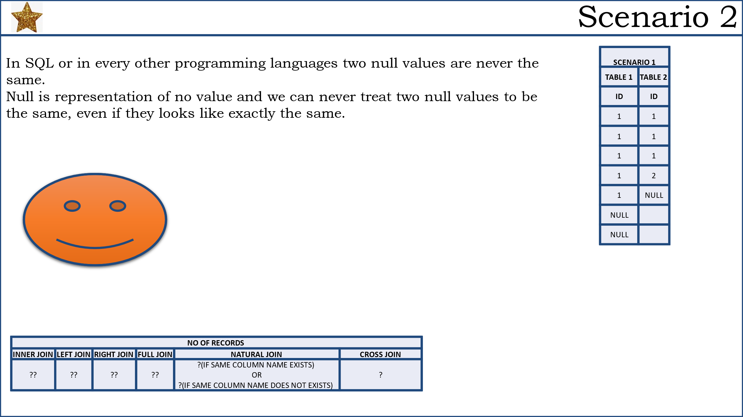

**PERSNOAL NOTES END**

****************************

**SET OPERATORS :-**

--------------------------

1. UNION
2. UNION ALL
3. INTERSECT
4. EXCEPT

A = 1,2,3,4

B = 1,2,5,6

|  |  |
| --- | --- |
| A **UNION** B = | 1,2,3,4,5,6 |
| A **UNION ALL** B = | 1,2,3,4,1,2,5,6 |
| A **INTERSECT** B = | 1,2 |
| A **EXCEPT** B = | 3,4 |
| B **EXCEPT** A = | 5,6 |

=> In SQL set operations performed between set of rows return by two queries

**Syntax :-**

SELECT STATEMENT 1

**UNION / UNION ALL / INTERSECT / EXCEPT**

SELECT STATEMENT 2

**Rules :-**

-----------

1. No of columns return by both queries must be same
2. Corresponding columns datatype must be same

SELECT JOB FROM EMP WHERE DEPTNO = 20

CLERK

MANAGER

ANALYST

CLERK

ANALYST

SELECT JOB FROM EMP WHERE DEPTNO = 30

SALESMAN

SALESMAN

SALESMAN

MANAGER

SALESMAN

CLERK

**UNION :-**

-------------

=> Union combines rows return by two queries.

=> Duplicates are eliminated

=> Result is sorted

SELECT JOB FROM EMP WHERE DEPTNO = 20

**UNION**

SELECT JOB FROM EMP WHERE DEPTNO = 30

**OUTPUT**

ANALYST

CLERK

MANAGER

SALESMAN

SELECT JOB, SAL FROM EMP WHERE DEPTNO = 20

**UNION**

SELECT JOB, SAL FROM EMP WHERE DEPTNO = 30

|  |  |
| --- | --- |
| **JOB** | **SAL** |
| ANALYST | 3450 |
| CLERK | 1140 |
| CLERK | 1150 |
| CLERK | 1265 |
| MANAGER | 3420 |
| MANAGER | 3421.25 |
| SALESMAN | 1500 |
| SALESMAN | 1800 |
| SALESMAN | 1920 |

**IQ: UNION VS JOIN :-**

------------------------

|  |  |
| --- | --- |
| **UNION** | **JOIN** |
| Combines Rows | Combines Columns |
| Corresponding columns datatype must be same. | Corresponding columns datatype can be different. |
| Horizontal Merge | Vertical Merge |
| Performed between two queries | Performed between two tables |
| Lengthens data | Widens data |
| Appends rows | Appends columns |

**Ex 1 :-**

T1 T2

F1 C1

1 10

2 20

3 30

**Result:**

**T1 UNION T2 :- T1 JOIN T2 :-**

1 1 10

2 2 20

3 3 30

10

20

30

**Ex 2 :-**

**EMP_US**

ENO ENAME SAL DNO

**EMP_IND**

ENO ENAME SAL DNO

**DEPT** (Stores both US and IND Dept Details)

DNO DNAME LOC

**IQ Ex:** When to Use Union and when to Use Join

=> Total employees list?

SELECT * FROM **EMP_US**

**UNION**

SELECT * FROM **EMP_IND**

=> Employees working at US loc with dept details?

SELECT **E.*,D.\***

FROM **EMP_US AS E INNER JOIN DEPT AS D**

**ON E.DNO = D.DNO**

=> Total employees with dept details ?

SELECT E.*,D.*

FROM **EMP_US AS E** **INNER JOIN** DEPT AS D

**ON E.DNO = D.DNO**

**UNION**

SELECT E.*,D.*

FROM **EMP_IND AS E** **INNER JOIN** DEPT AS D

**ON E.DNO = D.DNO**

**UNION ALL :-**

------------------

=> Combines rows

=> **Duplicates are not eliminated**

=> **Result is not sorted**

SELECT JOB FROM EMP WHERE DEPTNO = 20

**UNION ALL**

SELECT JOB FROM EMP WHERE DEPTNO = 30

**Result:** (Cobines rows, keeps duplicate, do not sort)

CLERK

MANAGER

ANALYST

CLERK

ANALYST

SALESMAN

SALESMAN

SALESMAN

MANAGER

SALESMAN

CLERK

**UNION VS UNION ALL :-**

--------------------------------

|  |  |
| --- | --- |
| **UNION** | **UNION ALL** |
| Eliminates duplicates | Doesn't eliminate duplicates |
| Result is sorted | Result is not sorted |
| Slower | Faster |

**INTERSECT :-**

------------------

=> Returns common values from the output of two queries

SELECT JOB FROM EMP WHERE DEPTNO = 20

**INTERSECT**

SELECT JOB FROM EMP WHERE DEPTNO = 30

**Result:**

CLERK

MANAGER

**EXCEPT :-**

--------------

=> Returns values present in 1st query output and not present in 2nd query output.

SELECT JOB FROM EMP WHERE DEPTNO = 20

**EXCEPT**

SELECT JOB FROM EMP WHERE DEPTNO = 30

**Result:**

ANALYST

=>

T1 T2

F1 C1

1 1

2 2

3 3

10 40

20 50

30 60

=> Write outputs for the following operations?

**1 INNER JOIN**

|  |  |
| --- | --- |
| 1 | 1 |
| 2 | 2 |
| 3 | 3 |

**2 LEFT JOIN**

|  |  |
| --- | --- |
| 1 | 1 |
| 2 | 2 |
| 3 | 3 |
| 10 | NULL |
| 20 | NULL |
| 30 | NULL |

**3 RIGHT JOIN**

|  |  |
| --- | --- |
| 1 | 1 |
| 2 | 2 |
| 3 | 3 |
| NULL | 40 |
| NULL | 50 |
| NULL | 60 |

**4 FULL JOIN**

|  |  |
| --- | --- |
| 1 | 1 |
| 2 | 2 |
| 3 | 3 |
| 10 | NULL |
| 20 | NULL |
| 30 | NULL |
| NULL | 40 |
| NULL | 50 |
| NULL | 60 |

**5 UNION**

|  |
| --- |
| 1 |
| 2 |
| 3 |
| 10 |
| 20 |
| 30 |
| 40 |
| 50 |
| 60 |

**6 UNION ALL**

|  |
| --- |
| 1 |
| 2 |
| 3 |
| 10 |
| 20 |
| 30 |
| 1 |
| 2 |
| 3 |
| 40 |
| 50 |
| 60 |

**7 INTERSECT**

|  |
| --- |
| 1 |
| 2 |
| 3 |

**8 EXCEPT**

**T1 EXCEPT T2**

|  |
| --- |
| 10 |
| 20 |
| 30 |

**T2 EXCEPT T1**

|  |
| --- |
| 40 |
| 50 |
| 60 |

9-JUL-24

**GROUP BY CLAUSE :-**

-----------------------------

=> Group by clause is used to group rows based on one or more columns to calculate min, max, sum, avg, count for each group. Ex To calculate dept wise total salary, first group the rows based on dept wise and apply sum function on each group.

|  |  |  |  |  |  |  |
| --- | --- | --- | --- | --- | --- | --- |
| **EMP** |  | | |  |  | |
| EMPNO | ENAME | SAL | DEPTNO |  |  | |
| 1 | A | 3000 | 10 |  | **GROUP BY RESULT** | |
| 2 | B | 6000 | 20 |  | **DEPTNO** | **TOTALSAL** |
| 3 | C | 4000 | 30 | =======🡺 | 10 | 8000 |
| 4 | D | 5000 | 10 |  | 20 | 9000 |
| 5 | E | 3000 | 20 |  | 30 | 4000 |
| DETAILED DATA | | | |  | SUMMARIZED DATA | |

=> Group by clause can be used to convert detailed data into summarized data which is useful for analysis.

**SYNTAX** Developer follows:-

SELECT columns

FROM tabname

[WHERE cond]

GROUP BY colname

[HAVING cond]

[ORDER BY col ASC/DESC]

**EXECUTION ORDER (SQL follows):-**

1. FROM
2. WHERE
3. GROUP BY
4. HAVING
5. SELECT
6. ORDER BY

**Examples :-**

=> Display dept wise total salary ?

SELECT DEPTNO, SUM(SAL) AS TOTSAL

FROM **EMP2** GROUP BY DEPTNO

|  |  |
| --- | --- |
| **DEPTNO** | **TOTSAL** |
| 10 | 9625 |
| 20 | 12736.25 |
| 30 | 11280 |

FROM EMP :-

-----------------

|  |  |  |  |
| --- | --- | --- | --- |
| **EMPNO** | **ENAME** | **SAL** | **DEPTNO** |
| 1 | A | 3000 | 10 |
| 2 | B | 6000 | 20 |
| 3 | C | 4000 | 30 |
| 4 | D | 5000 | 10 |
| 5 | E | 3000 | 20 |

GROUP BY DEPTNO :-

------------------------

|  |  |  |  |
| --- | --- | --- | --- |
| **DEPTNO** | **EMPNO** | **ENAME** | **SAL** |
| 10 | 1 | A | 3000 |
|  | 4 | D | 5000 |
| 20 | 2 | B | 6000 |
|  | 5 | E | 3000 |
| 30 | 3 | C | 4000 |

Select deptno, sum(sal) as totsal :-

---------------------------------------------

|  |  |
| --- | --- |
| **DEPTNO** | **TOTSAL** |
| 10 | 8000 |
| 20 | 9000 |
| 30 | 4000 |

=> Display job wise no of employees ?

SELECT JOB,COUNT(*) AS CNT

FROM EMP2

**GROUP BY JOB**

|  |  |
| --- | --- |
| **JOB** | **CNT** |
| ANALYST | 2 |
| CLERK | 4 |
| MANAGER | 3 |
| PRESIDENT | 1 |
| SALESMAN | 4 |

=> Display year wise no of employees joined ?

SELECT **DATEPART(YY,HIREDATE) AS YEAR,COUNT(*) AS CNT**

FROM EMP2

**GROUP BY DATEPART(YY,HIREDATE)**

|  |  |
| --- | --- |
| **YEAR** | **CNT** |
| 1980 | 1 |
| 1981 | 10 |
| 1982 | 2 |
| 1983 | 1 |

=> Day wise no of employees joined?

SELECT **DATENAME(DW,HIREDATE) AS DAY**,COUNT(*) AS CNT

**FROM EMP2**

**GROUP BY DATENAME(DW,HIREDATE)**

|  |  |
| --- | --- |
| **DAY** | **CNT** |
| Friday | 2 |
| Monday | 1 |
| Saturday | 1 |
| Sunday | 1 |
| Thursday | 4 |
| Tuesday | 3 |
| Wednesday | 2 |

=> Month wise no of employees joined in the year 1981 ?

SELECT **DATENAME(MM,HIREDATE) AS MONTH,COUNT(*) AS CNT**

**FROM EMP2**

**WHERE DATEPART(YY,HIREDATE)=1981**

**GROUP BY DATENAME(MM,HIREDATE)**

|  |  |
| --- | --- |
| **MONTH** | **CNT** |
| April | 1 |
| December | 2 |
| February | 2 |
| June | 1 |
| May | 1 |
| November | 1 |
| September | 2 |

=> Find the departments having more than 3 employees ?

SELECT DEPTNO,COUNT(*)

FROM EMP2

WHERE COUNT(*) > 3

**GROUP BY DEPTNO => ERROR**

**Note:-** SQL server cannot calculate dept wise count before group by and it can calculate only after group by, so apply the condition count(*) > 3 after group by using HAVING clause.

SELECT DEPTNO,COUNT(*) AS CNT

FROM EMP2

**GROUP BY DEPTNO HAVING COUNT(*) > 3**

|  |  |
| --- | --- |
| **DEPTNO** | **CNT** |
| 20 | 5 |
| 30 | 6 |

**WHERE VS HAVING :-**

--------------------------------

|  |  |
| --- | --- |
| **WHERE** | **HAVING** |
| Selects specific **rows** | Selects specific **groups** |
| Conditions applied **before group by** | Conditions applied **after group by** |
| Use where clause if condition doesn't contain aggregate function | Use having clause if condition contains  aggregate function |
| It can be used with Select Update and Delete | It can be used only with the Select. |
| WHERE Clause can be used without GROUP BY Clause | HAVING Clause can be used with GROUP BY Clause |

|  |  |
| --- | --- |
| **Having Clause** | **Group By Clause** |
| It is used for applying some extra condition to the query. | The group by clause is used to group the data according to particular column or row. |
| Having cannot be used without group by clause, in aggregate function, in that case it behaves like where clause. | Group by can be used without having clause with the select statement. |
| The having clause can contain aggregate functions. | It cannot contain aggregate functions. |
| It restricts the query output by using some conditions | It groups the output on basis of some rows or columns. |

=> Display dept wise no of employees where deptno = 10,20 and no of employees > 3 ?

SELECT DEPTNO, COUNT(*) AS CNT

FROM EMP2

**WHERE DEPTNO IN (10,20)**

**GROUP BY DEPTNO**

**HAVING COUNT(*) > 3**

|  |  |
| --- | --- |
| **DEPTNO** | **CNT** |
| 20 | 5 |

=> Find southern states having more than 5cr population?

PERSONS

AADHARNO NAME AGE GENDER ADDR CITY STATE

147+ CR

SELECT STATE, COUNT(*) AS POPULATION FROM PERSONS

**WHERE STATE IN ('AP','TG','KA','TN','KL')**

**GROUP BY STATE HAVING COUNT(*) > 50000000**

=> Display dept wise and within dept job wise total sal ?

SELECT DEPTNO,JOB,SUM(SAL) AS TOTSAL

FROM EMP2

**GROUP BY DEPTNO,JOB ORDER BY DEPTNO ASC**

|  |  |  |
| --- | --- | --- |
| **DEPTNO** | **JOB** | **TOTSAL** |
| 10 | CLERK | 1430 |
| 10 | MANAGER | 2695 |
| 10 | PRESIDENT | 5500 |
| 20 | ANALYST | 6900 |
| 20 | CLERK | 2415 |
| 20 | MANAGER | 3421.25 |
| 30 | CLERK | 1140 |
| 30 | MANAGER | 3420 |
| 30 | SALESMAN | 6720 |

=> Display year wise and within year quarter wise no of employees joined?

SELECT DATEPART(YY,HIREDATE) AS YEAR,DATEPART(QQ,HIREDATE) AS QRT,

COUNT(*) AS CNT FROM EMP2

**GROUP BY DATEPART(YY,HIREDATE) , DATEPART(QQ,HIREDATE)**

**ORDER BY DATEPART(YY,HIREDATE)**

GROUP BY YEAR,QRT => INVALID

ORDER BY YEAR => VALID

|  |  |  |
| --- | --- | --- |
| **YEAR** | **QRT** | **CNT** |
| 1980 | 4 | 1 |
| 1981 | 1 | 2 |
| 1981 | 2 | 3 |
| 1981 | 3 | 2 |
| 1981 | 4 | 3 |
| 1982 | 1 | 1 |
| 1982 | 4 | 1 |
| 1983 | 1 | 1 |

**NOTE :-**

1 Column alias cannot be used in where clause because where is executed before select

2 Column alias can be used in order by because order by is executed after select

10-JUL-24

**ROLLUP & CUBE :-**

----------------------------

=> Both functions are used to display subtotals and grand total

=> In SQL Server, both**ROLLUP**and**CUBE**are sub-clause of the GROUP BY clause and are used in conjunction with aggregate functions to produce summary reports. It helps to generate multiple group sets using the hierarchy. To enhance the capabilities of grouping and aggregation, SQL Server provides two powerful extensions: CUBE and ROLLUP. These extensions allow for the creation of more sophisticated and multi-dimensional summaries of data.

GROUP BY ROLLUP(COL1,COL2,--)

GROUP BY CUBE(COL1,COL2,---)

**ROLLUP :-**

--------------

=> **ROLLUP** displays subtotals for each group and also displays grand total.

SELECT DEPTNO,JOB,SUM(SAL) AS TOTSAL

FROM EMP2

GROUP BY ROLLUP(DEPTNO,JOB)

ORDER BY DEPTNO ASC

NULL NULL 29025.00 => grand total

10 CLERK 1300.00

10 MANAGER 2450.00

10 PRESIDENT 5000.00

10 NULL 8750.00 => dept subtotal

|  |  |  |  |
| --- | --- | --- | --- |
| **DEPTNO** | **JOB** | **TOTSAL** |  |
| NULL | NULL | 33641.25 | GRAND TOTAL |
| 10 | CLERK | 1430.00 |  |
| 10 | MANAGER | 2695.00 |  |
| 10 | PRESIDENT | 5500.00 |  |
| 10 | NULL | 9625.00 | DEPT SUBTOTAL |
| 20 | ANALYST | 6900.00 |  |
| 20 | CLERK | 2415.00 |  |
| 20 | MANAGER | 3421.25 |  |
| 20 | NULL | 12736.25 | DEPT SUBTOTAL |
| 30 | CLERK | 1140.00 |  |
| 30 | MANAGER | 3420.00 |  |
| 30 | SALESMAN | 6720.00 |  |
| 30 | NULL | 11280.00 | DEPT SUBTOTAL |

**CUBE :-**

------------

=> Cube displays subtotal for each group by column (Deptno, Job) and also displays grand total.

SELECT DEPTNO,JOB,SUM(SAL) AS TOTSAL

FROM EMP

GROUP BY CUBE(DEPTNO,JOB)

ORDER BY DEPTNO ASC

|  |  |  |  |
| --- | --- | --- | --- |
| **DEPTNO** | **JOB** | **TOTSAL** |  |
| NULL | ANALYST | 6900.00 | JOB WISE TOTAL SALARY |
| NULL | CLERK | 4985.00 |
| NULL | MANAGER | 9536.25 |
| NULL | PRESIDENT | 5500.00 |
| NULL | SALESMAN | 6720.00 |
| NULL | NULL | 33641.25 | GRAND TOTAL |
| ***10*** | ***NULL*** | ***9625.00*** | ***DEPT SUBTOTAL*** |
| 10 | PRESIDENT | ***5500.00*** |  |
| 10 | MANAGER | ***2695.00*** |  |
| 10 | CLERK | ***1430.00*** |  |
| 20 | CLERK | 2415.00 |  |
| 20 | MANAGER | 3421.25 |  |
| 20 | NULL | 12736.25 | DEPT SUBTOTAL |
| 20 | ANALYST | 6900.00 |  |
| 30 | NULL | 11280.00 | DEPT SUBTOTAL |
| 30 | SALESMAN | 6720.00 |  |
| 30 | MANAGER | 3420.00 |  |
| 30 | CLERK | 1140.00 |  |

=> Display year wise, quarter wise total amount and also display year wise subtotals?

SALES

DATEID PRODID CUSTID QTY AMT

2020-01-10 100 10 1 2000

Use Rollup

=> Display state wise, gender wise population and also display state wise and gender wise subtotals?

PERSONS

AADHARNO NAME AGE GENDER ADDR CITY STATE

Use CUBE

**GROUPING_ID() :-**

------------------------

=> This function accepts group by columns and returns subtotal belongs to which group by columns.

=> GROUPING_ID is applicable only in a SELECT statement that contains a GROUP BY extension, such as ROLLUP or CUBE, and a GROUPING function.

=> If we want to name the result of the ROLLUP() and CUBE() function then **GROUPING_ID()** is used.

**Ex :-** GROUPING_ID(deptno,job) =>

1 => Subtotal belongs to 1st group by column i.e. Deptno

2 => Subtotal belongs to 2nd group by column i.e. Job

3 => Grand Total

SELECT DEPTNO,JOB,SUM(SAL) AS TOTSAL,

CASE GROUPING_ID(DEPTNO,JOB)

WHEN 1 THEN 'Dept subtotal'

WHEN 2 THEN 'Job subtotal'

WHEN 3 THEN 'Grand total'

END AS SUBTOTALS

FROM EMP2

GROUP BY CUBE(DEPTNO,JOB)

ORDER BY DEPTNO ASC ,JOB ASC

|  |  |  |  |
| --- | --- | --- | --- |
| **DEPTNO** | **JOB** | **TOTSAL** | **SUBTOTALS** |
| NULL | NULL | 33641.25 | Grand total |
| NULL | ANALYST | 6900.00 | Job subtotal |
| NULL | CLERK | 4985.00 | Job subtotal |
| NULL | MANAGER | 9536.25 | Job subtotal |
| NULL | PRESIDENT | 5500.00 | Job subtotal |
| NULL | SALESMAN | 6720.00 | Job subtotal |
| 10 | NULL | 9625.00 | Dept subtotal |
| 10 | CLERK | 1430.00 | NULL |
| 10 | MANAGER | 2695.00 | NULL |
| 10 | PRESIDENT | 5500.00 | NULL |
| 20 | NULL | 12736.25 | Dept subtotal |
| 20 | ANALYST | 6900.00 | NULL |
| 20 | CLERK | 2415.00 | NULL |
| 20 | MANAGER | 3421.25 | NULL |
| 30 | NULL | 11280.00 | Dept subtotal |
| 30 | CLERK | 1140.00 | NULL |
| 30 | MANAGER | 3420.00 | NULL |
| 30 | SALESMAN | 6720.00 | NULL |

===========================================================================

**SUB-QUERIES / NESTED QUERIES :-**

-----------------------------------------------------

1. A query in another query is called sub-query or nested query.
2. One query is called inner / child / sub-query.
3. Other query is called outer / parent / main query.
4. First SQL server executes inner query and next it executes outer query.
5. Output of Inner query is input to Outer query.
6. Use sub-queries when where condition based on unknown value.

**Types of Sub-Queries :-**

------------------------------

1. Single row sub-queries
2. Multi row sub-queries
3. Co-related sub-queries
4. Derived tables & CTEs
5. Scalar sub-queries

**SINGLE ROW SUB-QUERIES :-**

---------------------------------

=> If inner query returns one value, then it is called single row sub-query

**Syntax:**

SELECT columns

FROM tabname

WHERE colname OP (SELECT STATEMENT)

=> OP must be any relational operator like > >= < <= = <>

SELECT * FROM EMP2

|  |  |  |  |  |  |  |  |
| --- | --- | --- | --- | --- | --- | --- | --- |
| **EMPNO** | **ENAME** | **JOB** | **MGR** | **HIREDATE** | **SAL** | **COMM** | **DEPTNO** |
| 7369 | SMITH | CLERK | 7902 | 17-12-1980 | 1150.00 | 500.00 | 20 |
| 7499 | ALLEN | SALESMAN | 7698 | 20-02-1981 | 1920.00 | 300.00 | 30 |
| 7521 | WARD | SALESMAN | 7698 | 22-02-1981 | 1500.00 | 500.00 | 30 |
| 7566 | JONES | MANAGER | 7839 | 02-04-1981 | 3421.25 | NULL | 20 |
| 7654 | MARTIN | SALESMAN | 7698 | 28-09-1981 | 1500.00 | 1400.00 | 30 |
| 7698 | BLAKE | MANAGER | 7839 | 01-05-1981 | 3420.00 | NULL | 30 |
| 7782 | CLARK | MANAGER | 7839 | 09-06-1981 | 2695.00 | NULL | 10 |
| 7788 | SCOTT | ANALYST | 7566 | 09-12-1982 | 3450.00 | NULL | 20 |
| 7839 | KING | PRESIDENT | NULL | 17-11-1981 | 5500.00 | NULL | 10 |
| 7844 | TURNER | SALESMAN | 7698 | 08-09-1981 | 1800.00 | 0 | 30 |
| 7876 | ADAMS | CLERK | 7788 | 12-01-1983 | 1265.00 | NULL | 20 |
| 7900 | JAMES | CLERK | 7698 | 03-12-1981 | 1140.00 | NULL | 30 |
| 7902 | FORD | ANALYST | 7566 | 03-12-1981 | 3450.00 | NULL | 20 |
| 7934 | MILLER | CLERK | 7782 | 23-01-1982 | 1430.00 | NULL | 10 |

**Ex :-**

=> Employees earning more than ‘Blake’?

SELECT * FROM EMP

WHERE SAL > (SELECT SAL FROM EMP WHERE ENAME='blake')

2850

=> Employees who are senior to ‘King’?

SELECT * FROM EMP

WHERE HIREDATE < (SELECT HIREDATE FROM EMP WHERE ENAME='KING')

1981-11-17

=> Name of the employee earning max salary ?

SELECT ENAME ,MAX(SAL) FROM EMP => ERROR

14 1

SELECT COL1,COL2 FROM TABNAME

No of values return by COL1 = No of values return by COL2

SELECT ENAME FROM EMP WHERE SAL = MAX(SAL) => Aggregate functions are not allowed in where clause

SELECT ENAME FROM EMP2

WHERE SAL = (SELECT MAX(SAL) FROM EMP2)

5000

**RESULT**: ENAME: KING

=> Name of the employee having max experience?

SELECT ENAME FROM EMP2

WHERE HIREDATE = (SELECT MIN(HIREDATE) FROM EMP2)

1980-12-17

=> Find the name having max no of Chars?

SELECT ENAME FROM EMP2

WHERE LEN(ENAME) = (SELECT MAX(LEN(ENAME)) FROM EMP2)

|  |
| --- |
| **ENAME** |
| MARTIN |
| TURNER |
| MILLER |

=> Display 2nd max salary?

SELECT MAX(SAL) AS HISALARY FROM EMP2

WHERE SAL <> (SELECT MAX(SAL) FROM EMP2) => HISALARY: 3450.00

=> Name of the employee earning 2nd max Sal?

SELECT ENAME FROM EMP2

WHERE SAL = ( SELECT MAX(SAL)

FROM EMP2

WHERE SAL <> (SELECT MAX(SAL) FROM EMP2))

|  |
| --- |
| **ENAME** |
| SCOTT |
| FORD |

11-jul-24

=> Increment sal by 10% having max experience?

UPDATE EMP2 SET SAL = SAL+(SAL*0.1)

WHERE HIREDATE = (SELECT MIN(HIREDATE) FROM EMP2)

17-12-1980

**Result:** Salary updated from 1150.00 to 1265.00

=> Swap employee salaries whose EMPNO is 7369, 7499 ?

**BEFORE SWAP AFTER SWAP**

7369 880 7369 1600

7499 1600 7499 880

UPDATE EMP

SET SAL = CASE EMPNO

WHEN 7369 THEN (SELECT SAL FROM EMP WHERE EMPNO=7499)

WHEN 7499 THEN (SELECT SAL FROM EMP WHERE EMPNO=7369)

END

WHERE EMPNO IN (7369,7499)

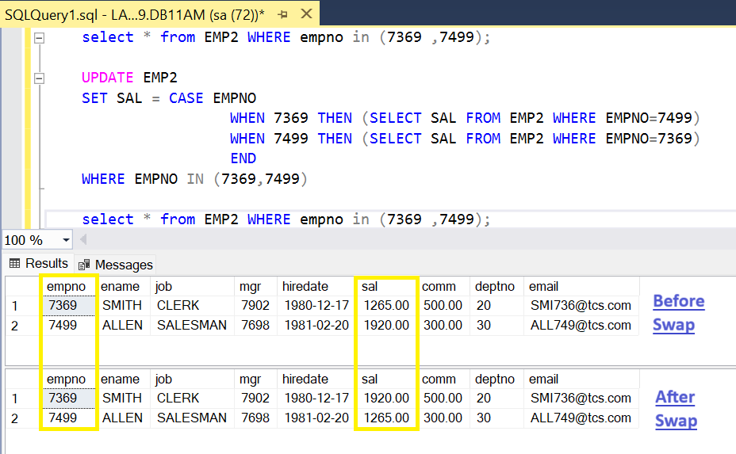

=> Display employee names working at NEW YORK loc?

**JOIN :-**

SELECT E.ENAME

FROM EMP2 AS E INNER JOIN DEPT AS D

ON E.DEPTNO = D.DEPTNO

WHERE D.LOC = 'NEW YORK'

|  |
| --- |
| **ENAME** |
| CLARK |
| KING |
| MILLER |

**SUB-QUERY :-**

SELECT ENAME FROM EMP2

WHERE DEPTNO = ( SELECT DEPTNO FROM DEPT WHERE LOC ='NEW YORK' )

|  |
| --- |
| **ENAME** |
| CLARK |
| KING |
| MILLER |

=> Display ENAME DNAME working at NEW YORK loc?

**JOIN :-**

SELECT E.ENAME,D.DNAME

FROM EMP2 AS E INNER JOIN DEPT AS D

ON E.DEPTNO = D.DEPTNO

WHERE D.LOC = 'NEW YORK'

|  |  |
| --- | --- |
| **ENAME** | **DNAME** |
| CLARK | ACCOUNTS |
| KING | ACCOUNTS |
| MILLER | ACCOUNTS |

**SUB-QUERY :-**

Not Possible

**Difference between join and sub-query ?**

=> To display data from one table and condition based on another table then use sub-query or join

=> To display data from two tables then use join operation

|  |  |
| --- | --- |
| **JOIN** | **Subquery** |
| A JOIN is a means for combining fields from two tables by using values common to each. | A subquery is a query nested inside another query and is used to return data that will be used in the main query as a condition to further restrict the data to be retrieved. |
| JOINs are generally faster than subqueries, especially for large datasets. | Subqueries can be slower than JOINs, especially if the subquery returns a large number of rows. |
| JOINs can be easier to read and understand, especially for simple queries. | Subqueries can be more complex and harder to read, especially when there are multiple levels of nesting. |
| JOINs are used to combine rows from two or more tables based on a related column. | Subqueries can be used in SELECT, WHERE, and FROM clauses, offering more flexibility. |
| JOINs are used when the relationships between the tables are known and fixed. | Subqueries are often used when the result of the query is not known or dynamic. |

**Multi-Row Sub-Queries :-**

------------------------------

=> If inner query returns **more than one value** then it is called multi row sub-query

SELECT columns

FROM tabname

WHERE colname OP (SELECT STATEMENT)

=> OP must be IN,NOT IN,ANY,ALL

|  |  |
| --- | --- |
| **SINGLE** | **MULTI** |
| = | IN |
| <> | NOT IN |
| > | >ANY >ALL |
| < | <ANY <ALL |

=> Employee names working at NEW YORK,CHICAGO locations ?

SELECT ENAME

FROM EMP2

WHERE DEPTNO IN (SELECT DEPTNO

FROM DEPT

WHERE LOC IN ('NEW YORK','CHICAGO'))

|  |
| --- |
| **ENAME** |
| CLARK |
| KING |
| MILLER |

**ANY, ALL operators :-**

------------------------------

=> use **ANY,ALL** for > < comparison with multiple values

=> SQL **ANY** compares a value of the first table with all values of the second table and returns the row if there is a match with any value.

=> SQL **ALL** compares a value of the first table with all values of the second table and returns the row if there is a match with all values.

**Syntax:**

SELECT column FROM table1

WHERE column OPERATOR **ANY/ALL** (SELECT column FROM table2);

|  |  |
| --- | --- |
| WHERE X > ANY(1000,2000,3000)  IF X = 800 FALSE  1500 TRUE  4500 TRUE | WHERE X < ANY (1000,2000,3000)  IF X = 800 TRUE  1500 TRUE  4500 FALSE |
| WHERE X > ALL(1000,2000,3000)  IF X = 800 FALSE  1500 FALSE  4500 TRUE | WHERE X < ALL (1000,2000,3000)  IF X = 800 TRUE  1500 FALSE  4500 FALSE |

=> Employees earning more than all managers?

SELECT EMPNO, ENAME, JOB, MGR, SAL FROM EMP2

WHERE SAL > **ALL**(**SELECT SAL FROM EMP2 WHERE JOB='MANAGER'**)

3421.25,3420.00,2695.00

|  |  |  |  |  |
| --- | --- | --- | --- | --- |
| **EMPNO** | **ENAME** | **JOB** | **MGR** | **SAL** |
| 7788 | SCOTT | ANALYST | 7566 | 3450 |
| 7839 | KING | PRESIDENT | NULL | 5500 |
| 7902 | FORD | ANALYST | 7566 | 3450 |

=> Employees earning more than at least one manager?

SELECT EMPNO, ENAME, JOB, MGR, SAL FROM EMP2

WHERE SAL > **ANY**(**SELECT SAL FROM EMP2 WHERE JOB='MANAGER'**)

3421.25,3420.00,2695.00

|  |  |  |  |  |
| --- | --- | --- | --- | --- |
| **EMPNO** | **ENAME** | **JOB** | **MGR** | **SAL** |
| 7566 | JONES | MANAGER | 7839 | 3421.25 |
| 7698 | BLAKE | MANAGER | 7839 | 3420 |
| 7788 | SCOTT | ANALYST | 7566 | 3450 |
| 7839 | KING | PRESIDENT | NULL | 5500 |
| 7902 | FORD | ANALYST | 7566 | 3450 |

**CO-RELATED SUB-QUERIES :-**

---------------------------------

=> If inner query refers values of outer query then it is called co-related sub-query.

=> Execution starts from outer query and inner query is executed no of times depends on no of rows return by outer query.

=> Use Co-Related Sub-Query to execute sub-query for each row return by outer query.

**Ex :-**

**EMP**

**EMPNO ENAME SAL DEPTNO**

1 A 3000 10

2 B 6000 20

3 C 4000 30

4 D 5000 10

5 E 3000 20

=> employees earning more than avg sal ?

SELECT EMPNO,ENAME, JOB, MGR, SAL FROM EMP2

WHERE SAL > (SELECT **AVG(SAL)** FROM EMP2)

2411.1607

|  |  |  |  |  |
| --- | --- | --- | --- | --- |
| **EMPNO** | **ENAME** | **JOB** | **MGR** | **SAL** |
| 7566 | JONES | MANAGER | 7839 | 3421.25 |
| 7698 | BLAKE | MANAGER | 7839 | 3420 |
| 7782 | CLARK | MANAGER | 7839 | 2695 |
| 7788 | SCOTT | ANALYST | 7566 | 3450 |
| 7839 | KING | PRESIDENT | NULL | 5500 |
| 7902 | FORD | ANALYST | 7566 | 3450 |

=> Employees earning more than avg sal of their dept ?

SELECT EMPNO, ENAME, JOB, MGR, SAL FROM EMP2 AS X

WHERE SAL > (SELECT AVG(SAL) FROM EMP2 WHERE DEPTNO = X.DEPTNO)

|  |  |  |  |  |
| --- | --- | --- | --- | --- |
| **EMPNO** | **ENAME** | **JOB** | **MGR** | **SAL** |
| 7839 | KING | PRESIDENT | NULL | 5500 |
| 7902 | FORD | ANALYST | 7566 | 3450 |
| 7788 | SCOTT | ANALYST | 7566 | 3450 |
| 7566 | JONES | MANAGER | 7839 | 3421.25 |
| 7698 | BLAKE | MANAGER | 7839 | 3420 |
| 7844 | TURNER | SALESMAN | 7698 | 1800 |

1 A 3000 10 3000 > (4000) FALSE

2 B 6000 20 6000 > (4500) TRUE

3 C 4000 30 4000 > (4000) FALSE

4 D 5000 10 5000 > (4000) TRUE

5 E 3000 20 3000 > (4500) FALSE

12-JUL-24

=> Employees earning max Sal in their dept ?

SELECT EMPNO,ENAME, JOB, MGR, SAL FROM EMP2 AS X

WHERE SAL = (SELECT MAX(SAL) FROM EMP2 WHERE DEPTNO = X.DEPTNO)

|  |  |  |  |  |
| --- | --- | --- | --- | --- |
| **EMPNO** | **ENAME** | **JOB** | **MGR** | **SAL** |
| 7698 | BLAKE | MANAGER | 7839 | 3420 |
| 7902 | FORD | ANALYST | 7566 | 3450 |
| 7788 | SCOTT | ANALYST | 7566 | 3450 |
| 7839 | KING | PRESIDENT | NULL | 5500 |

1 A 3000 10 3000 = (5000) FALSE

2 B 6000 20 6000 = (6000) TRUE

3 C 4000 30 4000 = (4000) TRUE

4 D 5000 10 5000 = (5000) TRUE

5 E 3000 20 3000 = (6000) FALSE

=> Display top 3 max salaries?

SAL

5000

1000

3000

2000

4000

SELECT DISTINCT A.SAL FROM EMP2 AS A

WHERE **3 >** (SELECT COUNT(DISTINCT B.SAL) FROM EMP2 AS B WHERE A.SAL < B.SAL)

ORDER BY A.SAL DESC

|  |
| --- |
| **SAL** |
| 5500.00 |
| 3450.00 |
| 3421.30 |

**EMP A EMP B**

SAL SAL

5000 5000 3 > (0) TRUE

4000 4000 3 > (1) TRUE

3000 3000 3 > (2) TRUE

2000 2000 3 > (3) FALSE

4000 4000 3 > (1) TRUE

=> Display **5th** max sal ?

SELECT **DISTINCT** A.SAL FROM EMP2 AS A

WHERE **(5-1)** = (SELECT COUNT(**DISTINCT** B.SAL)

FROM EMP2 AS B WHERE A.SAL < B.SAL) **ORDER BY A.SAL DESC**

|  |
| --- |
| **SAL** |
| 2695.00 |

=> Display **3rd** max sal ?

SELECT **DISTINCT** A.SAL FROM EMP2 AS A

WHERE **(3-1)** = (SELECT COUNT(**DISTINCT** B.SAL)

FROM EMP2 AS B WHERE A.SAL < B.SAL) **ORDER BY A.SAL DESC**

|  |
| --- |
| **SAL** |
| 3421.30 |

=> Display **1st** max sal ?

SELECT **DISTINCT** A.SAL FROM EMP2 AS A

WHERE **(1-1)** = (SELECT COUNT(**DISTINCT** B.SAL)

FROM EMP2 AS B WHERE A.SAL < B.SAL) **ORDER BY A.SAL DESC**

|  |
| --- |
| **SAL** |
| 5500.00 |

SELECT DISTINCT SAL FROM EMP2 ORDER BY SAL DESC

|  |
| --- |
| **SAL** |
| 5500.00 |
| 3450.00 |
| 3421.30 |
| 3420.00 |
| 2695.00 |
| 1920.00 |
| 1800.00 |
| 1500.00 |
| 1430.00 |
| 1265.00 |
| 1140.00 |

=> Select **3rd** highest sal from employee?

SELECT TOP 1 SAL FROM (SELECT DISTINCT TOP **3** SAL FROM EMP2 ORDER BY SAL DESC)A ORDER BY SAL ASC => 3421.30

=> Select **5th** highest sal from employee?

SELECT TOP 1 SAL FROM (SELECT DISTINCT TOP **5** SAL FROM EMP2 ORDER BY SAL DESC)A ORDER BY SAL ASC => 2695.00

=> Select **6th** highest sal from employee?

SELECT TOP 1 SAL FROM (SELECT DISTINCT TOP **6** SAL FROM EMP2 ORDER BY SAL DESC)A ORDER BY SAL ASC => 1920.00

**DERIVED TABLES :-**

----------------------------

=> Sub-Queries in FROM clause are called derived tables

**Syntax :** SELECT columns

FROM (SELECT STATEMENT) AS <ALIAS>

WHERE COND

=> Sub-Query output acts like a table for outer query

=> Derived tables are used in following scenarios

* + To control order of execution
  + To use result of one operation in another operation
  + To join two query outputs

**Controlling Order Of Execution:-**

-----------------------------------------

=> By default, SQL server executes the clauses in the following order

1. FROM
2. WHERE
3. GROUP BY
4. HAVING
5. SELECT
6. ORDER BY

=> Use derived table to control this order of execution

SELECT SELECT

FROM ==============> FROM (SELECT

WHERE FROM

ORDER BY ORDER BY )

WHERE

In above case if we want to change the order of execution from: FROM, WHERE, SELECT ORDER BY to ORDER BY, WHERE.

This is called Derived table i.e. Writing the query into sub-query.

**Example 1 :-**

=> Display ranks of employees based on Sal and highest paid should get 1st rank?

SELECT EMPNO, ENAME, SAL,

DENSE_RANK() OVER (ORDER BY SAL DESC) AS RNK FROM EMP2

|  |  |  |  |
| --- | --- | --- | --- |
| **EMPNO** | **ENAME** | **SAL** | **RNK** |
| 7839 | KING | 5500.00 | 1 |
| 7902 | FORD | 3450.00 | 2 |
| 7788 | SCOTT | 3450.00 | 2 |
| 7566 | JONES | 3421.30 | 3 |
| 7698 | BLAKE | 3420.00 | 4 |
| 7782 | CLARK | 2695.00 | 5 |
| 7369 | SMITH | 1920.00 | 6 |
| 7844 | TURNER | 1800.00 | 7 |
| 7654 | MARTIN | 1500.00 | 8 |
| 7521 | WARD | 1500.00 | 8 |
| 7934 | MILLER | 1430.00 | 9 |
| 7876 | ADAMS | 1265.00 | 10 |
| 7499 | ALLEN | 1265.00 | 10 |
| 7900 | JAMES | 1140.00 | 11 |

=> Above query returns rank of all the employees but to display top 5 employees

SELECT EMPNO, ENAME, SAL,

DENSE_RANK() OVER (ORDER BY SAL DESC) AS RNK

FROM EMP2 WHERE RNK<=5 => ERROR

=> Column alias cannot be used in where clause because where clause is executed before select. To overcome this use INLINE views.

SELECT * FROM (SELECT EMPNO, ENAME, SAL, DENSE_RANK() OVER (ORDER BY SAL DESC) AS RNK FROM EMP2) AS E WHERE RNK <= 5

|  |  |  |  |
| --- | --- | --- | --- |
| **EMPNO** | **ENAME** | **SAL** | **RNK** |
| 7839 | KING | 5500.00 | 1 |
| 7902 | FORD | 3450.00 | 2 |
| 7788 | SCOTT | 3450.00 | 2 |
| 7566 | JONES | 3421.30 | 3 |
| 7698 | BLAKE | 3420.00 | 4 |
| 7782 | CLARK | 2695.00 | 5 |

=> Display top 5 Max salaries?

SELECT DISTINCT SAL FROM(SELECT SAL, DENSE_RANK() OVER (ORDER BY SAL DESC) AS RNK FROM EMP2) AS E WHERE **RNK <= 5** ORDER BY SAL DESC

|  |
| --- |
| **SAL** |
| 5500.00 |
| 3450.00 |
| 3421.30 |
| 3420.00 |
| 2695.00 |

=> 5th max Sal?

SELECT DISTINCT SAL FROM(SELECT SAL, DENSE_RANK() OVER (ORDER BY SAL DESC) AS RNK FROM EMP2) AS E WHERE **RNK = 5** ORDER BY SAL DESC => 2695.00

=> Display first 5 rows from emp table?

SELECT * FROM (SELECT ROW_NUMBER() OVER (ORDER BY EMPNO ASC) AS RNO,

EMPNO, ENAME, SAL FROM EMP2) AS E WHERE **RNO <= 5**

|  |  |  |  |
| --- | --- | --- | --- |
| **RNO** | **EMPNO** | **ENAME** | **SAL** |
| 1 | 7369 | SMITH | 1920.00 |
| 2 | 7499 | ALLEN | 1265.00 |
| 3 | 7521 | WARD | 1500.00 |
| 4 | 7566 | JONES | 3421.30 |
| 5 | 7654 | MARTIN | 1500.00 |

SELECT * FROM (SELECT ROW_NUMBER() OVER (ORDER BY EMPNO ASC) AS RNO,

EMPNO, ENAME, SAL FROM EMP2) AS E WHERE **RNO = 5**

|  |  |  |  |
| --- | --- | --- | --- |
| **RNO** | **EMPNO** | **ENAME** | **SAL** |
| 5 | 7654 | MARTIN | 1500.00 |

SELECT * FROM (SELECT ROW_NUMBER() OVER (ORDER BY EMPNO ASC) AS RNO,

EMPNO, ENAME, SAL FROM EMP2) AS E WHERE **RNO IN (5,10,14)**

|  |  |  |  |
| --- | --- | --- | --- |
| **RNO** | **EMPNO** | **ENAME** | **SAL** |
| 5 | 7654 | MARTIN | 1500.00 |
| 10 | 7844 | TURNER | 1800.00 |
| 14 | 7934 | MILLER | 1430.00 |

SELECT * FROM (SELECT ROW_NUMBER() OVER (ORDER BY EMPNO ASC) AS RNO,

EMPNO, ENAME, SAL FROM EMP2) AS E WHERE **RNO BETWEEN 5 AND 10**

|  |  |  |  |
| --- | --- | --- | --- |
| **RNO** | **EMPNO** | **ENAME** | **SAL** |
| 5 | 7654 | MARTIN | 1500.00 |
| 6 | 7698 | BLAKE | 3420.00 |
| 7 | 7782 | CLARK | 2695.00 |
| 8 | 7788 | SCOTT | 3450.00 |
| 9 | 7839 | KING | 5500.00 |
| 10 | 7844 | TURNER | 1800.00 |

SELECT * FROM (SELECT ROW_NUMBER() OVER (ORDER BY EMPNO ASC) AS RNO,

EMPNO, ENAME, SAL FROM EMP2) AS E WHERE **RNO%2 = 0**

|  |  |  |  |
| --- | --- | --- | --- |
| **RNO** | **EMPNO** | **ENAME** | **SAL** |
| 2 | 7499 | ALLEN | 1265.00 |
| 4 | 7566 | JONES | 3421.30 |
| 6 | 7698 | BLAKE | 3420.00 |
| 8 | 7788 | SCOTT | 3450.00 |
| 10 | 7844 | TURNER | 1800.00 |
| 12 | 7900 | JAMES | 1140.00 |
| 14 | 7934 | MILLER | 1430.00 |

=> Display last 3 rows?

SELECT * FROM ( SELECT ROW_NUMBER() OVER (ORDER BY EMPNO ASC) AS RNO,

EMPNO,ENAME,SAL FROM EMP2) AS E WHERE RNO >= (SELECT COUNT(*)-2 FROM EMP2)

|  |  |  |  |
| --- | --- | --- | --- |
| **RNO** | **EMPNO** | **ENAME** | **SAL** |
| 12 | 7900 | JAMES | 1140.00 |
| 13 | 7902 | FORD | 3450.00 |
| 14 | 7934 | MILLER | 1430.00 |

13-JUL-24

=> Delete first 3 rows from emp ?

DELETE FROM (SELECT ROW_NUMBER() OVER (ORDER BY EMPNO ASC) AS RNO, EMPNO,ENAME,SAL FROM EMP ) AS E WHERE RNO <= 3 **=> ERROR**

**NOTE :-**

=> In **derived tables outer query cannot be DML statement** and **it must be always SELECT.** To overcome this problem, use CTEs.

**CTE :- (Common Table Expression)**

---------------------------------------------

=> Using CTE we can give name to the query output and we can use that name in another query like INSERT / UPDATE / DELETE.

=> with CTE whatever action performed on CTE name, gets reflected into actual table.

=> In CTEs outer query can be INSERT / UPDATE / DELETE / SELECT.

=> CTEs are used to simplify complex queries.

=> **A CTE (Common Table Expression) is a one-time result set that only exists for the duration of the query**. It allows us to refer to data within a single SELECT, INSERT, UPDATE, DELETE, CREATE VIEW, or MERGE statement's execution scope. It is temporary because its result cannot be stored anywhere and will be lost as soon as a query's execution is completed. It first came with SQL Server 2005 version. A DBA always preferred CTE to use as an alternative to a Subquery/View.

**Syntax:**

**WITH** <cte-name1>

**AS**

(SELECT STATEMENT) ,

<cte-name2>

**AS**

(SELECT STATEMENT)………………………………

**SELECT / INSERT / UPDATE / DELETE**

**Ex 1**:- Delete first 3 rows from emp?

WITH **E**

AS

(SELECT ROW_NUMBER() OVER (ORDER BY EMPNO ASC) AS RNO, EMPNO,ENAME,SAL

FROM EMP2) DELETE * FROM **E WHERE RNO <= 3**

**Below rows will be deleted:**

|  |  |  |  |
| --- | --- | --- | --- |
| **RNO** | **EMPNO** | **ENAME** | **SAL** |
| 1 | 7369 | SMITH | 1920.00 |
| 2 | 7499 | ALLEN | 1265.00 |
| 3 | 7521 | WARD | 1500.00 |

**Ex 2:-** Delete duplicate rows ?

**EMP33**

ENO ENAME SAL

1 A 5000

2 B 6000

3 C 7000

1 A 5000 => duplicate

2 B 6000 => duplicate

STEP 1:- Generate row numbers within the group of eno, ename, sal

SELECT ENO, ENAME, SAL, ROW_NUMBER() OVER (PARTITION BY ENO,ENAME,SAL ORDER BY ENO ASC) AS RNO

FROM EMP33

1 A 5000.00 1

1 A 5000.00 2

2 B 6000.00 1

2 B 6000.00 2

3 C 7000.00 1

STEP 2:- Delete the records with rno > 1

WITH **E**

AS

**(**SELECT ENO, ENAME, SAL, ROW_NUMBER() OVER (PARTITION BY ENO, ENAME, SAL

ORDER BY ENO ASC) AS RNO FROM EMP33**)**

DELETE FROM **E WHERE RNO > 1**

=>

**T1 T2**

F1 C1

1 A

2 B

3 C

**OUTPUT: -**

1 A

2 B

3 C

=>

**T1**

AMT

1000

-200

3000

-800

2000

-500

**OUTPUT :-**

**POS NEG**

1000 -200

3000 -800

2000 -500

**SCALAR SUB-QUERIES :-**

----------------------------

=> sub-queries in select clause are called scalar sub-queries

**Syntax:** SELECT (subquery1) , (subquery2) , ----------

FROM tabname WHERE cond

=> sub-query output acts like a column for outer query

=> use scalar sub-query to show the query output in seperate column

**Ex 1 :-**

SELECT (SELECT COUNT(*) FROM EMP) AS EMP, (SELECT COUNT(*) FROM DEPT) AS DEPT

**EMP DEPT**

11 4

**Ex 2 :-**

=> Display dept wise total sal?

SELECT DEPTNO, SUM(SAL) AS DEPT_TOTSAL

FROM EMP

GROUP BY DEPTNO

10 8750.00

20 10075.00

30 6550.00

=> Display DEPTNO, DEPT_TOTSAL, TOTSAL?

SELECT DEPTNO, SUM(SAL) AS DEPT_TOTSAL, (SELECT SUM(SAL) FROM EMP) AS TOTSAL

FROM EMP GROUP BY DEPTNO

10 8750.00 25375.00

20 10075.00 25375.00

30 6550.00 25375.00

=> Display DEPTNO, DEPT_TOTSAL, TOTSAL, PCT?

PCT = (DEPT_TOTSAL/TOTSAL)*100

SELECT DEPTNO, SUM(SAL) AS DEPT_TOTSAL,

(SELECT SUM(SAL) FROM EMP) AS TOTSAL ,

(SUM(SAL) / (SELECT SUM(SAL) FROM EMP))*100 AS PCT

FROM EMP GROUP BY DEPTNO

10 8750.00 25375.00 34.48

20 10075.00 25375.00 39.70

30 6550.00 25375.00 25.81

select stmt

where

order by

distinct

top

functions

group by

joins

set operators

sub-queries

integrity constraints

15-jul-24

**DATABASE TRANSACTIONS: -**

--------------------------------------------

=> A transaction is a unit of work that contains one or more DML’s (insert, update, delete) and must be saved as a whole or must be cancelled as a whole.

**Ex** :- Money Transfer

Acct1---------------------1000---------------------Acct2

**Update1 Update2**

(bal = bal - 1000) (bal = bal + 1000)

Successful Failed INVALID

Failed Successful INVALID

Successful Successful VALID

Failed Failed VALID

=> Every DB transaction must guarantee a property called atomicity i.e. all or none, if transaction contains multiple DML’s , if all DML’s are successful then it must be saved and if one of the DML fails **then entire transaction must be cancelled.**

=> The following commands provided by SQL server to handle transactions called TCL commands.

1. COMMIT => to save transaction
2. ROLLBACK => to cancel transaction
3. SAVE TRANSACTION => to cancel part of the transaction

=> Every transaction has a begin point and an end point

=> In SQL server a transaction begins implicitly with DML command and ends implicitly with commit.

=> A user can also start transaction by using "**BEGIN TRANSACTION**" command and ends transaction with **COMMIT / ROLLBACK**.

**Ex 1:-**

CREATE TABLE a(a INT) => txn ends with commit

INSERT INTO a VALUES(10) => txn ends with commit

INSERT INTO a VALUES(20) => txn ends with commit

INSERT INTO a VALUES(30) => txn ends with commit

INSERT INTO a VALUES(40) => txn ends with commit

**ROLLBACK => error** => trying to end without starting

**Output** :- All operations are implicitly committed.

**Ex 2 :-**

CREATE TABLE a(a INT) => implicitly committed

**BEGIN TRANSACTION => txn begins T1**

INSERT INTO a VALUES(10)

INSERT INTO a VALUES(20)

INSERT INTO a VALUES(30)

INSERT INTO a VALUES(40)

**ROLLBACK => txn ends**

=> if transaction ends with **Rollback** then it is called **Aborted** transaction and operations are cancelled.

**Ex 3 :-**

CREATE TABLE a(a INT) => implicitly committed

**BEGIN TRANSACTION** => **txn begins T1**

INSERT INTO a VALUES(10)

INSERT INTO a VALUES(20)

**COMMIT** => **txn ends**

INSERT INTO a VALUES(30) => implicitly committed

INSERT INTO a VALUES(40) => implicitly committed

**ROLLBACK**  => **ERROR**

=> If transaction ends with **Commit** then it is called **Successful Transaction** and operations are saved.

**SAVE TRANSACTION :-**

-----------------------------------

=> We can declare **Save Transaction** and we can **cancel upto the Save Transaction.**

=> Using **Save Transaction** we **can cancel part of the transaction.**

ex :-

CREATE TABLE a(a INT)

**BEGIN TRANSACTION**

INSERT INTO a VALUES(10)

INSERT INTO a VALUES(20)

**SAVE TRANSACTION ST1**

INSERT INTO a VALUES(30)

INSERT INTO a VALUES(40)

**SAVE TRANSACTION ST2**

INSERT INTO a VALUES(50)

INSERT INTO a VALUES(60)

**ROLLBACK TRANSACTION ST2**

SELECT * FROM a

10

20

30

40

16-jul-24

**DATABASE SECURITY :-**

-------------------------------

1. LOGINS => provides security at server level
2. USERS => provides security at DB level
3. PRIVILEGES => provides security at table level
4. VIEWS => provides security at row & col level

SERVER (LOGINS)

DATABASE (USERS)

TABLE (PRIVILEGES)

ROWS & COLS (VIEWS)

**LOGIN :** (Login is to connect to the database)

SA (System Admin)

NARESH

**DB11AM** (User like DBO(default), VIJAY) is to access the Database)

DBO (SA) (Database Owner)

EMP

DEPT

STUDENT

CUST

VIJAY (NARESH)

In above all the tables are initially created under the DBO(before VIJAY User created).

**CREATING LOGINS IN SQL SERVER :-**

------------------------------------------------------

=> In object explorer select logins => new login

Enter login name :- NARESH

select SQL server authentication

Enter password :- 123

=> click OK

*Login is to connect to the database.

**CREATEING USER IN DB :-**

-----------------------------------------

=> Expand the DB in which you want to create user.

DB4PM

SECURITY

USER => NEW USER

=> Enter Username :- VIJAY

Enter Login :- NARESH

=> click OK

* User is to access the database.

* To access the database a user must associate with the username.

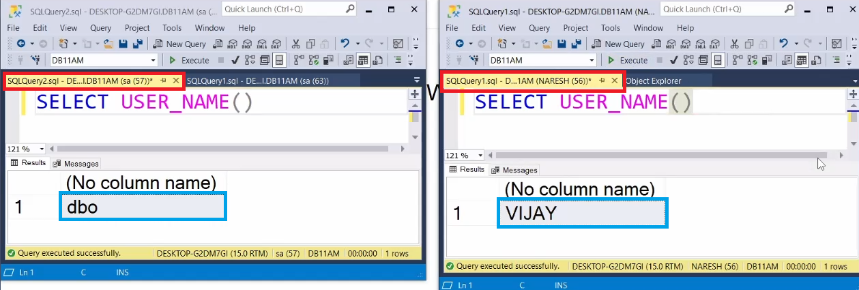

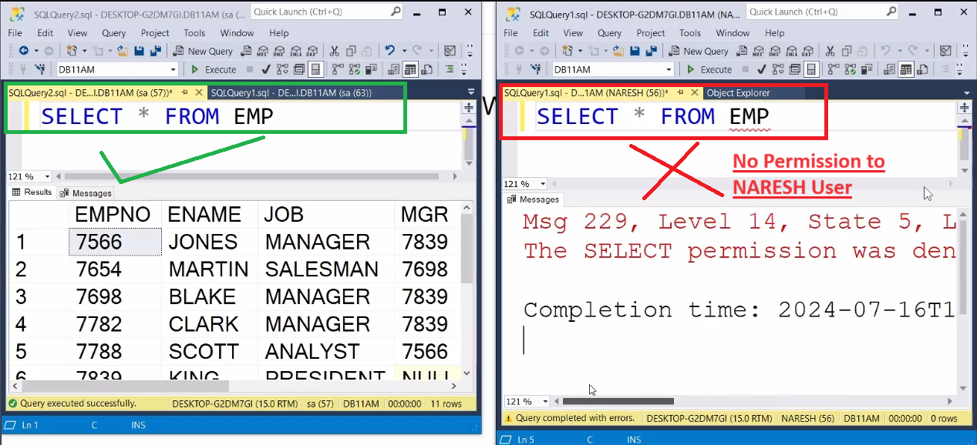

**Note** **:-** Tables created by DBO cannot be accessed by VIJAY , if VIJAY wants to access tables created by DBO then VIJAY needs permissions.

**PRIVILEGES :-**

--------------------

=> Privileges means permissions

=> Permissions are granted by owner using GRANT command

**Syntax :-** GRANT <privileges> ON <tabname> TO <usernames>

**Ex :-**

DBO :-

----------

GRANT SELECT, INSERT, UPDATE, DELETE ON EMP TO VIJAY

VIJAY :-

-----------

1 SELECT * FROM EMP

2 UPDATE EMP SET SAL =2000 WHERE EMPNO = 7369

3 DELETE FROM EMP WHERE EMPNO = 7844

**NOTE :-** Changes made by VIJAY are visible to DBO

**REVOKE Command :-**

------------------------------

=> Command used to take back permissions from user

**Syntax :-** REVOKE <privileges> ON <TABNAME> FROM <USERNAME>

**Ex :-**

DBO :-

----------

REVOKE SELECT, INSERT, UPDATE, DELETE ON EMP FROM VIJAY

**DB Objects:-**

==========

**SQL :-**

=======

1 TABLES

2 VIEWS

3 SYNONYMS

4 SEQUENCES

5 INDEXES

**T-SQL :-**

=======

6 STORED PROCEDURES

7 FUNCTIONS

8 TRIGGERS

**VIEWS :-**

-----------

=> A view is a subset of a table i.e. part of the table.

=> A view is a logical table based on one or more actual tables.

=> A view is a virtual table because it **doesn't** **store data and doesn't occupy memory** and it always derives data from base table.

=> A view is a representation of a query.

=> Views are created

1 To provide security

2 To reduce complexity

=> views are 2 types

1 Simple Views

2 Complex Views

**SIMPLE VIEWS :-**

----------------------

=> If view created **on single table** then it is called simple view

**Syntax:**  CREATE VIEW <NAME>

AS

SELECT STATEMENT

**Ex :-**

CREATE VIEW V1

AS

SELECT EMPNO, ENAME, JOB, HIREDATE, DEPTNO FROM EMP

=> SQL server creates **view** "v1" and stores query but not query output.

SELECT * FROM **V1**

|  |  |  |  |  |
| --- | --- | --- | --- | --- |
| **EMPNO** | **ENAME** | **JOB** | **HIREDATE** | **DEPTNO** |
| 7369 | SMITH | CLERK | 17-12-1980 | 20 |
| 7499 | ALLEN | SALESMAN | 20-02-1981 | 30 |
| 7521 | WARD | SALESMAN | 22-02-1981 | 30 |
| 7566 | JONES | MANAGER | 02-04-1981 | 20 |
| 7654 | MARTIN | SALESMAN | 28-09-1981 | 30 |
| 7698 | BLAKE | MANAGER | 01-05-1981 | 30 |
| 7782 | CLARK | MANAGER | 09-06-1981 | 10 |
| 7788 | SCOTT | ANALYST | 09-12-1982 | 20 |
| 7839 | KING | PRESIDENT | 17-11-1981 | 10 |
| 7844 | TURNER | SALESMAN | 08-09-1981 | 30 |
| 7876 | ADAMS | CLERK | 12-01-1983 | 20 |
| 7900 | JAMES | CLERK | 03-12-1981 | 30 |
| 7902 | FORD | ANALYST | 03-12-1981 | 20 |
| 7934 | MILLER | CLERK | 23-01-1982 | 10 |

=> When above query submitted to SQL server , it executes the query as follows

SELECT * FROM (SELECT EMPNO,ENAME,JOB,HIREDATE,DEPTNO FROM EMP)

**PROVIDING SECURITY :-**

------------------------

=> With the help of VIEWS we can Grant specific rows & cols to users.

**DBO :-**

----------

**GRANT SELECT, INSERT, UPDATE, DELETE ON V1 TO VIJAY**

VIJAY :-

------------

1 SELECT * FROM V1

2 UPDATE V1 SET JOB='CLERK' WHERE EMPNO = 7566

3 UPDATE V1 SET SAL=4000 WHERE EMPNO = 7566 => ERROR

4 INSERT INTO V1 VALUES(999,'ABC','CLERK',GETDATE(),10)

**ROW LELVEL SECURITY: -**

-------------------------------------

CREATE VIEW V2

AS

SELECT EMPNO,ENAME,JOB,DEPTNO

FROM EMP

WHERE DEPTNO = 20

**DBO :-**

-----------

GRANT SELECT, INSERT, UPDATE, DELETE ON V2 TO VIJAY

**VIJAY :-**

------------

INSERT INTO V2 VALUES(888,'KLM','MANAGER',30)

above insert command executed successfully even though it is violating

where condition.

**WITH CHECK OPTION :-**

----------------------------------

=> If view created with **" WITH CHECK OPTION "** then any DML command through view violates where condition that DML is not accepted.

CREATE VIEW V3

AS

SELECT EMPNO, ENAME, JOB, DEPTNO

FROM EMP

**WHERE DEPTNO = 20**

**WITH CHECK OPTION**

**DBO :-**

----------

GRANT SELECT, INSERT, UPDATE, DELETE ON V3 TO VIJAY

**VIJAY :-**

---------

INSERT INTO V3 VALUES(777,'PQR','CLERK',30) => **ERROR**

17-jul-24

**COMPLEX VIEWS :-**

------------------------

=> A view said to be complex

1 If it is **based on multiple tables**

2 It query contains **GROUP BY CLAUSE**

**DISTINCT CLAUSE**

**AGGREGATE FUNCTIONS**

**SET OPERATORS**

**SUB-QUERIES**

=> With the help of views, complex queries can be converted into simple queries

**Ex 1 :-**

CREATE VIEW CV1

AS

SELECT E.EMPNO,E.ENAME,E.SAL,

D.DEPTNO,D.DNAME,D.LOC

FROM EMP AS E INNER JOIN DEPT AS D

ON E.DEPTNO = D.DEPTNO

=> After creating view, whenever we want employee details with dept details then instead of writing join query write the simple query.

SELECT * FROM CV1

**Ex 2 :-**

CREATE VIEW CV2

AS

SELECT D.DNAME,MAX(E.SAL) AS MAXSAL,

MIN(E.SAL) AS MINSAL,

SUM(E.SAL) AS TOTSAL,

COUNT(*) AS CNT

FROM EMP AS E **INNER JOIN** DEPT AS D

ON E.DEPTNO = D.DEPTNO

GROUP BY D.DNAME

=> After creating view, whenever we want dept wise summary then execute the following query

SELECT * FROM CV2

=> Difference between simple and complex views ?

|  |  |  |
| --- | --- | --- |
|  | **SIMPLE** | **COMPLEX** |
| 1 | Based on single table | Based on multiple tables |
| 2 | Query performs simple Operations | Query performs complex operations like joins, group by, aggregate etc |
| 3 | Always updatable i.e. allows DML’s | Not updatable i.e. doesn't allow DML’s |

=> List of tables & views ?

**SELECT * FROM INFORMATION_SCHEMA.TABLES**

=> List of views ?

**SELECT * FROM INFORMATION_SCHEMA.VIEWS**

=> Display only tables list?

SELECT TABLE_NAME,TABLE_TYPE

FROM INFORMATION_SCHEMA.TABLES

WHERE TABLE_TYPE='BASE TABLE'

**Dropping :-**

------------

**DROP VIEW V1**

=> If we drop table what about views created on table ?

**Ans :-** Views are not dropped but view cannot be queried

SQL> DROP TABLE products;

What is the implication of this command? (Choose all that apply.)

A. All data along with the table structure is deleted. T

B. The pending transaction in the session is committed. T

C. All indexes on the table will remain but they are invalidated. T

D. All views and synonyms will remain but they are invalidated. T

E. All data in the table are deleted but the table structure will remain. F

**SYNONYMS :-**

----------------

=> A **SYNONYM** is another name or alternative name for table or view.

=> If table name is lengthy then we can give a simple and short name to the table called synonym, instead of using table name we can use synonym name in select / insert / update / delete queries.

**Syntax :-** CREATE SYNONYM <NAME> FOR <TABNAME>

**Ex :-** CREATE SYNONYM E FOR EMP

=> After creating synonym instead of using table name use synonym name in select/insert/update/delete queries.

1 SELECT * FROM E

2 UPDATE E SET COMM = 500 WHERE EMPNO = 7369

=> What is difference between below commands

1 CREATE SYNONYM E FOR EMP => ‘E’ is a Synonym

2 SELECT * FROM EMP AS E => ‘E’ is a alias for EMP

3 SP_RENAME 'EMP','E' => ‘EMP’ gets renamed to ‘E’

=> Difference between synonym and alias?

|  |  |  |
| --- | --- | --- |
|  | **SYNONYM** | **ALIAS** |
| 1 | Permanent | Not Permanent |
| 2 | Stored in DB | Not stored in DB |
| 3 | Scope of the synonym scope is up to the schema. | Scope of the alias is up to the query. |

=> list of Synonyms?

**SELECT NAME,BASE_OBJECT_NAME FROM SYS.SYNONYMS**

**Dropping :-**

---------------

DROP SYNONYM E

=> If we drop table what about synonyms created on table?

Ans :-

* Synonyms are not dropped but cannot be queried.
* To answer anything about dropping use remember below structure i.e. if Table dropped then Rows and columns, Constraints, Indexes and triggers also get dropped.
* Wisely if User is dropped then Table, Views and Synonym also gets dropped.

SERVER

DATABASE

USER

TABLE

ROWS & COLS

CONSTRAINTS

INDEXES

TRIGGERS

VIEWS

SYNONYM

18-jul-24

**SEQUENCES :-**

----------------------

=> **Sequence** is also a DB object created to generate sequence numbers.

=> Used to auto increment column values.

|  |  |
| --- | --- |
| CREATE SEQUENCE <NAME> | Mandatory Sequence name. |
| [START WITH <value>] | Starting Value when sequence first time used. |
| [INCREMENT BY <value>] | Increment by value after each use. |
| [MAXVALUE <value>] | Maximum value upto sequence can have. |
| [MINVALUE <value>] | Minimum value sequence can have. |
| [CYCLE] | Sequence values are repeating or not. |

**Ex 1 :-**

CREATE SEQUENCE S1

START WITH 1

INCREMENT BY 1

MAXVALUE 5

CREATE TABLE STUDENT(SID INT,SNAME VARCHAR(10))

INSERT INTO STUDENT VALUES(**NEXT VALUE FOR S1** , 'A')

INSERT INTO STUDENT VALUES(**NEXT VALUE FOR S1** , 'B')

INSERT INTO STUDENT VALUES(**NEXT VALUE FOR S1** , 'C')

INSERT INTO STUDENT VALUES(**NEXT VALUE FOR S1** , 'D')

INSERT INTO STUDENT VALUES(**NEXT VALUE FOR S1** , 'E')

INSERT INTO STUDENT VALUES(**NEXT VALUE FOR S1** , 'F') => **ERROR**

SELECT * FROM STUDENT

**SID SNAME**

1 A

2 B

3 C

4 D

5 E

**Ex 2 :-**

CREATE SEQUENCE S2

START WITH 100

INCREMENT BY 1

MAXVALUE 999

=> Use above sequence to update empno?

UPDATE EMP SET EMPNO = **NEXT VALUE FOR S2**

**Ex 3 :-**

How to generate/use bill no with combination of Characters, date part and sequence value?

**BILL**

BILLNO BDATE AMT

DMART/0724/1

DMART/0724/2

CREATE SEQUENCE **S3**

START WITH 1

INCREMENT BY 1

MAXVALUE 9999

CREATE TABLE BILL(BILLNO VARCHAR(20) , BDATE DATETIME,AMT MONEY)

INSERT INTO BILL VALUES

(**'DMART/'+ FORMAT(GETDATE(),'MMyy')+'/'+CAST(NEXT VALUE FOR S3 AS VARCHAR)**, GETDATE(),3000)

SELECT * FROM BILL

DMART/0724/1 2024-07-18 11:57:46.663 1000.00

DMART/0724/2 2024-07-18 11:57:56.427 2000.00

DMART/0724/3 2024-07-18 11:58:01.050 3000.00

**How To Restart Sequence? :-**

------------------------------------

1 MANUALLY

2 CYCLE OPTION

**MANUALLY :-**

---------------

**ALTER SEQUENCE S1 RESTART WITH 1**

**USING CYCLE OPTION :-**

----------------------------

=> By **default** sequence created with **NOCYCLE**.

=> If created with **NOCYCLE** then it starts from start with and generates up to max and after reaching max then it stops.

=> If created with **CYCLE** then it starts from start with and generates up to max and after reaching max then it will reset to min.

**Ex :-**

CREATE SEQUENCE S4

START WITH 1

INCREMENT BY 1

MAXVALUE 5

MINVALUE 1

CYCLE

=> List of sequences?

SELECT * FROM **INFORMATION_SCHEMA.SEQUENCES**

**Dropping sequences :-**

------------------------------

DROP SEQUENCE S1

**IDENTITY :-**

----------------

=> **IDENTITY** is also used to generate sequence numbers

**Syntax:**

IDENTITY(SEED,INCR)

**SEED** => Start Default 1

**INCR** => Increment Default 1

**Ex :-**

CREATE TABLE CUST

(

**CID INT IDENTITY(100,1),**

CNAME VARCHAR(10)

)

**INSERT INTO CUST(CNAME) VALUES('A')**

**INSERT INTO CUST(CNAME) VALUES('B')**

**INSERT INTO CUST(CNAME) VALUES('C')**

SELECT * FROM CUST

CID CNAME

100 A

101 B

102 C

=> Difference between Identity and Sequence?

|  |  |  |
| --- | --- | --- |
|  | **IDENTITY** | **SEQUENCE** |
| 1 | Identity tied to a particular column in particular table. | Not tied to a particular column. |
| 2 | Not declared with maximum | Created with maximum. |
| 3 | Generates value whenever a new row is inserted | Generate value by calling next value for sequence. |
| 4 | Can be reset by using DBCC command | Can be reset by using cycle option or alter command |

**How To Reset Identity :- Database Consistency Checker (DBCC)**

-----------------------------

**Syntax :-** DBCC CHECKIDENT(Tablanem, Reseed, Value)

**Ex :-**

DBCC CHECKIDENT('CUST', RESEED, 99)

19-jul-24

**INDEXES :-**

-------------

=> **Index** is also a DB object created to improve performance of data accessing.

=> **Index** in DB is similar to index in textbook, in textbook using index a particular topic can be located quickly but In DB using **index** a particular record can be located quickly.

=> **Indexes** created on columns and that column is **called index key**.

=> **Indexes** created on columns that are

1 Frequently used in **Where Clause**

2 Frequently used in **Join Operation**

**Types of Indexes :-**

--------------------------

1. Non-Clustered Index
2. Simple Index
3. Composite Index
4. Unique Index
5. Clustered Index

**Simple Non-Clustered Index :-**

---------------------------------------

=> If index created on **single column**, then it is called **simple index**

**Syntax:**

CREATE INDEX <NAME> ON <TABNAME>(COLNAME)

**Ex :-** Below structure is called Balanced Binary Tree (B-Tree). Leaf nodes are interlinked with each other. In below examples without indexes to find the records matching SAL =3000, we need 8 comparisons, and with the indexes we need 4 comparisons i.e. no. of comparisons using indexes are always half or less than half.

**CREATE INDEX I1 ON EMP (SAL)**

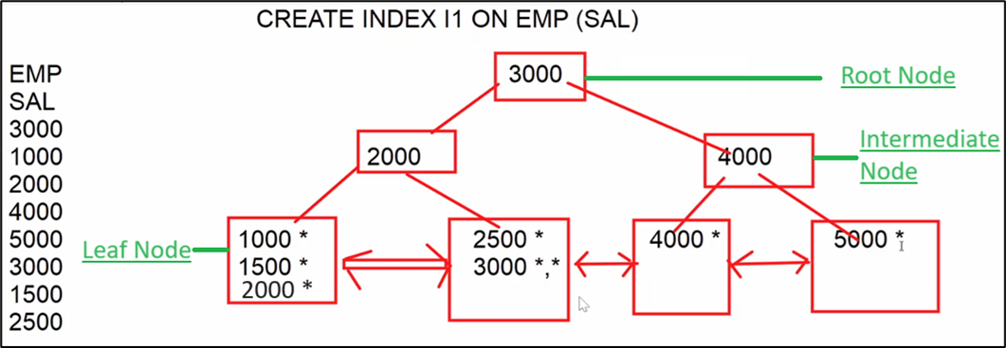

Depending on condition it is decided what is to be used to generate the result.

SELECT * FROM EMP WHERE SAL = 3000 (**INDEX**) :select specific record only

SELECT * FROM EMP WHERE SAL >= 3000 (**INDEX**) :Select all records left side of 3000

SELECT * FROM EMP WHERE SAL <= 3000 (**INDEX**) :Select all records right side of 3000

SELECT * FROM EMP WHERE ENAME='blake' (**TABLE**)

SELECT * FROM EMP (**TABLE**)

**Note** **\*** indicates Address of the record whose Sal (Ex:1500) and stored in index, use of **\*\*** then two records with same salary and two indexes will be stored in index.

**COMPOSITE INDEX:-**

-----------------------------

=> If index created on multiple columns, then it is called composite index.

**Syntax:**

CREATE INDEX I2 ON EMP (DEPTNO, JOB)

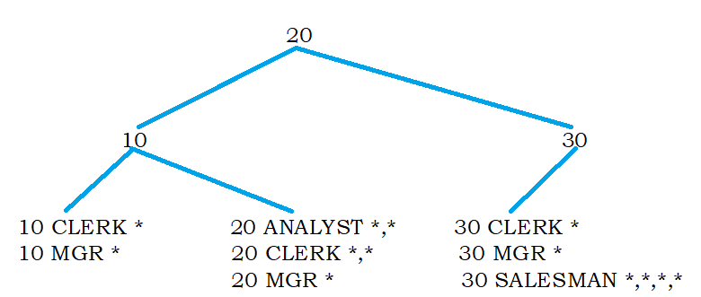

=> SQL SERVER uses above index when where condition is based on leading column of the index i.e. deptno.

1. SELECT * FROM EMP WHERE DEPTNO = 20 (**INDEX**)
2. SELECT * FROM EMP WHERE DEPTNO = 20 AND JOB = 'CLERK' (**INDEX**)
3. SELECT * FROM EMP WHERE JOB='CLERK' (**TABLE**) (Non leading column condition)

If user is saying 1st query is running slow then create Simple Index on DEPTNO, and if user is saying both queries are running slow then create Composite Index on

**UNIQUE INDEX :-**

------------------------

=> Unique index **doesn't allow duplicate values into the column on which index is created.**

**Syntax: -** CREATE UNIQUE INDEX I3 ON EMP(ENAME)

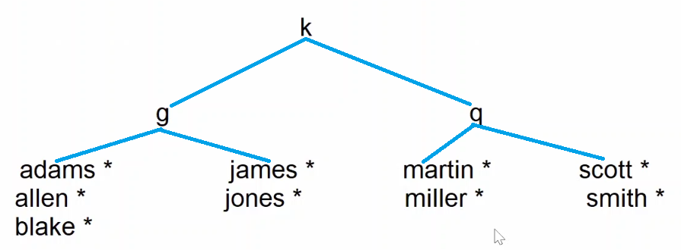

1. SELECT * FROM EMP WHERE ENAME='blake' (**INDEX**)
2. INSERT INTO EMP(EMPNO,ENAME,SAL) VALUES(100,'blake',4000)

=>ERROR Duplicating

If there are duplicates in column then remove the duplicate and then create Unique Index.

**=> What are the different methods to enforce uniqueness?**

1 Primary key / Unique constraint

2 Unique index

=> **Primary key / Unique columns are automatically indexed** by SQL server and SQL **server creates a unique index on primary key / unique columns** and unique index doesn't allow duplicates, so primary key / unique also doesn't allow duplicates.

20-jul-24

**CLUSTERED INDEX :-**

-----------------------------

=> A NON-CLUSTERED index stores pointers to actual records, whereas **CLUSTERED INDEX STORES ACTUAL RECORDS.**

=> Only one clustered index allowed per table

=> SQL server implicitly creates a clustered index on primary key column

**Ex :-**

CREATE TABLE CUST(CID INT,CNAME VARCHAR(10))

CREATE **CLUSTERED** **INDEX I5 ON CUST(CID)**

INSERT INTO CUST VALUES(10,'A')

INSERT INTO CUST VALUES(80,'B')

INSERT INTO CUST VALUES(40,'C')

INSERT INTO CUST VALUES(60,'D')

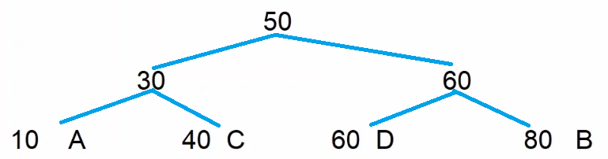

1. SELECT * FROM CUST WHERE CID = 60
2. SELECT * FROM CUST => SQL server goes to index and access all leaf nodes from left to right.

10 A

40 C

60 D

80 B

**CLUSTERED VS NON CLUSTERED Indexes :-**

----------------------------------------------------------------

|  |  |  |
| --- | --- | --- |
|  | **NON-CLUSTERED** | **CLUSTERED** |
| 1 | Stores pointers to actual records. | Stores actual records. |
| 2 | Order of the records in table and order of the records in index are not same. | Order of the records in table and index are same. |
| 3 | Index and table are two separate objects. | Index and table are one object. |
| 4 | Requires extra storage. | Doesn't need extra storage. |
| 5 | Requires two lookups to get specific row. | Requires single lookup. |
| 6 | SQL server allows 999 non clustered indexes per table. | Only one clustered index allowed per table. |
| 7 | By default, non-clustered index created on unique column. | By default, a clustered index created on primary key column. |

=> How to check list of Indexes created on table?

**SP_HELPINDEX CUST**

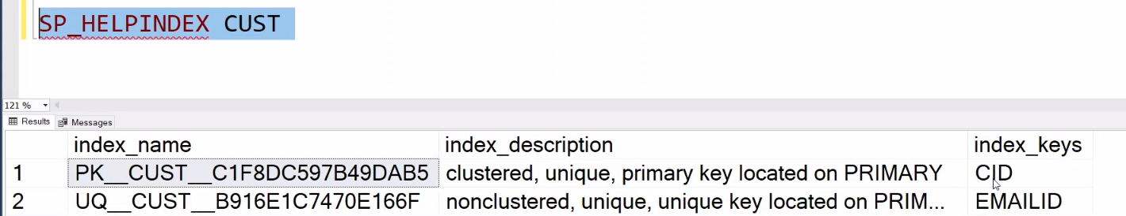

============================================================================

CREATING NEW TABLE FROM EXISTING TABLE (replica) :-

-----------------------------------------------------------------------------------

SELECT columns / * INTO <new-tabname>

FROM <old-tabname>

[WHERE condition]

ex 1 :- (copying all rows and all cols)

SELECT * INTO EMP10

FROM EMP

=> a new table is created with rows & cols return by query

ex 2 :- copying specific rows & cols

SELECT EMPNO,ENAME,JOB,SAL INTO EMP11

FROM EMP

WHERE JOB IN ('CLERK','MANAGER')

ex 3 :- copy only structure (cols) but not data (rows)

SELECT * INTO EMP12

FROM EMP

WHERE 1=2

ex 4 :- copy table from one db to another db

copy emp table from DB11AM to HR db ?

SELECT * INTO HR.DBO.EMP

FROM DB11AM.DBO.EMP

copying data from one table to another table :-

---------------------------------------------------------------

INSERT INTO <TARGET-TABLE>

SELECT COLUMNS / * FROM <SOURCE-TABLE>

Ex :-

=> copy data from emp to emp12 ?

INSERT INTO EMP12

SELECT * FROM EMP

MERGE command :-

------------------------------

=> command used to merge data into a table.

=> merge is the combination of insert , update & delete.

=> merge is used to manage replicas.

=> using merge command we can apply changes made to one table to another table.

syntax :-

MERGE INTO <TARGET-TABLE> AS <ALIAS>

USING <SOURCE-TABLE> AS <ALIAS>

ON (CONDITION)

WHEN MATCHED THEN

UPDATE

WHEN NOT MATCHED THEN

INSERT

WHEN NOT MATCHED BY SOURCE THEN

DELETE ;

22-jul-24

Example :-

step 1 :- create source table

create table custs

(

cid int ,

cname varchar(10),

city char(3)

)

insert into custs values(10,'A','HYD') , (11,'B','MUM')

step 2 :- create target table

select * into custt from custs

step 3 :- modify source table

insert into custs values(12,'C','DEL')

update custs set city = 'BLR' where cid = 10

step 4 :- apply changes made to custs to custt ?

MERGE INTO CUSTT AS T

USING CUSTS AS S

ON (S.CID = T.CID)

WHEN MATCHED THEN

UPDATE SET T.CITY = S.CITY

WHEN NOT MATCHED THEN

INSERT VALUES(S.CID,S.CNAME,S.CITY)

WHEN NOT MATCHED BY SOURCE THEN

DELETE ;

ex 2 :-

EMPS EMPT

EMPID ENAME SAL EMPID ENAME SAL

100 A 5000 100 A

101 B 6000 101 B

102 C 7000 102 C

=> copy salaries from EMPS to EMPT ?

1 update command

2 merge command

===================================================================

PIVOT operator / CROSS-TAB Query :-

-------------------------------------------------

=> used to convert rows into columns

=> used to display data in matrix form.

syn :-

SELECT columns

FROM (SELECT required data FROM tabname) AS <ALIAS>

PIVOT

(

aggr-expr FOR COLNAME IN (V1,V2,V3----)

) AS <pivot-table-name>

ORDER BY colname ASC/DESC

Ex 1 :-

10 20 30

ANALYST ? 6000 ?

CLERK ? ? ?

MANAGER ? ? ?

SALESMAN ? ? 5600

SELECT *

FROM ( SELECT DEPTNO,JOB,SAL FROM EMP) AS E

PIVOT

(

SUM(SAL) FOR DEPTNO IN ([10],[20],[30])

) AS PIVOT_TBL

ORDER BY JOB ASC

Ex 2 :-

1 2 3 4

1980 ? ? ? ?

1981 ? ? ? ?

1982

1983

SELECT *

FROM (SELECT DATEPART(YY,HIREDATE) AS YEAR,

DATEPART(QQ,HIREDATE) AS QRT,

EMPNO

FROM EMP) AS E

PIVOT

(

COUNT(EMPNO) FOR QRT IN ([1],[2],[3],[4])

) AS PIVOT_TBL

ORDER BY YEAR ASC

Ex 3 :-

STUDENT

SNO SNAME SUBJECT MARKS

1 A MAT 80

1 A PHY 70

1 A CHE 60

2 B MAT 60

2 B PHY 70

2 B CHE 50

output :-

SNO SNAME MAT PHY CHE

1 A 80 70 60

2 B 60 70 50

SQL

COMMANDS CLAUSES OPERATIONS OBJECTS

__________________________________________________________________

DDL WHERE FILTERING TABLES

DML ORDER BY SORTING VIEWS

DQL DISTINCT ELIMINATING DUPLICATES SYNONYMS

TCL TOP TOP N ROWS SEQUENCES

DCL GROUP BY GROUPING INDEXES

ON JOINS

SUB-QUERIES

FUNCTIONS

=================================================================

23-Jul-24

T-SQL (TRANSACT-SQL)

======

1 BASIC T-SQL PROGRAMMING

2 CONDITIONAL STATEMENTS

3 LOOPS

4 CURSORS

5 ERROR HANDLING

6 STORED PROCEDURES

7 FUNCTIONS

8 TRIGGERS

9 DYNAMIC SQL

SQL server

non-procedural procedural

SQL T-SQL

(commands) (blocks)

Features :-

--------------

1 improves performance :-

---------------------------------

=> In t-SQL we can group SQL commands into one block and we submit that block to SQL server ,

so in t-SQL no of requests and response between user and SQL server are reduced and

performance is improved.

2 supports conditional statements :-

------------------------------------------------

=> t-SQL supports conditional statements like if-else , so in t-SQL we can execute

SQL commands based on conditions.

3 supports loops :-

--------------------------

=> t-SQL supports looping statements like while , so with the help of loops we

can execute SQL commands repeatedly multiple times.

4 supports error handling :-

-----------------------------------

=> In t-SQL if any statement causes error then we can handle that error and we

can replace system generate message with our own simple and user

friendly message.

5 supports reusability :-

-----------------------------

=> t-SQL programs can be stored in db , so applications which are connected to db

can reuse t-SQL programs.

=> T-SQL blocks are 2 types

1 anonymous blocks

2 named blocks

stored procedures

functions

triggers

Anonymous Blocks :-

----------------------------

=> a t-SQL program without name is called anonymous block

=> the following statements are used in t-SQL programs

1 DECLARE

2 SET

3 PRINT

DECLARE :-

-----------------

=> statement used to declare variables

syn :- DECLARE @varname datatype(size)

ex :-

DECLARE @x INT

DECLARE @s VARCHAR(10)

DECLARE @d DATE

OR

DECLARE @x INT,@s VARCHAR(10),@d DATE

SET :-

----------

=> statement used to assign value to variable

SET @varname = value

ex :-

SET @x = 100

SET @s = 'welcome'

SET @d = getdate()

SET @x = 100 , @s = 'welcome ' , @d = getdate() => invalid

PRINT :-

------------

=> statement used to print messages / values

PRINT message / variable

ex :-

PRINT 'hello'

PRINT @x

examples :-

=> write a prog to add two numbers ?

DECLARE @a INT,@b INT,@c INT

SET @a = 100

SET @b = 200

SET @c = @a + @b

PRINT @c

=> write a prog to input date and print day of the week ?

DECLARE @d DATE

SET @d = GETDATE()

PRINT DATENAME(DW,@d)

DB PROGRAMMING WITH T-SQL :-

----------------------------------------------------

=> from t-SQL to work with db execute SQL commands from t-SQL program.

=> the following commands can be executed from t-SQL program.

1 DML (insert,update,delete,merge)

2 DQL (select)

3 TCL (commit,rollback,save transaction)

SELECT stmt syntax :-

------------------------------

SELECT @var1 = col1 ,

@var2 = col2 ,

----------------

FROM tabname

WHERE cond

ex :-

SELECT @n = ename,

@s = sal

FROM emp

WHERE empno = 105

24-jul-24

=> write a prog to input empno and print name & salary ?

DECLARE @eno INT,@name VARCHAR(10),@sal MONEY

SET @eno = 7788

SELECT @name = ename ,@sal = sal FROM emp WHERE empno = @eno

PRINT @name + ' ' + CAST(@sal AS VARCHAR)

=> write a prog to input empno and calculate and print experience ?

DECLARE @eno INT,@hire DATE,@expr TINYINT

SET @eno = 7844

SELECT @hire = hiredate FROM emp WHERE empno = @eno

SET @expr = DATEDIFF(YY,@hire,getdate())

PRINT ' EXPERIENCE = ' + CAST(@expr AS VARCHAR) + ' YEARS'

Conditional statements :-

-----------------------------------

1 IF-ELSE

2 MULTI IF

3 NESTED IF

IF-ELSE :-

--------------

IF COND

BEGIN

statements

END

ELSE

BEGIN

statements

END

MULTI IF :-

---------------

IF COND1

BEGIN

statements

END

ELSE IF COND2

BEGIN

statements

END

ELSE IF COND3

BEGIN

statements

END

ELSE

BEGIN

statements

END

NESTED IF :-

-----------------

IF COND

BEGIN

IF COND

BEGIN

statements

END

ELSE

BEGIN

statements

END

END

ELSE

BEGIN

statements

END

examples :-

=> write a prog to input empno and increment sal by specific amount and

after increment if sal exceeds 5000 then cancel that increment ?

DECLARE @eno INT,@amt MONEY,@sal MONEY

SET @eno = 7788

SET @amt = 2500

BEGIN TRANSACTION

UPDATE emp SET sal = sal + @amt WHERE empno = @eno

SELECT @sal = sal FROM emp WHERE empno = @eno

IF @sal > 5000

ROLLBACK

ELSE

COMMIT

=> write a prog to input empno and increment salary as follows ?

if job=clerk incr by 10%

salesman 15%

manager 20%

others 5%

DECLARE @eno INT ,@job VARCHAR(10),@pct TINYINT

SET @eno = 7844

SELECT @job=job FROM emp WHERE empno = @eno

IF @job='CLERK'

SET @pct = 10

ELSE IF @job='SALESMAN'

SET @pct = 15

ELSE IF @job='MANAGER'

SET @pct = 20

ELSE

SET @pct = 5

UPDATE emp SET sal = sal + (sal*@pct/100) WHERE empno = @eno

SQL query :-

---------------

UPDATE EMP

SET SAL = CASE JOB

WHEN 'CLERK' THEN sal + (sal*0.1)

WHEN 'SALESMAN' THEN sal + (sal*0.15)

WHEN 'MANAGER' THEN sal + (sal*0.2)

ELSE sal + (sal*0.05)

END

=> write a prog to process bank transaction (W/D) ?

ACCOUNTS

ACCNO ACTYPE BAL

100 S 10000

101 S 20000

DECLARE @acno INT ,@type CHAR(1),@amt MONEY,@bal MONEY

SET @acno = 100

SET @type='W'

SET @amt = 1000

IF @type='W'

BEGIN

SELECT @bal = bal FROM accounts WHERE accno = @acno

IF @amt > @bal

PRINT 'insufficient balance'

ELSE

UPDATE accounts SET bal = bal - @amt WHERE accno = @acno

END

ELSE IF @type='D'

UPDATE accounts SET bal = bal + @amt WHERE accno = @acno

ELSE

PRINT 'invalid transaction type'

=> WAP for money transfer ?

DECLARE @sacno INT,@tacno INT,@amt MONEY,@bal MONEY

SET @sacno = 100

SET @tacno = 101

SET @amt = 1000

SELECT @bal = bal FROM accounts WHERE accno = @sacno

IF @amt > @bal

PRINT 'insufficient balance'

ELSE

BEGIN

UPDATE accounts SET bal = bal - @amt WHERE accno = @sacno

UPDATE accounts SET bal = bal + @amt WHERE accno = @tacno

END

25-jul-24

=> wap to input sno and calculate total,avg,result and insert into result table ?

STUDENT

SNO SNAME S1 S2 S3

1 A 80 90 70

2 B 30 60 50

RESULT

SNO TOTAL AVG RESULT

DECLARE @sno INT , @s1 TINYINT,@s2 TINYINT,@s3 TINYINT

DECLARE @total INT,@avg DECIMAL(5,2),@result CHAR(4)

SET @sno = 1

SELECT @s1 = s1 , @s2 = s2,@s3= s3 FROM student WHERE sno = @sno

SET @total = @s1 + @s2 + @s3

SET @avg = @total/3.0

IF @s1>=35 AND @s2 >=35 AND @s3>=35

SET @result='pass'

ELSE

SET @result='fail'

INSERT INTO result VALUES(@sno,@total,@avg,@result)

WHILE loop :-

--------------------

=> loops are used to execute statements repeatedly multiple times

WHILE(cond)

BEGIN

statements

END

if cond = true loop continues

if cond = false loop terminates

examples :-

=> wap to print numbers from 1 to 20 ?

DECLARE @x TINYINT = 1

WHILE(@x <= 20)

BEGIN

PRINT @x

SET @x = @x + 1

END

=> wap to print 2024 calendar ?

DATE DAY

2024-01-01 ??

2024-01-02 ?

2024-12-31 ?

DECLARE @d1 DATE,@d2 DATE

SET @d1 = '2024-01-01'

SET @d2 = '2024-12-31'

WHILE(@d1 <= @d2)

BEGIN

PRINT CAST(@d1 AS VARCHAR) + ' ' + DATENAME(DW,@d1)

SET @d1 = DATEADD(DD,1,@d1)

END

=> wap to print sundays between two given dates ?

DECLARE @d1 DATE,@d2 DATE

SET @d1 = '2024-01-01'

SET @d2 = '2024-12-31'

WHILE(@d1 <= @d2)

BEGIN

IF DATENAME(DW,@d1) ='SUNDAY'

PRINT CAST(@d1 AS VARCHAR) + ' ' + DATENAME(DW,@d1)

SET @d1 = DATEADD(DD,1,@d1)

END

DECLARE @d1 DATE,@d2 DATE

SET @d1 = '2024-01-01'

SET @d2 = '2024-12-31'

/* to find first sunday */

WHILE(DATENAME(DW,@d1) <> 'SUNDAY')

BEGIN

SET @d1 = DATEADD(DD,1,@d1)

END

/* to print sundays */

WHILE(@d1 <= @d2)

BEGIN

PRINT CAST(@d1 AS VARCHAR) + ' ' + DATENAME(DW,@d1)

SET @d1 = DATEADD(DD,7,@d1)

END

=> wap to print following pattern ?

input :- NARESH

output :-

N

A

R

E

S

H

DECLARE @s VARCHAR(10) = 'NARESH' , @x TINYINT = 1

WHILE(@x <= LEN(@s))

BEGIN

PRINT SUBSTRING(@s,@x,1)

SET @x = @x + 1

END

=> wap to print following pattern ?

input :- NARESH

output :-

N

NA

NAR

NARE

NARES

NARESH

DECLARE @s VARCHAR(10) = 'NARESH' , @x TINYINT = 1

WHILE(@x <= LEN(@s))

BEGIN

PRINT SUBSTRING(@s,1,@x)

SET @x = @x + 1

END

=> wap to input string and print reverse?

input :- NARESH

output :- HSERAN

DECLARE @s1 VARCHAR(10),@s2 VARCHAR(10)=''

DECLARE @x TINYINT

SET @s1 = 'NARESH'

SET @x = LEN(@s1)

WHILE(@x >= 1)

BEGIN

SET @s2 = @s2 + SUBSTRING(@s1,@x,1)

SET @x = @x-1

END

PRINT @s2

IF @s1 = @s2

PRINT 'palindrome'

ELSE

PRINT 'not a palindrome'

26-jul-24

CURSORS :-

------------------

=> cursors are used to process multiple records in t-SQL program.

=> using cursors we can access row-by-row in t-SQL program.

=> from t-SQL program if we submit a query to SQL server , it goes to db and

gets the data from db and copies that data into temporary memory

called cursor. In t-SQL program we can give name the cursor and

access row-by-row from cursor to the t-SQL program and process the row.

=> follow below steps to use cursor

1 DECLARE

2 OPEN

3 FETCH

4 CLOSE

5 DEALLOCATE

DECLARE :-

-------------------

DECLARE <NAME> CURSOR FOR SELECT STATEMENT

Ex :-

DECLARE C1 CURSOR FOR SELECT ENAME,SAL FROM EMP

OPEN :-

------------

OPEN <CURSOR-NAME>

Ex :-

OPEN C1

1 select stmt submitted to SQL server

2 SQL server executes the query and data returned by query is copied to cursor

3 c1 points to cursor

FETCH :-

-------------

=> "FETCH" statement is used to fetch record from cursor

FETCH NEXT FROM <CURSOR-NAME> INTO <VARIABLES>

EX :-

FETCH NEXT FROM C1 INTO vename,vsal ;

=> a fetch statement fetches one row at a time but to process multiple rows fetch stmt

should be executed multiple times , so fetch stmt should be in a loop.

CLOSE :-

-------------

CLOSE <cursor-name>

Ex :- CLOSE C1

DEALLOCATE :-

----------------------

DEALLOCATE <cursor-name>

Ex :- DEALLOCATE C1

@@FETCH_STATUS ;-

---------------------------------

=> It is a system variable that returns fetch status

0 => if fetch successful

-1 => if fetch unsuccessful

=> fetch_status is useful for loop condition

Examples :-

=> write a prog to print all employee names and salaries ?

DECLARE C1 CURSOR FOR SELECT ename,sal FROM emp

DECLARE @name VARCHAR(10),@sal MONEY

OPEN C1

FETCH NEXT FROM C1 INTO @name,@sal

WHILE(@@FETCH_STATUS=0)

BEGIN

PRINT @name + ' ' + CAST(@sal AS VARCHAR)

FETCH NEXT FROM C1 INTO @name,@sal

END

CLOSE C1

DEALLOCATE C1

=> wap to calculate total sal without using sum function ?

DECLARE C1 CURSOR FOR SELECT sal FROM emp

DECLARE @sal MONEY,@t MONEY = 0

OPEN C1

FETCH NEXT FROM C1 INTO @sal

WHILE(@@FETCH_STATUS=0)

BEGIN

SET @t = @t + @sal

FETCH NEXT FROM C1 INTO @sal

END

PRINT @t

CLOSE C1

DEALLOCATE C1

=> wap to find max sal without using max function ?

DECLARE C1 CURSOR FOR SELECT sal FROM emp

DECLARE @sal MONEY,@max MONEY = 0

OPEN C1

FETCH NEXT FROM C1 INTO @sal

WHILE(@@FETCH_STATUS=0)

BEGIN

IF @sal > @max

SET @max = @sal

FETCH NEXT FROM C1 INTO @sal

END

PRINT @max

CLOSE C1

DEALLOCATE C1

DECLARE C1 CURSOR FOR SELECT sal FROM emp ORDER BY sal DESC

DECLARE @sal MONEY

OPEN C1

FETCH NEXT FROM C1 INTO @sal

PRINT @sal

CLOSE C1

DEALLOCATE C1

=> wap to find min sal ?

DECLARE C1 CURSOR FOR SELECT sal FROM emp

DECLARE @sal MONEY,@min MONEY

OPEN C1

FETCH NEXT FROM C1 INTO @min

WHILE(@@FETCH_STATUS=0)

BEGIN

FETCH NEXT FROM C1 INTO @sal

IF @sal < @min

SET @min = @sal

END

PRINT @min

CLOSE C1

DEALLOCATE C1

DECLARE C1 CURSOR FOR SELECT sal FROM emp ORDER BY sal ASC

DECLARE @sal MONEY

OPEN C1

FETCH NEXT FROM C1 INTO @sal

PRINT @sal

CLOSE C1

DEALLOCATE C1

=> wap to calculate all the students total,avg,result and insert into result table ?

STUDENT

SNO SNAME S1 S2 S3

1 A 80 90 70

2 B 30 60 50

RESULT

SNO TOTAL AVG RESULT

DECLARE C1 CURSOR FOR SELECT sno,s1,s2,s3 FROM student

DECLARE @sno INT,@s1 INT,@s2 INT,@s3 INT,@total INT,@avg DECIMAL(5,2),@res CHAR(4)

OPEN C1

FETCH NEXT FROM C1 INTO @sno,@s1,@s2,@s3

WHILE(@@FETCH_STATUS=0)

BEGIN

SET @total = @s1 + @s2 + @s3

SET @avg = @total / 3

IF @s1>=35 AND @s2>=35 AND @s3>=35

SET @res = 'PASS'

ELSE

SET @res = 'FAIL'

INSERT INTO result VALUES(@sno,@total,@avg,@res)

FETCH NEXT FROM C1 INTO @sno,@s1,@s2,@s3

END

CLOSE C1

DEALLOCATE C1

SNO S1 S2 S3

1 80 90 70

2 30 60 50

=> wap to copy data from custs to custt ?

CUSTS

CID NAME

10 SACHIN RAMESH TENDULKAR

11 MAHENDRA SINGH DHONI

CUSTT

CID FNAME MNAME LNAME

=> wap to calculate total amount of particular order ?

ORDERS PRODUCTS

ORDID PRODID QTY PRODID PNAME PRICE

1000 100 2 100 A 1000

1000 101 1 101 B 500

1000 102 2 102 C 1500

1001 100 2

input ordid = 1000

output amount = 5500

27-jul-24

SCROLLABLE CURSOR :-

------------------------------------

=> by default cursor is forward only cursor and it supports only forward navigation but doesn't support

backward navigation.

=> if cursor declared with SCROLL then it is called scrollable cursor and it supports both forward and

backward navigation.

=> a forward only cursor supports only FETCH NEXT statement but a scrollable supports

the following fetch statements.

FETCH FIRST => fetches 1st row

FETCH NEXT => fetches next row

FETCH LAST => fetches last row

FETCH PRIOR => fetches previous row

FETCH ABSOLUTE N => fetches Nth row from 1st row

FETCH RELATIVE N => fetches Nth row from current row

Example1 :-

=> wap to print all employee names from last to first ?

DECLARE C1 CURSOR SCROLL FOR SELECT ename FROM emp

DECLARE @name VARCHAR(10)

OPEN C1

FETCH LAST FROM C1 INTO @name

WHILE(@@FETCH_STATUS=0)

BEGIN

PRINT @name

FETCH PRIOR FROM C1 INTO @name

END

CLOSE C1

DEALLOCATE C1

=> wap to print every 5th row ?

DECLARE C1 CURSOR SCROLL FOR SELECT ename FROM emp

DECLARE @name VARCHAR(10)

OPEN C1

FETCH RELATIVE 5 FROM C1 INTO @name

WHILE(@@FETCH_STATUS=0)

BEGIN

PRINT @name

FETCH RELATIVE 5 FROM C1 INTO @name

END

CLOSE C1

DEALLOCATE C1

ERROR HANDLING / EXCEPTION HANDLING :-

-------------------------------------------------------------------

1 syntax errors

2 logical errors

3 runtime errors (exceptions)

=> errors that are raised during program execution are called runtime errors

ex :- declare @x tinyint

set @x = 1000 => runtime error

print @x

=> if any statement causes runtime error then SQL server displays error message and continues program execution

=> to replace system generated message with our own simple and user friendly message then we need to

handle runtime error.

=> to handle runtime error then include a block called TRY----CATCH block

BEGIN TRY

statements => causes exception

END TRY

BEGIN CATCH

statements => handles exception

END CATCH

example :-

DECLARE @a TINYINT,@b TINYINT,@c TINYINT

BEGIN TRY

SET @a=100

SET @b=0

SET @c=@a/@b

PRINT @c

END TRY

BEGIN CATCH

PRINT 'ERROR----TRY AGAIN'

END CATCH

error handling functions :-

----------------------------------

1 ERROR_NUMBER() => returns error number

2 ERROR_MESSAGE() => returns error message

Example 1 :-

DECLARE @a TINYINT,@b TINYINT,@c TINYINT

BEGIN TRY

SET @a=100

SET @b=0

SET @c=@a/@b

PRINT @c

END TRY

BEGIN CATCH

IF ERROR_NUMBER() = 220

PRINT 'value exceeding limit'

ELSE IF ERROR_NUMBER() = 8134

PRINT 'divisor cannot be zero'

ELSE

PRINT ERROR_MESSAGE()

END CATCH

Example 2 :-

CREATE TABLE EMP66

(

EMPID INT PRIMARY KEY,

ENAME VARCHAR(10) NOT NULL,

SAL MONEY CHECK(SAL>=3000)

)

=> wap to insert data into emp66 table ?

DECLARE @eno INT,@name VARCHAR(10),@sal MONEY

BEGIN TRY

SET @eno=101

SET @name='B'

SET @sal = 1000

INSERT INTO EMP66 VALUES(@eno,@name,@sal)

END TRY

BEGIN CATCH

IF ERROR_NUMBER() = 2627

PRINT 'empno should not be duplicate'

ELSE IF ERROR_NUMBER() = 515

PRINT 'name should not be null'

ELSE IF ERROR_NUMBER() = 547

PRINT 'sal >= 3000'

END CATCH

=> list of errors ?

select * from sys.messages

USER DEFINED ERRORS :-

--------------------------------------

=> errors raised by user are called user defined errors

=> user raises exception to stop program execution based on some condition.

=> user raises exception by using RAISERROR built-in procedure

RAISERROR(error msg,severity level,state)

severity level => 0 to 25

0 to 10 => informational messages

11 to 18 => errors

19 to 25 => fatal errors

state => 0 to 255 => if same error raised at multiple locations using state

we can identity which part of the program causing

the error

Example :-

DECLARE @eno INT,@amt MONEY

SET @eno = 7844

SET @amt = 1000

IF DATENAME(DW,GETDATE())='SUNDAY'

RAISERROR('sunday not allowed',19,1)

ELSE

UPDATE EMP SET SAL = SAL + @amt WHERE EMPNO = @eno

==========================================================================

**29-jul-24**

NAMED T-SQL BLOCKS :-

-------------------------------------

1 STORED PROCEDURES

2 FUNCTIONS

3 TRIGGERS

SUB-PROGRAMS :-

--------------------------

1 STORED PROCEDURES

2 FUNCTIONS

Advantages :-

------------------

1 modular programming ;-

---------------------------------

=> with the help of procedures & functions we can divide a big t-sql program into small modules

2 reusability :-

-------------------

=> procedures and functions can be stored in db , so applications which are connected to db

can reuse procedures & functions.

3 invoked from front-end :-

-----------------------------------

=> proc / func can be invoked from front-end applications like java / .net

4 improves performance :-

-----------------------------------

=> proc/func improves performance because one time compilation i.e. when we create a

procedure program is compiled and stored in db and whenever we call procedure

only execution is repeated but not compilation , so this improves performance.

STORED PROCEDURES :-

--------------------------------------

=> a stored procedure is a named T-SQL block that accepts some input performs

some action on db and may or may not returns a value.

=> procedures are created to perform one or more dml operations on tables.

CREATE OR ALTER PROCEDURE <name>

parameters if any

AS

statements

parameters :-

-----------------

=> we can declare parameters and we can pass values to parameters.

=> parameters can receives values coming from another program.

=> parameters are 2 types

1 INPUT (DEFAULT)

2 OUTPUT

=> INPUT always receives value from main program.

=> OUTPUT always sends value to main program.

main procedure

X -----------------------------------------> A (INPUT)

Y <----------------------------------------- B (OUTPUT)

Example 1 :- procedure without parameters

=> create procedure to increment all the employee salaries by 1000 ?

CREATE OR ALTER PROCEDURE RAISE_SALARY

AS

UPDATE EMP SET SAL = SAL + 1000

procedure created ( compiled + stored in db)

Execution :-

1 from ssms

2 from another t-sql prog

3 from front-end application

executing from ssms :-

--------------------------------

EXECUTE procname

ex :-

EXECUTE RAISE_SALARY

Example 2 :- procedures with INPUT parameters

=> create procedure to increment specific employee sal by specific amount ?

CREATE OR ALTER PROCEDURE RAISE_SALARY

@eno INT ,

@amt MONEY

AS

UPDATE EMP SET SAL = SAL + @amt WHERE EMPNO = @eno

Execution :-

1 EXECUTE RAISE_SALARY 7369,1000 positional association

2 EXECUTE RAISE_SALARY @eno=7369,@amt=1000 named association

3 EXECUTE RAISE_SALARY @amt=1000 , @eno = 7369

Example 3 :- procedure with output parameter

=> create procedure to increment specific employee sal by specific amount

and after increment send the updated sal to calling program ?

CREATE OR ALTER PROCEDURE RAISE_SALARY

@eno INT,

@amt MONEY,

@newsal MONEY OUTPUT

AS

UPDATE EMP SET SAL = SAL + @amt WHERE EMPNO = @eno

SELECT @newsal = SAL FROM EMP WHERE EMPNO = @eno

EXECUTION :-

-------------------

DECLARE @S MONEY

EXECUTE RAISE_SALARY 7369,1000,@S OUTPUT

PRINT @S

EXECUTE RAISE_SALARY @eno=7369,@amt=1000,@newsal = @S OUTPUT

30-jul-24

Declaring parameters with default value :-

----------------------------------------------------------

=> a parameter can be declared with default value as follows

ex :- @amt money = 500

=> while calling procedure if we do not pass value to @amt then sql server assigns default value

Ex :-

CREATE OR ALTER PROCEDURE RAISE_SALARY

@eno INT,

@amt MONEY = 500 ,

@newsal MONEY OUTPUT

AS

UPDATE EMP SET SAL = SAL + @amt WHERE EMPNO = @eno

SELECT @newsal = SAL FROM EMP WHERE EMPNO = @eno

Execution :-

declare @s money

execute raise_salary 7369,DEFAULT,@s output

print @s

declare @s money

execute raise_salary @eno=7369,@newsal=@s output

print @s

=> create a procedure for money withdrawl ?

ACCOUNTS

ACCNO ACTYPE BAL

100 S 10000

101 S 20000

TRANSACTIONS

TRID TTYPE TDATE TAMT ACCNO

CREATE TABLE ACCOUNTS

(

ACCNO INT,

ACTYPE CHAR(1),

BAL MONEY)

INSERT INTO ACCOUNTS VALUES(100,'A',10000),(101,'B',20000)

CREATE TABLE TRANSACTIONS

(

TRID INT IDENTITY,

TTYPE CHAR(1),

TDATE DATETIME,

TAMT MONEY,

ACCNO INT

)

CREATE OR ALTER PROCEDURE DEBIT

@acno INT,

@amt MONEY,

@newbal MONEY OUTPUT

AS

DECLARE @bal MONEY

SELECT @bal = bal FROM accounts WHERE accno = @acno

IF @amt > @bal

RAISERROR('insufficient balance',16,1)

ELSE

BEGIN

BEGIN TRANSACTIONS

UPDATE accounts SET bal = bal - @amt WHERE accno = @acno

INSERT INTO transactions(ttype,tdate,tamt,accno)

VALUES('W',getdate(),@amt,@acno)

COMMIT

SELECT @newbal = bal FROM accounts WHERE accno = @acno

END

EXECUTION :-

DECLARE @B MONEY

EXECUTE DEBIT 100,1000,@B OUTPUT

PRINT @B

=> create procedure for money deposit ?

=> create procedure for money transfer ?

USER DEFINED FUNCTIONS :-

--------------------------------------------

=> functions created by user are called user defined functions.

=> when predefine functions not meeting our requirements then we create our own

functions called user define functions.

=> a function is also a named T-SQL block that accepts some input performs some

calculation and must return a value.

=> functions are 2 types

1 scalar valued functions (SVF)

2 table valued functions (TVF)

scalar valued functions :-

----------------------------------

=> these functions returns one value

=> return type must be scalar types like int,varchar,date etc

=> return expression must be scalar variable

CREATE OR ALTER

FUNCTION <name>(parameters if any) RETURNS <type>

AS

BEGIN

statements

RETURN <expr>

END

Ex 1 :-

CREATE OR ALTER

FUNCTION CALC(@a INT,@b INT,@op CHAR(1)) RETURNS INT

AS

BEGIN

DECLARE @c INT

IF @op='+'

SET @c = @a + @b

ELSE IF @op='-'

SET @c = @a - @b

ELSE IF @op='*'

SET @c = @a*@b

ELSE

SET @c = @a/@b

RETURN @c

END

EXECUTION :-

1 sql commands

2 ssms

3 front-end

executing from sql commands :-

--------------------------------------------

SELECT DBO.CALC(10,20,'*') => 200

=> create a function to calculate experience of specific employee ?

CREATE OR ALTER

FUNCTION getExpr(@eno INT) RETURNS INT

AS

BEGIN

DECLARE @hire DATE ,@expr INT

SELECT @hire = hiredate FROM emp WHERE empno = @eno

SET @expr = DATEDIFF(YY,@hire,GETDATE())

RETURN @expr

END

Execution :-

1 SELECT DBO.GETEXPR(7844) => 43

2 SELECT EMPNO,ENAME,DBO.GETEXPR(EMPNO) AS EXPR FROM EMP

=> create a function to return total amount of particular order ?

ORDERS PRODUCTS

ordid prodid qty prodid pname price

1000 100 1 100 A 1000

1000 101 2 101 B 2000

1000 102 3 102 C 500

1001 100 2

INPUT ordid = 1000

OUTPUT amount = 6500

=> create a function that accepts deptno and returns name of the employees working for that dept ?

INPUT deptno = 20

OUTPUT SMITH,JONES,SCOTT,ADAMS,FORD

STRING_AGG() :-

--------------------------

=> functions used to concatenate column values

STRING_AGG(colname , seperator)

Ex :-

SELECT STRING_AGG(ENAME,',') FROM EMP

31-jul-24

TABLE VALUED FUNCTIONS :-

---------------------------------------------

=> these functions returns rows / records

=> return type of these functions must be TABLE.

=> return expression must be a select stmt

CREATE OR ALTER

FUNCTION <name> (parameters) RETURNS TABLE

AS

RETURN (select statement)

=> table valued functions allows only one stmt and it must be return statement.

example 1 :-

=> create a function that accepts deptno and returns list of employees working for the dept ?

CREATE OR ALTER

FUNCTION getEmpList(@dno INT) RETURNS TABLE

AS

RETURN (SELECT * FROM EMP WHERE DEPTNO = @dno)

Execution :-

-----------------

=> table valued functions are invoked in FROM clause.

SELECT * FROM DBO.getEmpList(20)

Ex 2 :-

=> create a function that returns top n employees list based on sal ?

CREATE OR ALTER FUNCTION getTopNEmpList(@n INT) RETURNS TABLE

AS

RETURN (SELECT *

FROM (SELECT EMPNO,ENAME,SAL,

DENSE_RANK() OVER (ORDER BY SAL DESC) AS RNK

FROM EMP) AS E

WHERE RNK <= @n )

Execution :-

select * from dbo.getTopNEmpList(5)

Assignment :-

ACCOUNTS

ACCNO ACTYPE BAL

TRANSACTIONS

TRID TTYPE TDATE TAMT ACCNO

create the following procedures & functions to implement various bank transactions ?

1 account opening (proc)

2 account closing (proc)

3 balance enquiry (svf)

4 money deposit (proc)

5 money withdrawl (proc)

6 money transfer (proc)

7 statement between two given dates (tvf)

8 latest n transactions of particular customer (tvf)

=> difference between procedures & functions ?

procedures functions

1 may or may not returns a value must return a value

2 can return multiple values always returns one value

3 returns values using output parameter returns value using return stmt

4 can contain dmls statements cannot contain dml statements

5 cannot be executed from can be executed from sql commands

sql commands

6 created to perform one or more created for calculations or to fetch data

dml operations on tables from table

=> difference between scalar and table valued functions ?

scalar table

1 returns one value returns records

2 return type must be scalar types return type must be always table

3 return expr is a scalar variable return expr is a select stmt

4 invoked in select clause invoked in from clause

=> list of procedures & functions created by user ?

SELECT * FROM INFORMATION_SCHEMA.ROUTINES

=> display DEBIT procedure code ?

SELECT ROUTINE_DEFINITION

FROM INFORMATION_SCHEMA.ROUTINES

WHERE ROUTINE_NAME='DEBIT'

Droping :-

--------------

DROP PROCEDURE DEBIT

DROP FUNCTION CALC

01-AUG-24

TRIGGERS :-

------------------

=> a trigger is also a named T-SQL block like procedure but executed implicitly by sql server

whenever user submits DML commands to sql server.

=> triggers are created

1 to control dmls

2 to enforce complex rules and validations

3 to audit day-to-day operations on tables

syntax :-

CREATE OR ALTER TRIGGER <NAME>

ON <TABNAME>

AFTER / INSTEAD OF INSERT,UPDATE,DELETE

AS

STATEMENTS

AFTER triggers :-

--------------------------

=> if trigger is after then sql server executes the trigger after executing dml

INSTEAD OF triggers :-

----------------------------------

=> if trigger is instead of then sql server executes the trigger instead of executing dml

examples :-

=> create trigger to not to allow dmls on emp table on sunday ?

CREATE OR ALTER TRIGGER T1

ON EMP

AFTER INSERT,UPDATE,DELETE

AS

IF DATENAME(DW,GETDATE())='SUNDAY'

BEGIN

ROLLBACK

RAISERROR('sunday not allowed',16,1)

END

Testing :-

UPDATE EMP SET COMM = 800 WHERE EMPNO = 7839

=> create trigger to not to allow dmls on emp table as follows ?

MON - FRI <10am and >4pm

SAT <10am and >2pm

SUN --------------------------

CREATE OR ALTER TRIGGER T2

ON EMP

AFTER INSERT,UPDATE,DELETE

AS

IF DATEPART(DW,GETDATE()) BETWEEN 2 AND 6

BEGIN

IF DATEPART(HH,GETDATE()) < 10 OR DATEPART(HH,GETDATE()) >= 16

BEGIN

ROLLBACK

RAISERROR('only between 10am and 4pm',16,1)

END

END

ELSE IF DATEPART(DW,GETDATE())=7

BEGIN

IF DATEPART(HH,GETDATE()) < 10 OR DATEPART(HH,GETDATE()) >= 14

BEGIN

ROLLBACK

RAISERROR('only between 10am and 2pm',16,1)

END

END

ELSE

BEGIN

ROLLBACK

RAISERROR ('sunday not allowed',16,1)

END

=> create trigger to not to allow to update empno ?

CREATE OR ALTER TRIGGER T3

ON EMP

AFTER UPDATE

AS

IF UPDATE(EMPNO) OR UPDATE(HIREDATE)

BEGIN

ROLLBACK

RAISERROR(' cannot update',16,1)

END

Testing :-

UPDATE EMP SET HIREDATE = '2024-08-01' WHERE EMPNO = 7839 => error

Magic tables ;-

-----------------------

1 INSERTED

2 DELETED

=> these tables are called magic tables because they are created and deleted automatically

=> with the help of magic tables we can access data affected by dmls in triggers

=> record user is trying to insert is copied to inserted table

=> record user is trying to delete is copied to deleted table

=> record user is trying to update is copied to both inserted & deleted tables

INSERT INTO EMP VALUES(100,'ABC','CLERK',4000,------,20) => INSERTED

DELETE FROM EMP WHERE EMPNO = 7844 => DELETED

UPDATE EMP SET SAL = 2000 WHERE EMPNO = 7499 => INSERTED

EMPNO SAL

7499 2000

DELETED

EMPNO SAL

7499 1600

=> create trigger to not to allow to decrement salary ?

CREATE OR ALTER TRIGGER T4

ON EMP

AFTER UPDATE

AS

DECLARE @OLDSAL MONEY,@NEWSAL MONEY

SELECT @OLDSAL = SAL FROM DELETED

SELECT @NEWSAL = SAL FROM INSERTED

IF @NEWSAL < @OLDSAL

BEGIN

ROLLBACK

RAISERROR('sal cannot be decremented',16,1)

END

Testing :-

UPDATE EMP SET SAL = 5000 WHERE EMPNO = 7369

1 row is copied to inserted,deleted tables

2 executes update command

3 executes trigger

02-AUG-24

=> create trigger to insert details into emp_resign when employee resigns ?

EMP_RESIGN

EMPNO ENAME JOB SAL HIREDATE DOR

CREATE TABLE EMP_RESIGN

(

EMPNO INT,

ENAME VARCHAR(10),

JOB VARCHAR(10),

SAL MONEY,

HIREDATE DATE,

DOR DATE

)

CREATE OR ALTER TRIGGER T5

ON EMP

AFTER DELETE

AS

INSERT INTO EMP_RESIGN

SELECT EMPNO,ENAME,JOB,SAL,HIREDATE,GETDATE() FROM DELETED

Testing :-

DELETE FROM EMP WHERE EMPNO = 7369

1 row is copied to deleted table

2 executes delete command

3 executes trigger

Auditing :-

---------------

=> Auditing means monitoring day-to-day activities on tables

=> triggers are created to perform auditing

EMP_AUDIT

UNAME OPERATION OPTIME NEW_ENO NEW_ENAME NEW_SAL OLD_ENO OLD_ENAME OLD_SAL

CREATE TABLE EMP_AUDIT

(

UNAME VARCHAR(20),

OPERATION VARCHAR(10),

OPTIME DATETIME,

NEW_ENO INT,

NEW_ENAME VARCHAR(10),

NEW_SAL MONEY,

OLD_ENO INT,

OLD_ENAME VARCHAR(10),

OLD_SAL MONEY

)

CREATE OR ALTER TRIGGER T6

ON EMP

AFTER INSERT,UPDATE,DELETE

AS

DECLARE @OLDENO INT,@OLDENAME VARCHAR(10),@OLDSAL MONEY

DECLARE @NEWENO INT,@NEWENAME VARCHAR(10),@NEWSAL MONEY

DECLARE @OP VARCHAR(10)

DECLARE @CNT1 INT,@CNT2 INT

SELECT @CNT1 = COUNT(*) FROM INSERTED

SELECT @CNT2 = COUNT(*) FROM DELETED

IF @CNT1=1 AND @CNT2=0

SET @OP='INSERT'

ELSE IF @CNT1=0 AND @CNT2=1

SET @OP='DELETE'

ELSE

SET @OP = 'UPDATE'

SELECT @NEWENO=EMPNO,@NEWENAME=ENAME,@NEWSAL=SAL

FROM INSERTED

SELECT @OLDENO=EMPNO,@OLDENAME=ENAME,@OLDSAL=SAL

FROM DELETED

INSERT INTO EMP_AUDIT

VALUES(USER_NAME(),@OP,GETDATE(),

@NEWENO,@NEWENAME,@NEWSAL,

@OLDENO,@OLDENAME,@OLDSAL)

Testing :-

1 INSERT INTO EMP(EMPNO,ENAME,SAL) VALUES(100,'A',5000)

2 UPDATE EMP SET SAL=6000 WHERE EMPNO = 100

3 DELETE FROM EMP WHERE EMPNO = 100

4 SELECT *FROM EMP_AUDIT

11-DEC-23

INSTEAD OF trigger :-

---------------------------------

=> if trigger is instead of then sql server executes the trigger instead of executing dml.

Ex :-

=> create trigger to not to allow more than 4 employees per dept ?

EMP33

ENO ENAME DNO

1 A 10

2 B 10

3 C 10

4 D 10

5 E 10 => not allowed

CREATE OR ALTER TRIGGER T7

ON EMP33

INSTEAD OF INSERT

AS

DECLARE @ENO INT,@NAME VARCHAR(10),@DNO INT,@CNT INT

SELECT @ENO=ENO,@NAME=ENAME,@DNO = DNO FROM INSERTED

SELECT @CNT = COUNT(*) FROM EMP33 WHERE DNO = @DNO

IF @CNT=4

RAISERROR('max 4 emps per dept',15,1)

ELSE

INSERT INTO EMP33 VALUES(@ENO,@NAME,@DNO)

Testing :-

-------------

INSERT INTO EMP33 VALUES(1,'A',10)

INSERT INTO EMP33 VALUES(2,'B',10)

INSERT INTO EMP33 VALUES(3,'C',10)

INSERT INTO EMP33 VALUES(4,'D',10)

INSERT INTO EMP33 VALUES(5,'E',10) => ERROR

AFTER INSTEAD OF

IF COND IF COND

BEGIN RAISE

ROLLBACK ELSE

RAISE DML

END

=> list of triggers created on tables ?

select trg.name,tab.name

from sys.triggers as trg INNER JOIN sys.tables as tab

on trg.parent_id = tab.object_id

T1 EMP

Droping triggers :-

----------------------

drop trigger t1

03-aug-24

Dynamic SQL :-

----------------------

=> sql commands generated at runtime are called dynamic sql commands

ex :- DROP TABLE EMP (static sql)

DECLARE @TNAME VARCHAR(10)

SET @TNAME='EMP'

DROP TABLE @TNAME (dynamic sql)

=> dynamic sql commands are executed by using EXEC procedure.

EXEC ( ' dynamic sql command ')

=> dynamic sql command that you want to execute should be passed as a string to

exec procedure.

=> dynamic sql is useful when we don't know table names and column names until

runtime.

example 1 :-

=> create a procedure to drop table ?

CREATE OR ALTER PROCEDURE DROP_TABLE

@tname VARCHAR(100)

AS

EXEC (' DROP TABLE ' + @tname)

Testing :-

EXECUTE DROP_TABLE 'EMP_RESIGN'

=> create a procedure to drop all tables ?

CREATE OR ALTER PROCEDURE DROP_ALL_TABLES

AS

DECLARE C1 CURSOR FOR SELECT TABLE_NAME

FROM INFORMATION_SCHEMA.TABLES

WHERE TABLE_TYPE='BASE TABLE'

DECLARE @TNAME VARCHAR(100)

OPEN C1

FETCH NEXT FROM C1 INTO @TNAME

WHILE(@@FETCH_STATUS=0)

BEGIN

EXEC (' DROP TABLE ' + @TNAME)

FETCH NEXT FROM C1 INTO @TNAME

END

CLOSE C1

DEALLOCATE C1

Testing :-

EXECUTE DROP_ALL_TABLES

using sp_executesql :-

---------------------------------

sp_executesql ' dynamic sql '

=> program to drop all views ?

declare c1 cursor for select table_name from INFORMATION_SCHEMA.VIEWS

declare @vname varchar(20) ,@str nvarchar(100)

open c1

fetch next from c1 into @vname

while(@@fetch_status=0)

begin

set @str = 'DROP VIEW ' + @vname

execute sp_executesql @str

fetch next from c1 into @vname

end

close c1

deallocate c1

=> wap to display no of rows in all tables ?

tablename no of rows

--------------- ----------------

EMP 14

DEPT 4

declare c1 cursor for select table_name from INFORMATION_SCHEMA.TABLES

declare @tname varchar(20) ,@str nvarchar(100),@CNT INT

open c1

fetch next from c1 into @tname

while(@@fetch_status=0)

begin

set @str = 'SELECT @X = COUNT(*) FROM ' + @tname

execute sp_executesql @str ,N'@X INT OUTPUT' , @X=@CNT OUTPUT

print @tname + ' ' + CAST(@CNT AS VARCHAR)

fetch next from c1 into @tname

end

close c1

deallocate c1

===========================================================================

5-AUG-24

BACKUP & RESTORE :-

-----------------------------------

=> DB must be protected from different failures like hardware & software

=> with the help of backup we can protect db from failures

=> backup is the procedure that copies data from db to file (.bak file)

=> backup is useful to restore db when any failure occurs.

=> recovering db from backup is called restore

creating backup :-

-------------------------

=> select the db that you want to take backup

DB11AM => TASK => BACKUP

backup type :- FULL / DIFFERENTIAL

FULL => full db is copied to backup.

DIFFERENTIAL => since last backup whatever changes made to db only those

changes are copied to backup.

select destination => disk / url

add filename :- D:\BACKUP\db11am.bak

=> click OK

Command to take backup :-

--------------------------------------

=> open master database and execute the following command

backup database db11am to disk = 'D:\BACKUP\DB11AM.BAK'

How to take backup of all databases :-

----------------------------------------------------

CREATE OR ALTER PROCEDURE BACKUPDBS

AS

DECLARE C1 CURSOR FOR SELECT NAME FROM SYS.DATABASES WHERE DATABASE_ID > 4

DECLARE @DBNAME VARCHAR(30) ,@FNAME VARCHAR(100)

OPEN C1

FETCH NEXT FROM C1 INTO @DBNAME

WHILE(@@FETCH_STATUS=0)

BEGIN

SET @FNAME = 'D:\BACKUP\' + @DBNAME + '.BAK'

BACKUP DATABASE @DBNAME TO DISK = @FNAME

FETCH NEXT FROM C1 INTO @DBNAME

END

CLOSE C1

DEALLOCATE C1

EXECUTION :-

EXECUTE BACKUPDBS

Restoring Database :-

------------------------------

=> recovering database from backup is called restore

=> to restore database select Databases => Restore Database

=> select device

=> select backup filename

=> click ok

command to restore database :-

------------------------------------------

RESTORE DATABASE <name> FROM DISK = FILENAME

EX :-

RESTORE DATABASE DB11AM FROM DISK = 'D:\BACKUP\DB11AM.BAK'

=> what are temporary & global temporary tables ?

=> temporary tables are created to store data temporarly

=> used to store intermediate result

=> temporary tables are created in tempdb

=> temporary tables are 2 types

1 local temporary tables

2 global temporary tables

local temporary tables :-

-------------------------------

=> created in one connection (session) and can be accessed only with in that connection

and cannot be accessed in another connection

=> local temporary tablenames are prefixed with "#"

method 1 :-

creating temporary table :-

-------------------------------------

CREATE TABLE #TEMP

(

EMPNO INT,ENAME VARCHAR(10),SAL MONEY,RNK INT

)

inserting data into temporary table :-

---------------------------------------------------

INSERT INTO #TEMP

SELECT EMPNO,ENAME,SAL,

DENSE_RANK() OVER (ORDER BY SAL DESC) AS RNK

FROM EMP

display top 5 highest paid employees ?

SELECT * FROM #TEMP WHERE RNK <= 5

method 2 :-

SELECT EMPNO,ENAME,SAL,

DENSE_RANK() OVER (ORDER BY SAL DESC) AS RNK INTO #TEMP

FROM EMP

Global temporary tables :-

------------------------------------

=> these tables are created in one­­ connection and can be accessed in another connection

=> global temporary tablenames are prefixed with ##

SELECT EMPNO,ENAME,SAL,

DENSE_RANK() OVER (ORDER BY SAL DESC) AS RNK INTO ##TEMP

FROM EMP

­

Extra :

Q1. How to declare variable of column data type to avoid errors while handling data.